Name: Astha Arpit Bhatt

Enrollment: 196140316006

**Practical – 1**

Develop an applet that draws a circle. The dimension of the applet should be 500 x 300 pixels. The circle should be centered in the applet and have a radius of 100 pixels. Display your name centered in a circle. (Using drawOval() method).

**CODE:**

import java.applet.Applet;

import java.awt.*;

public class pra1 extends Applet

{

public void paint(Graphics g)

{

g.drawOval(200,100,100,100);

g.drawString("Astha",238,150);

}

}

/*

<applet code="pra1.class" width="500" height="300">

</applet>

*/

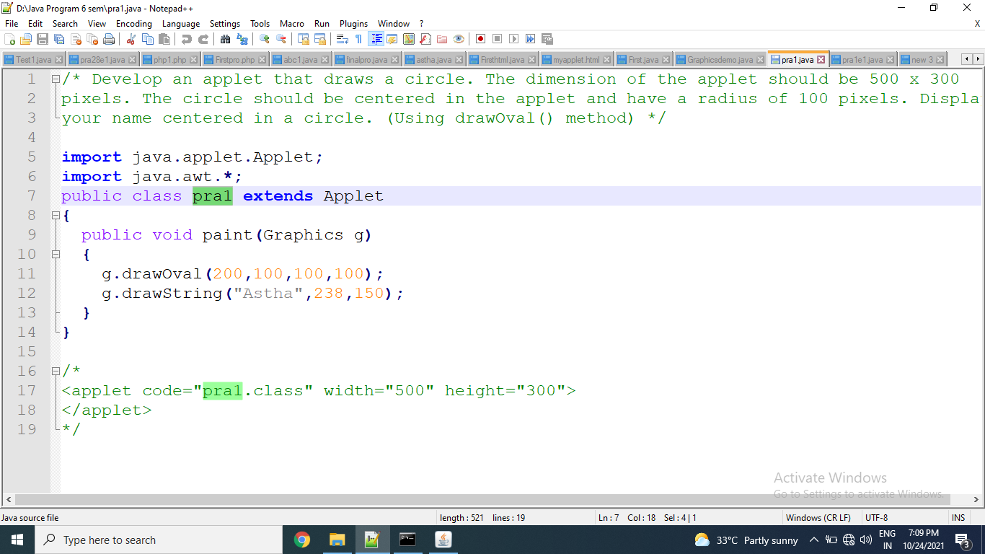

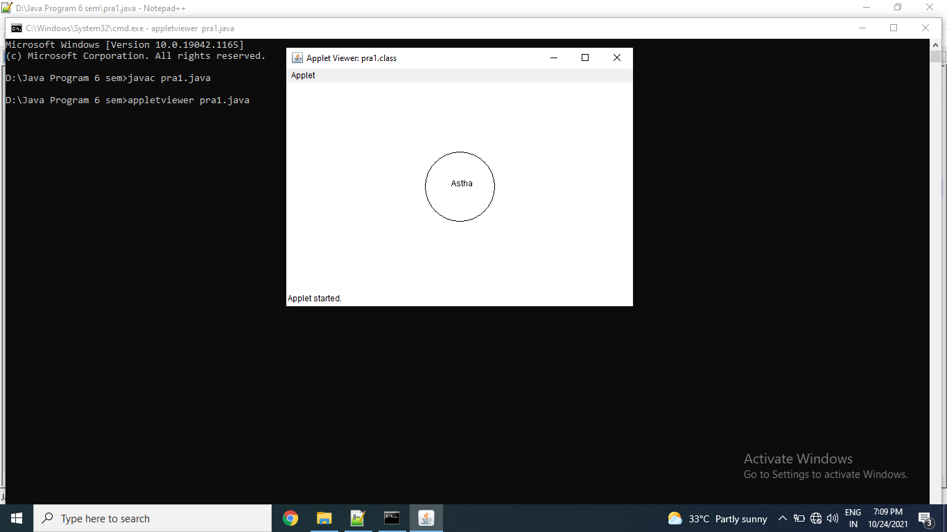

**Exercise:**

1. Draw a circle and square near circle in center of the applet.

import java.applet.Applet;

import java.awt.*;

public class pra1e1 extends Applet

{

public void paint(Graphics g)

{

g.drawOval(100,100,150,100);

g.drawRect(300,100,150,100);

}

}

/*

<applet code="pra1e1.class" width="500" height="300">

</applet>

*/

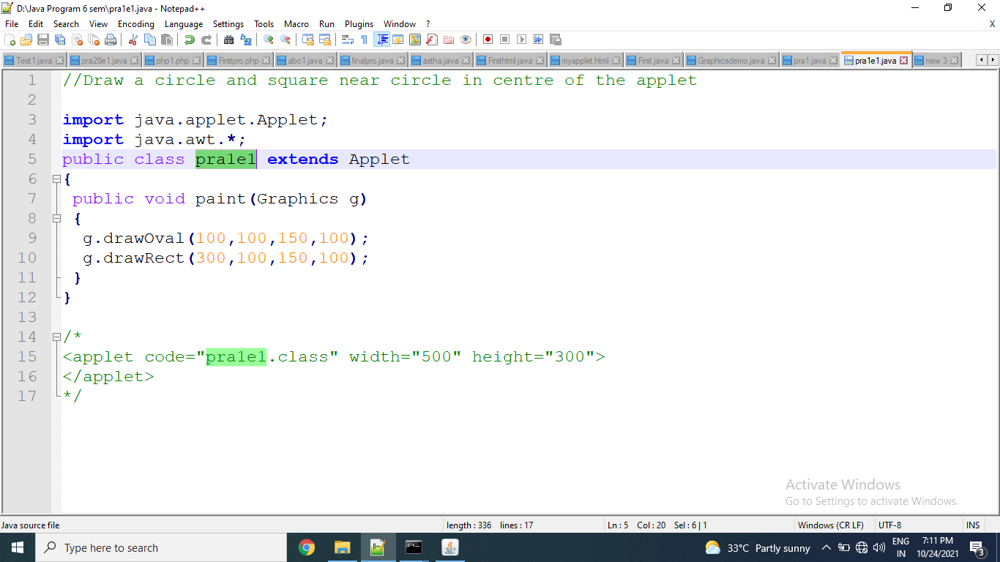

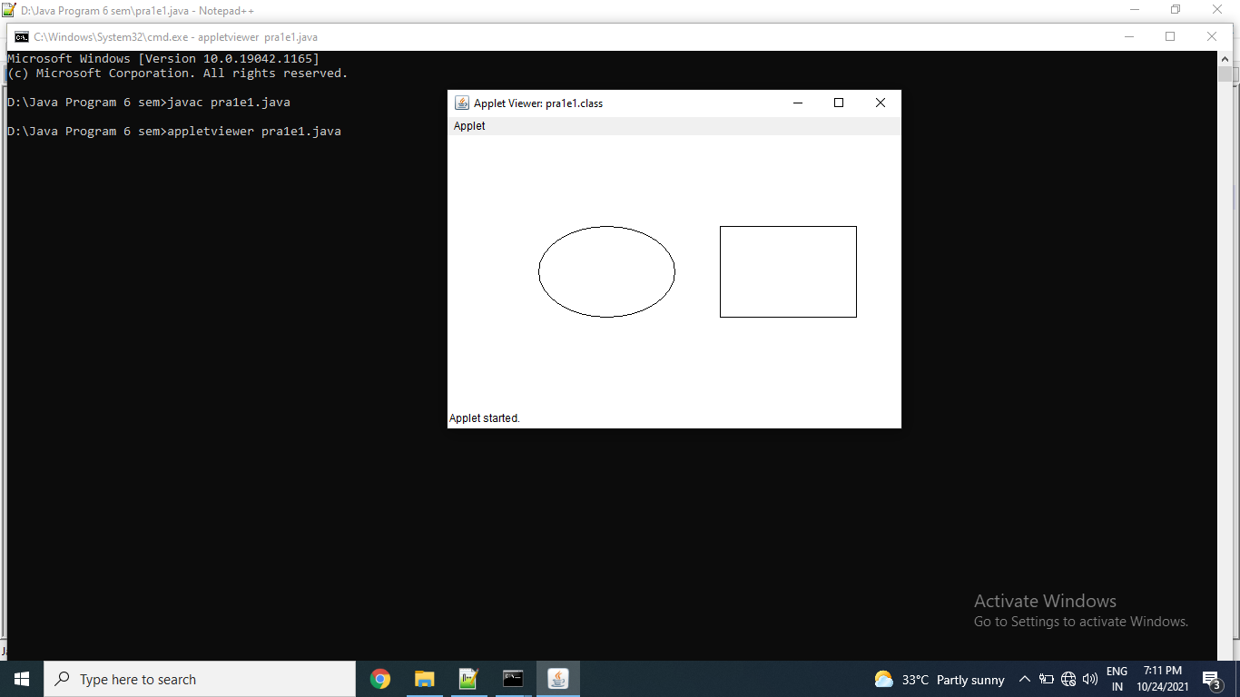

1. Draw a rectangle inside an oval in top left corner of the applet.

import java.applet.Applet;

import java.awt.*;

public class pra1e2 extends Applet

{

public void paint(Graphics g)

{

g.drawOval(0,0,170,120);

g.drawRect(33,25,100,70);

}

}

/*

<applet code="pra1e2.class" width="300" height="300">

</applet>

*/

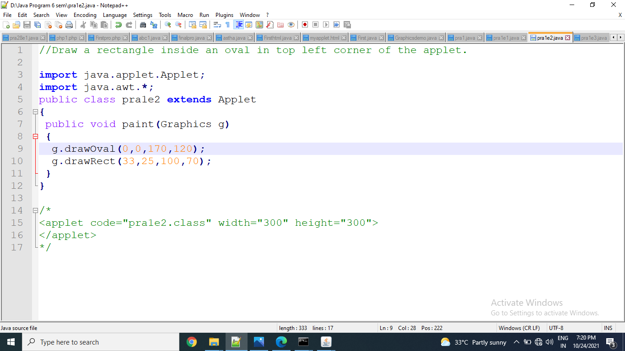

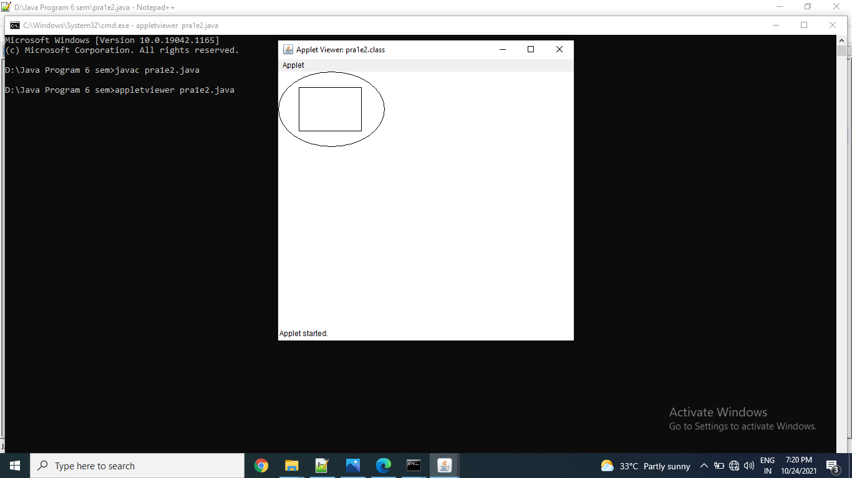

1. Draw the following ouput using drawLine function.

import java.applet.Applet;

import java.awt.*;

public class pra1e3 extends Applet

{

public void paint(Graphics g)

{

g.drawLine(10,10,100,10);

g.drawLine(10,10,100,90);

g.drawLine(10,90,10,200);

}

}

/*

<applet code="pra1e3.class" width="300" height="300">

</applet>

*/

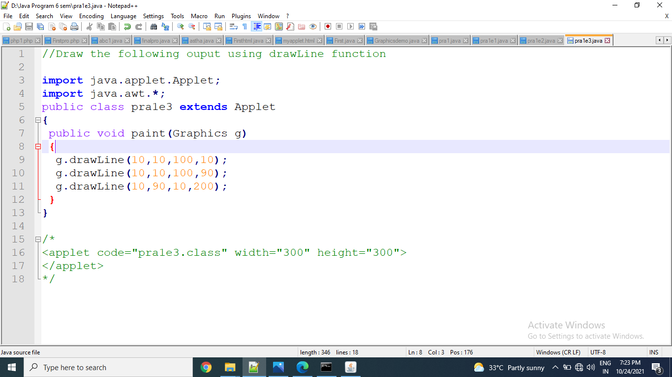

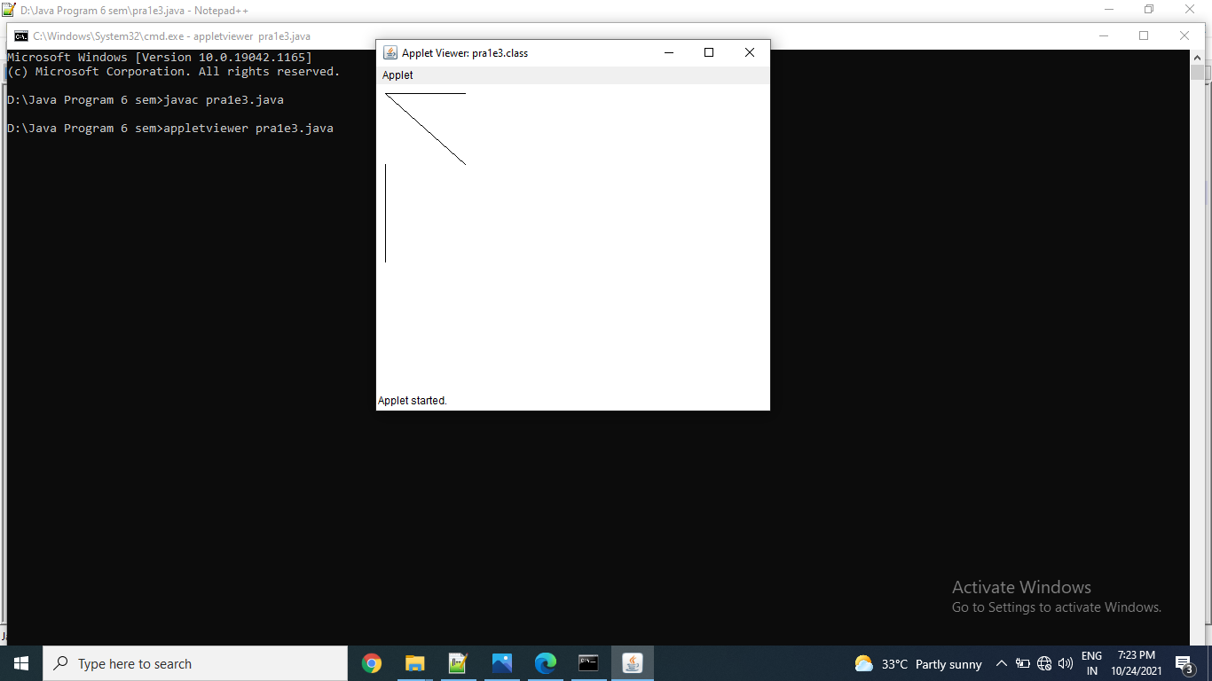

Thanks mam!!!

Name: Astha Arpit Bhatt

Enrollment: 196140316006

**Practical – 2**

Draw ten red circles in a vertical column in the center of the applet.

**CODE:**

import java.applet.Applet;

import java.awt.*;

public class pra2 extends Applet

{

public void paint(Graphics g)

{

for(int i=0;i<10;i++)

{

g.setColor(Color.red);

g.fillOval(200, i*50, 50, 50);

}

}

}

/*

<applet code="pra2.class" width="500" height="300">

</applet>

*/

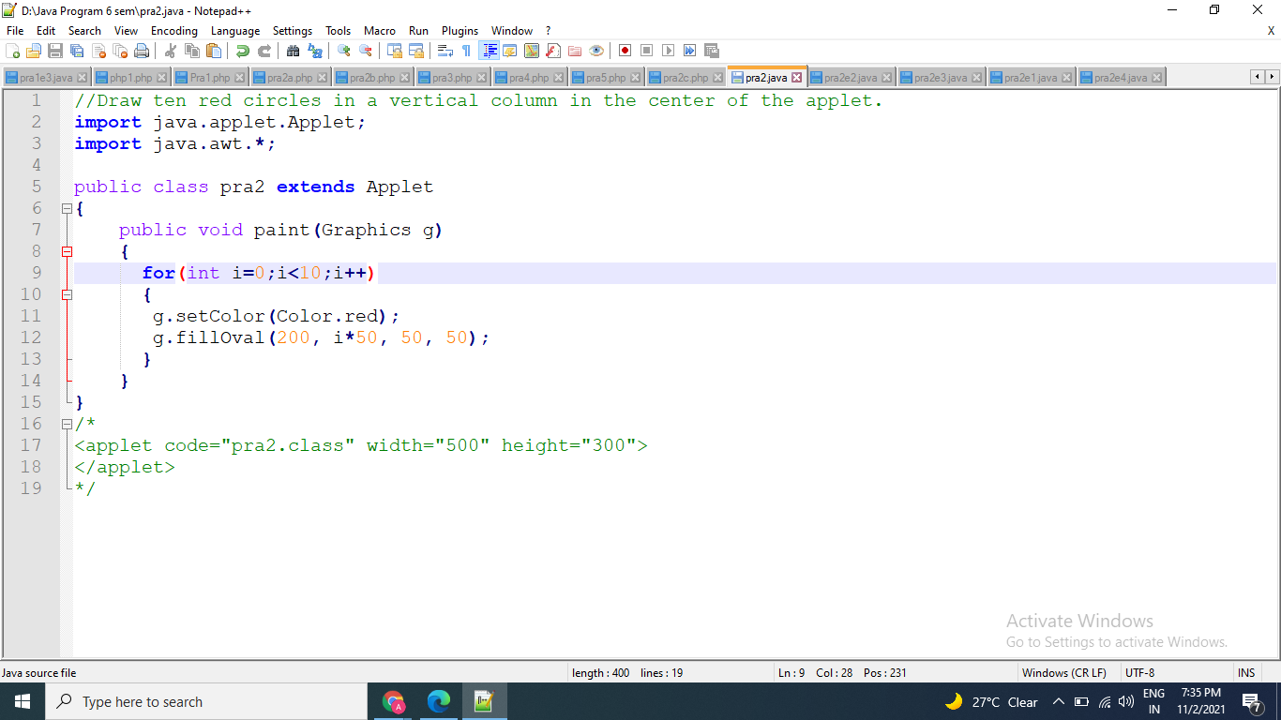

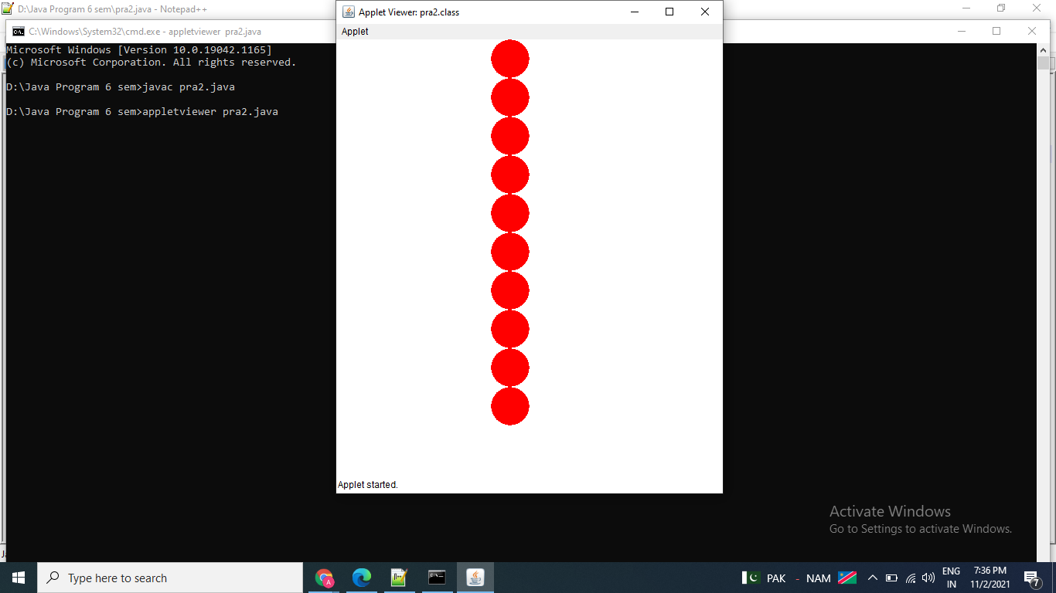

**Exercise:**

1. Draw five red circles and five blue circles alternatively in a vertical column in the centre of the applet.

import java.applet.Applet;

import java.awt.*;

public class pra2e1 extends Applet

{

public void paint(Graphics g)

{

g.fillOval(200,50,50,50);

g.setColor(Color.red);

for(int i=0;i<10;i++)

{

if(i%2==0)

{

g.fillOval(200,i*50,50,50);

g.setColor(Color.blue);

}

else

{

g.fillOval(200,i*50,50,50);

g.setColor(Color.red);

}

}

}

}

/*

<applet code="pra2e1.class" width="500" height="300">

</applet>

*/

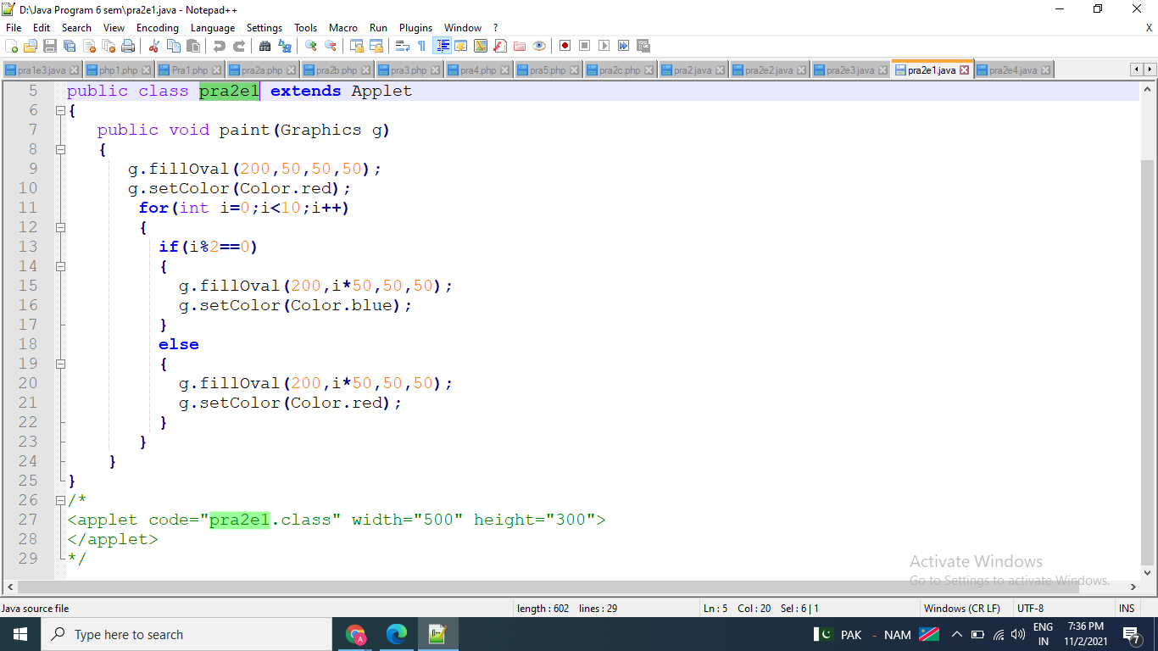

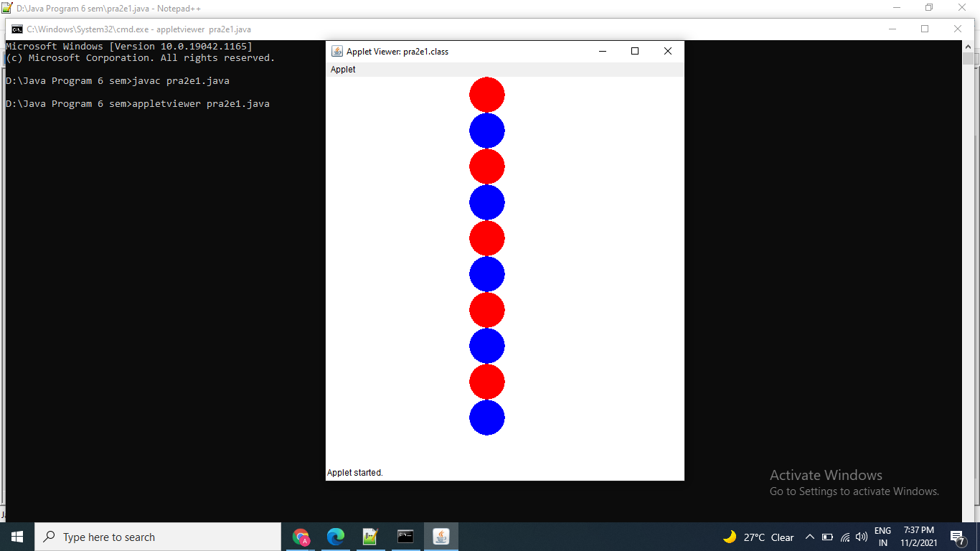

1. Draw five red circles and five blue circles alternatively horizontally in the centre of the applet.

import java.applet.Applet;

import java.awt.*;

public class pra2e2 extends Applet

{

public void paint(Graphics g)

{

g.setColor(Color.red);

g.fillOval(50,175,20,20);

g.fillOval(110,175,20,20);

g.fillOval(170,175,20,20);

g.fillOval(230,175,20,20);

g.fillOval(290,175,20,20);

g.setColor(Color.blue);

g.fillOval(80,175,20,20);

g.fillOval(140,175,20,20);

g.fillOval(200,175,20,20);

g.fillOval(260,175,20,20);

g.fillOval(320,175,20,20);

}

}

/*

<applet code="pra2e2" width="400" height="500">

</applet> */

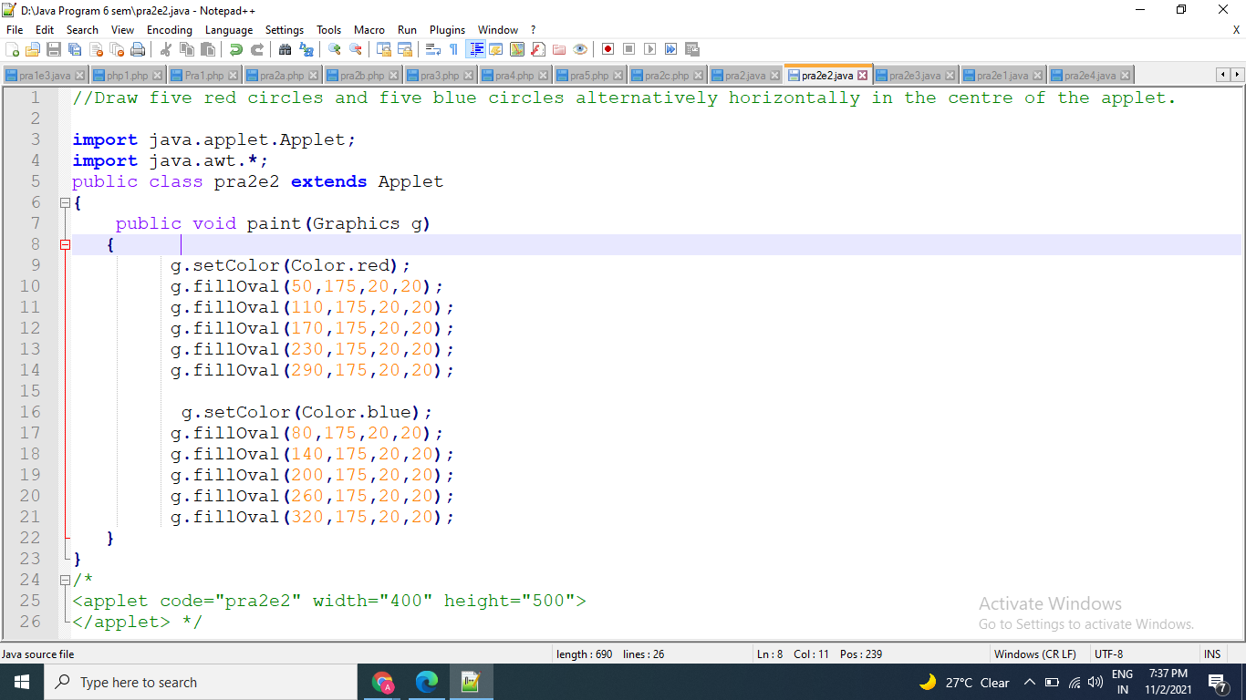

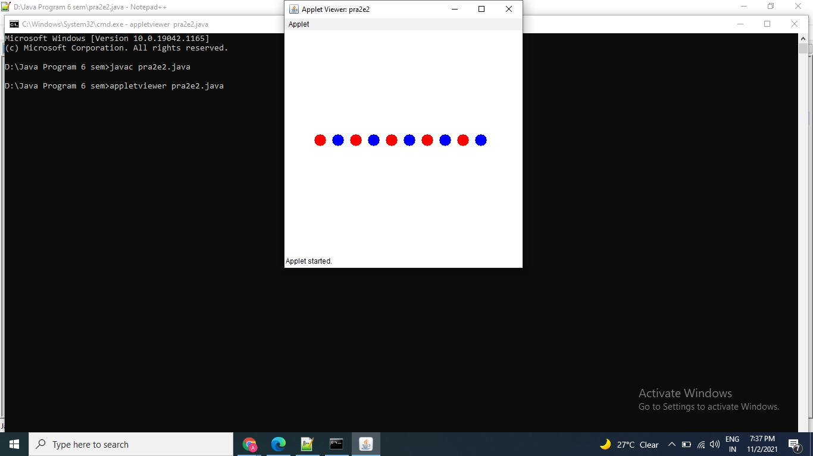

1. Draw an applet page, where left column consist of square filled in blue colour, centre column consists of oval in red colour and right column consists of rectangle filled with pink colour.

import java.applet.Applet;

import java.awt.*;

public class pra2e3 extends Applet

{

public void paint(Graphics g)

{

g.setColor(Color.blue);

g.drawRect(20,20,50,50);

g.fillRect(20,20,25,50);

g.setColor(Color.red);

g.drawOval(80,20,50,50);

g.fillOval(95,20,20,50);

g.setColor(Color.pink);

g.drawRect(140,20,50,50);

g.fillRect(165,20,25,50);

}

}

/*

<applet code="pra2e3.class" width="500" height="300">

</applet>

*/

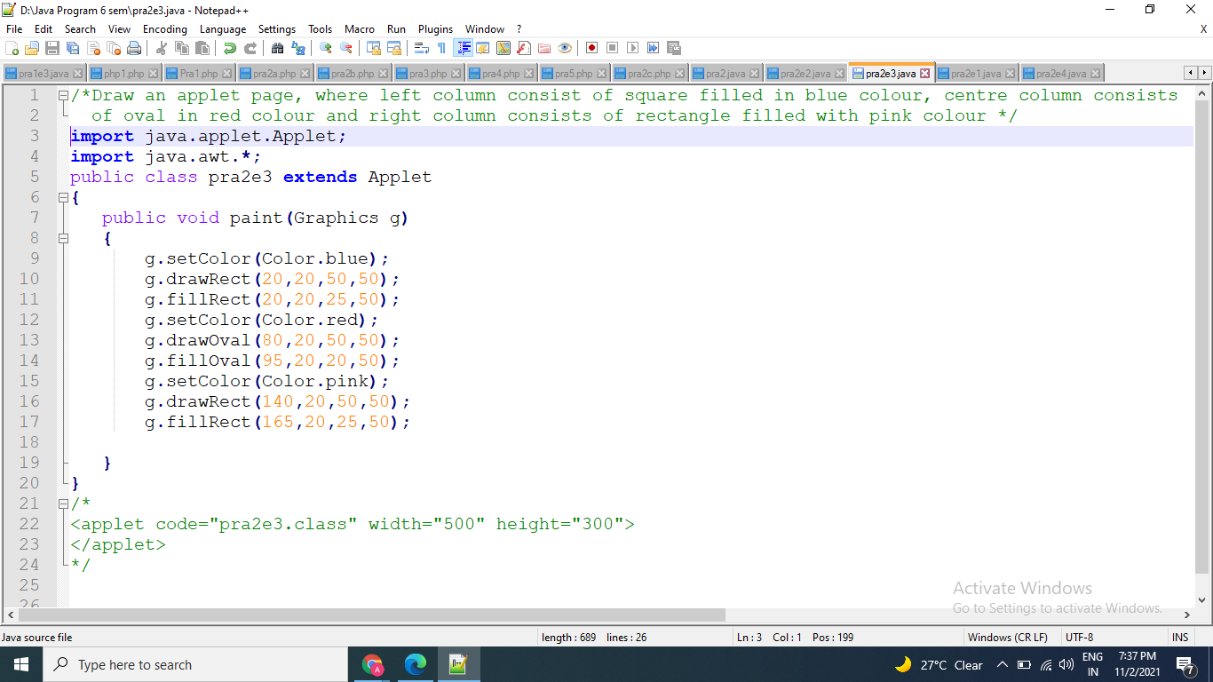

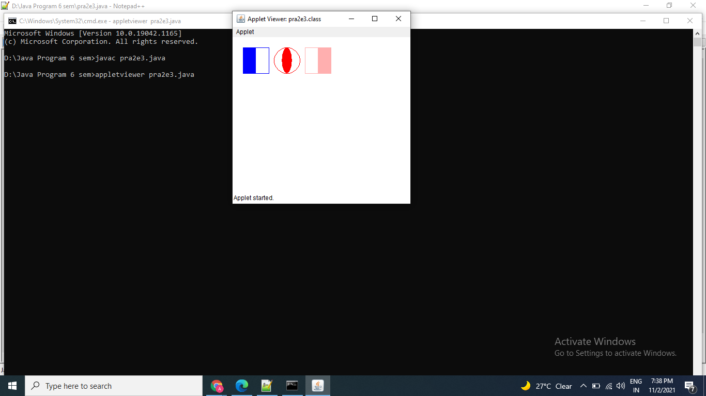

1. Draw the following applet

import java.applet.Applet;

import java.awt.*;

public class pra2e4 extends Applet

{

public void paint(Graphics g)

{

g.drawString("Applet Lifecycle",240,90);

g.setColor(Color.pink);

g.fillOval(230,110,100,100);

g.drawString("1",320,120);

g.setColor(Color.white);

g.drawString("Applet is",250,150);

g.drawString("initialized",250,170);

g.setColor(Color.red);

g.fillOval(140,190,100,100);

g.drawString("5",150,190);

g.setColor(Color.white);

g.drawString("Applet is",160,230);

g.drawString("destroyed",160,250);

g.setColor(Color.blue);

g.fillOval(320,190,100,100);

g.drawString("2",430,240);

g.setColor(Color.white);

g.drawString("Applet is",340,230);

g.drawString("started",340,250);

g.setColor(Color.orange);

g.fillOval(170,300,100,100);

g.drawString("4",160,320);

g.setColor(Color.white);

g.drawString("Applet is",190,340);

g.drawString("stopped",190,360);

g.setColor(Color.cyan);

g.fillOval(290,300,100,100);

g.drawString("3",280,390);

g.setColor(Color.white);

g.drawString("Applet is",310,340);

g.drawString("painted",310,360);

}

}

/*

<applet code="pra2e4.class" width="600" height="500">

</applet>

*/

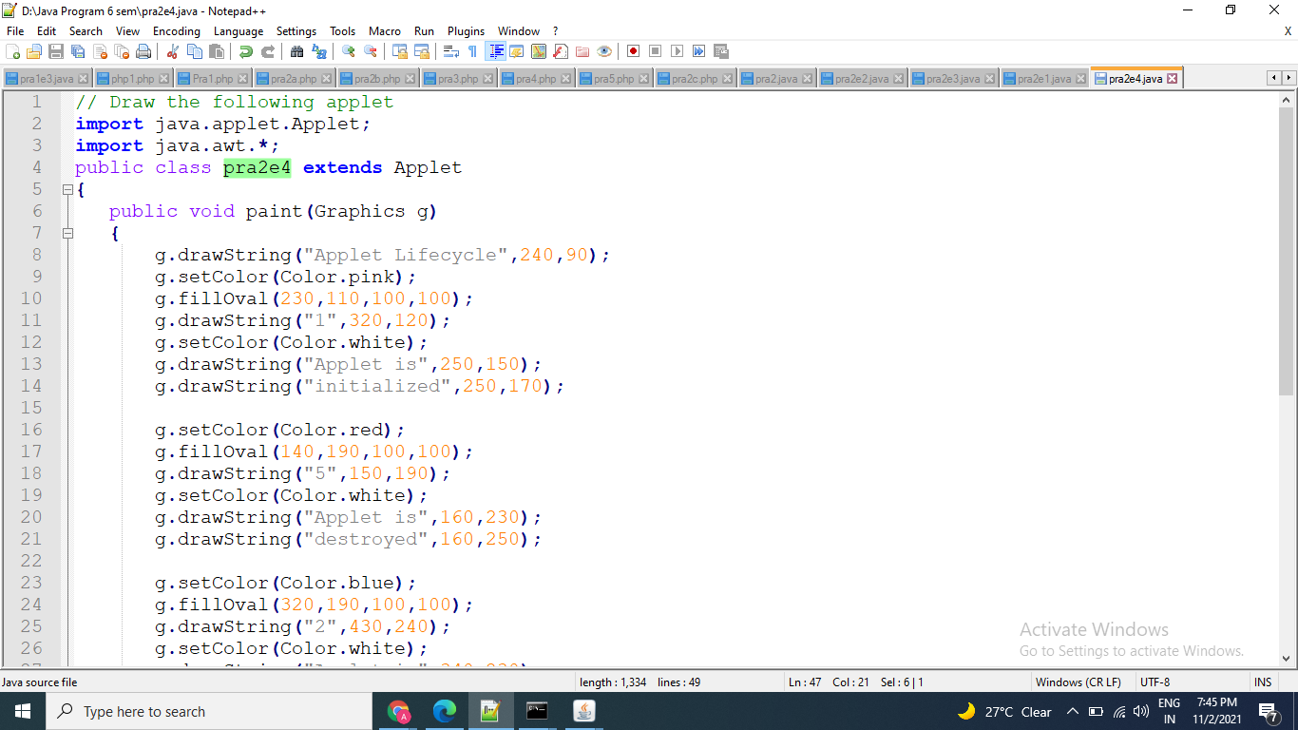

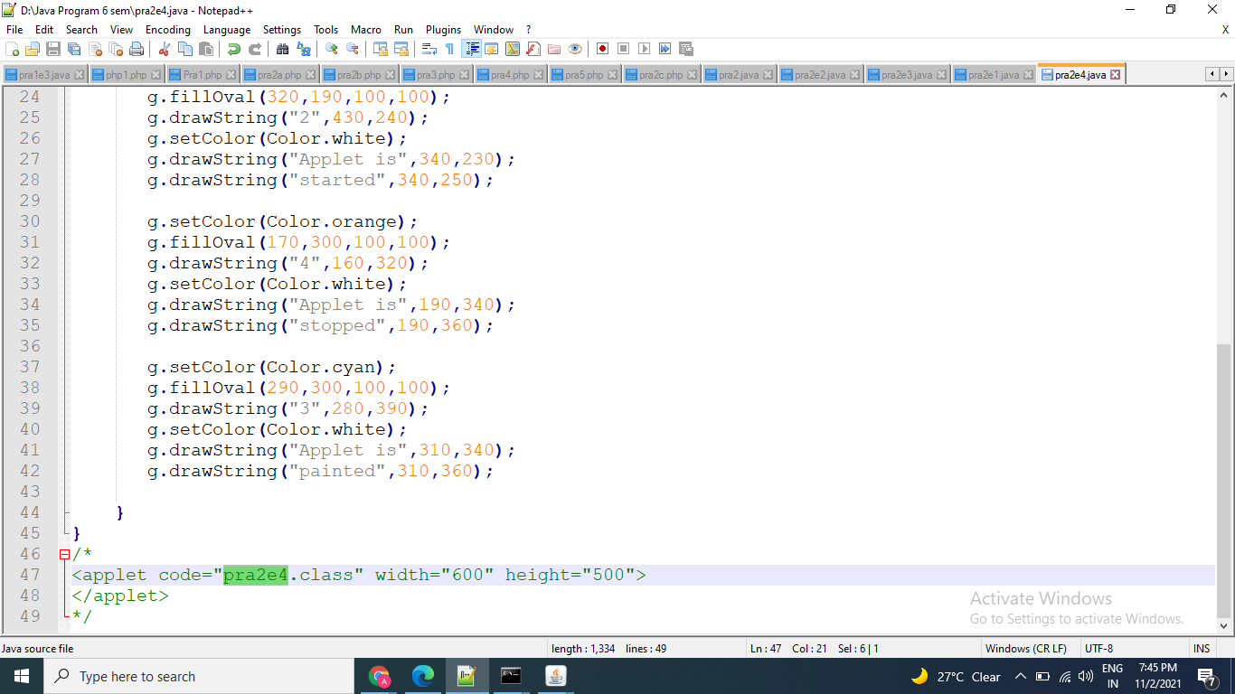

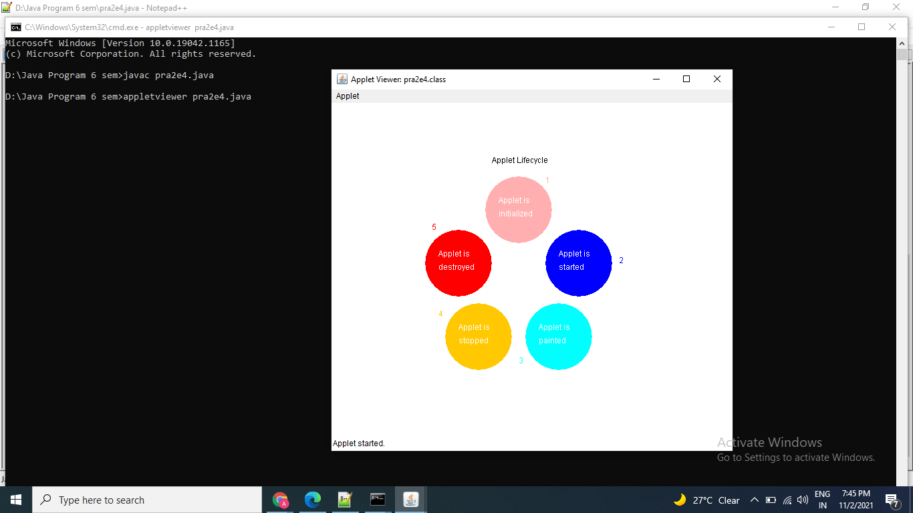

Thanks mam!!!

Name: Astha Arpit Bhatt

Enrollment: 196140316006

**Practical – 3**

Built an applet that displays a horizontal rectangle in its centre. Let the rectangle fill with colour from UP to Down.

import java.awt.Graphics;

import java.awt.event.*;

import java.awt.*;

import java.applet.*;

public class pra3 extends Applet

{

public void paint(Graphics g)

{

int width=50;

int height=10;

g.setColor(Color.red);

g.drawRect(150,100,50,200);

for(int i=1;i<21;i++)

{

try

{

Thread.sleep(1000);

}

catch(InterruptedException e)

{

}

g.fillRect(150,100,width,height);

height = height +10;

}

}

}

/*

<applet code="pra3.class" width=600 height=400>

</applet>

*/

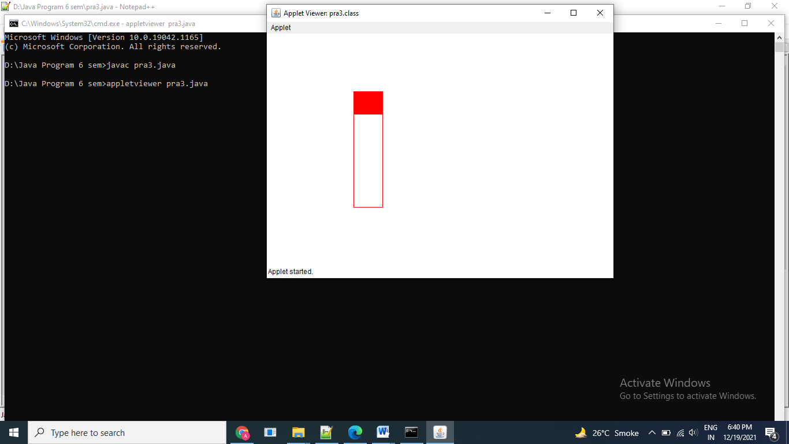

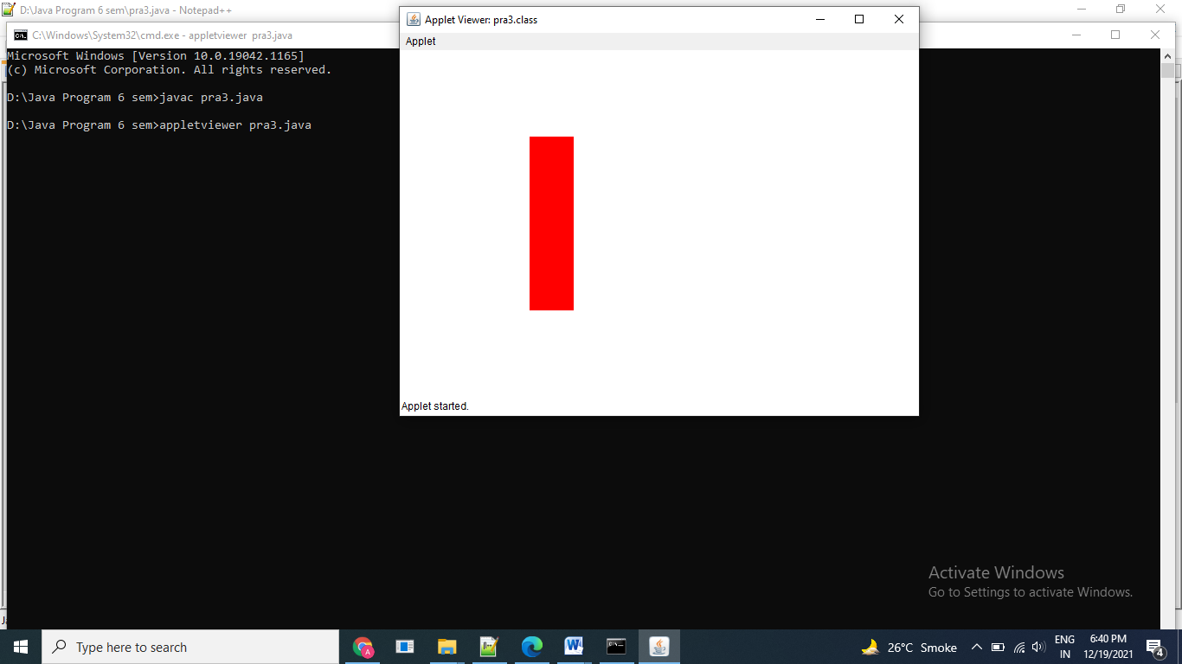

Exercise:

1. Draw the following in applet window.

import java.awt.Graphics;

import java.awt.event.*;

import java.awt.*;

import java.applet.*;

public class pr3e1 extends Applet

{

public void paint(Graphics g)

{

g.setColor(Color.RED);

g.drawOval(145,100,150,140);

g.setColor(Color.MAGENTA);

g.drawOval(175,100,90,140);

g.setColor(Color.YELLOW);

g.drawOval(205,100,30,140);

}

}

/*

<applet code="pr3e1.class" width=600 height=400>

</applet>

*/

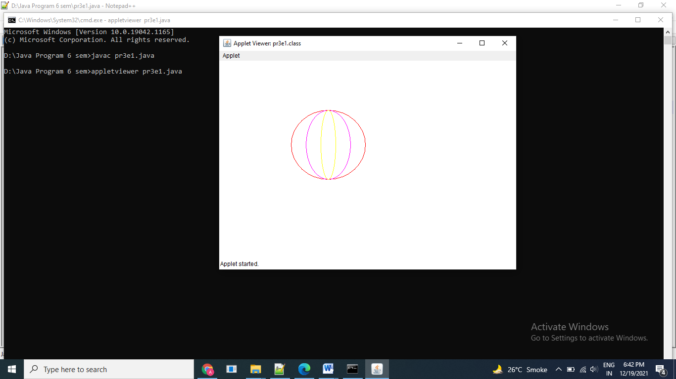

1. Draw an oval that fills up eventually with pink colour

import java.awt.Graphics;

import java.awt.event.*;

import java.awt.*;

import java.applet.*;

public class pra3e2 extends Applet

{

public void paint(Graphics g)

{

g.drawOval(20,20,200,120);

g.setColor(Color.pink);

g.fillOval(20,20,200,120);

}

}

/*

<applet code="pra3e2.class" width=600 height=400>

</applet>

*/

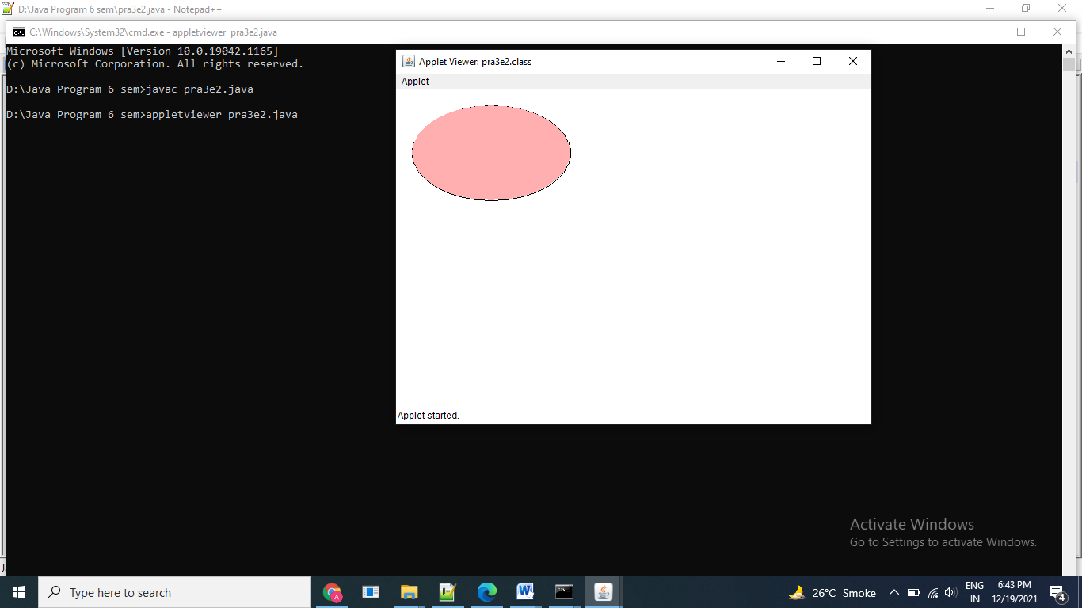

Thanks mam!!!

Name: Astha Arpit Bhatt

Enroll: 196140316006

Practical-4

Aim: Develop an applet that displays the position of the mouse at the upper left corner of the applet when it is dragged or moved. Draw a 10x10 pixel rectangle filed with black at the current mouse position

Code:

import java.applet.*;

import java.awt.*;

import java.awt.event.*;

/*<applet code="pra4.class" height=500 width=500></applet>*/

public class pra4 extends Applet implements MouseMotionListener

{

static int x,y;

public void init()

{

addMouseMotionListener(this);

}

public void paint(Graphics g)

{

g.drawString("X = " +x+ " ,Y = " +y,15,15);

g.fillRect(x,y,10,10);

}

public void mouseMoved(MouseEvent e)

{

x = e.getX();

y = e.getY();

repaint();

}

public void mouseDragged(MouseEvent e)

{

x = e.getX();

y = e.getY();

repaint();

}

public void mouseExited(MouseEvent e)

{

}

public void mouseEntered(MouseEvent e)

{

}

public void mouseClicked(MouseEvent e)

{

}

}

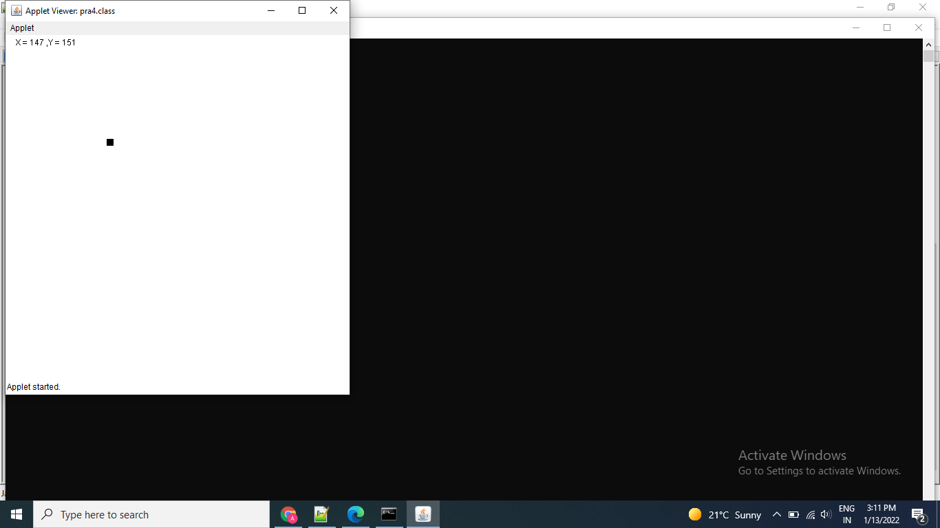

Exercise :

Develop an applet that draws an oval filled with blue color at current mouse position

Code:

import java.applet.*;

import java.awt.*;

import java.awt.event.*;

/*<applet code="pra4e1.class" height=500 width=500></applet>*/

public class pra4e1 extends Applet implements MouseMotionListener

{

static int x,y;

public void init()

{

addMouseMotionListener(this);

}

public void paint(Graphics g)

{

g.drawString("X = " +x+ " ,Y = " +y,15,15);

g.setColor(Color.blue);

g.fillOval(x,y,20,25);

}

public void mouseMoved(MouseEvent e)

{

x = e.getX();

y = e.getY();

repaint();

}

public void mouseDragged(MouseEvent e)

{

x = e.getX();

y = e.getY();

repaint();

}

public void mouseExited(MouseEvent e)

{

}

public void mouseEntered(MouseEvent e)

{

}

public void mouseClicked(MouseEvent e)

{

}

}

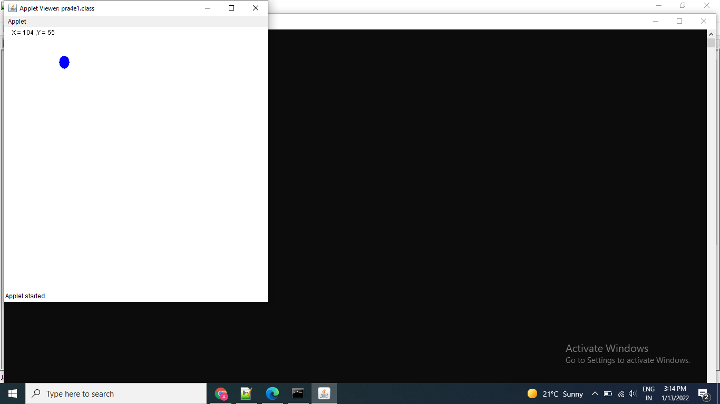

Thanks mam!!

Name: Astha Arpit Bhatt

Enroll: 196140316006

Practical-5

Aim: Develop an applet that contains one button. Initialize the label on the button to “start”, when the user presses the button, which changes the label between these two values each time the button is pressed

Code:

import java.awt.*;

import java.awt.event.*;

import java.applet.*;

/*<applet code="pra5" height=500 width=500></applet>*/

public class pra5 extends Applet implements ActionListener

{

Button b;

public void init()

{

b=new Button("Start");

b.addActionListener(this);

add(b);

}

public void actionPerformed(ActionEvent ae)

{

String label=b.getLabel();

if(label.compareTo("Start")==0)

{

b.setLabel("Stop");

}

else

{

b.setLabel("Start");

}

}

}

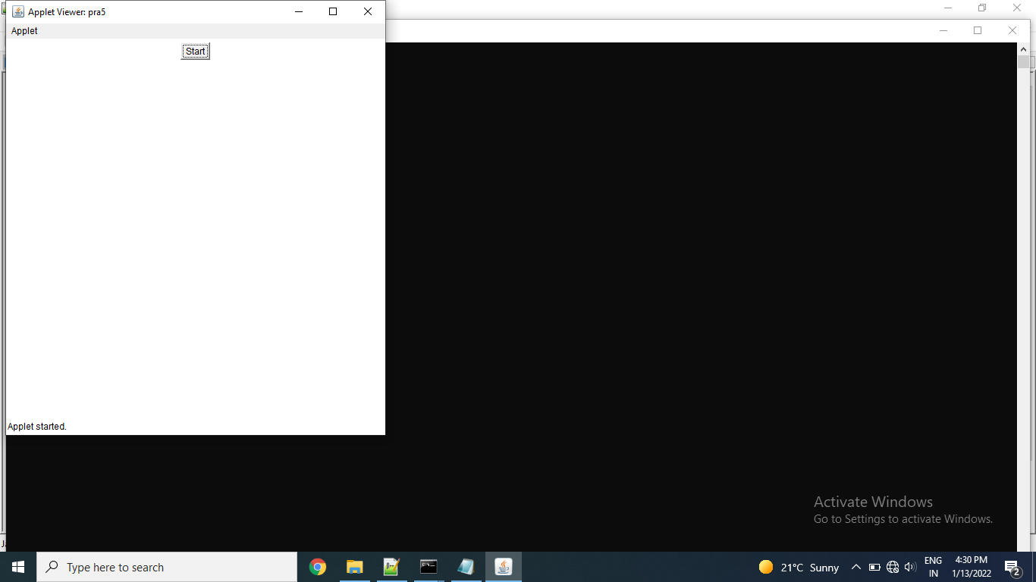

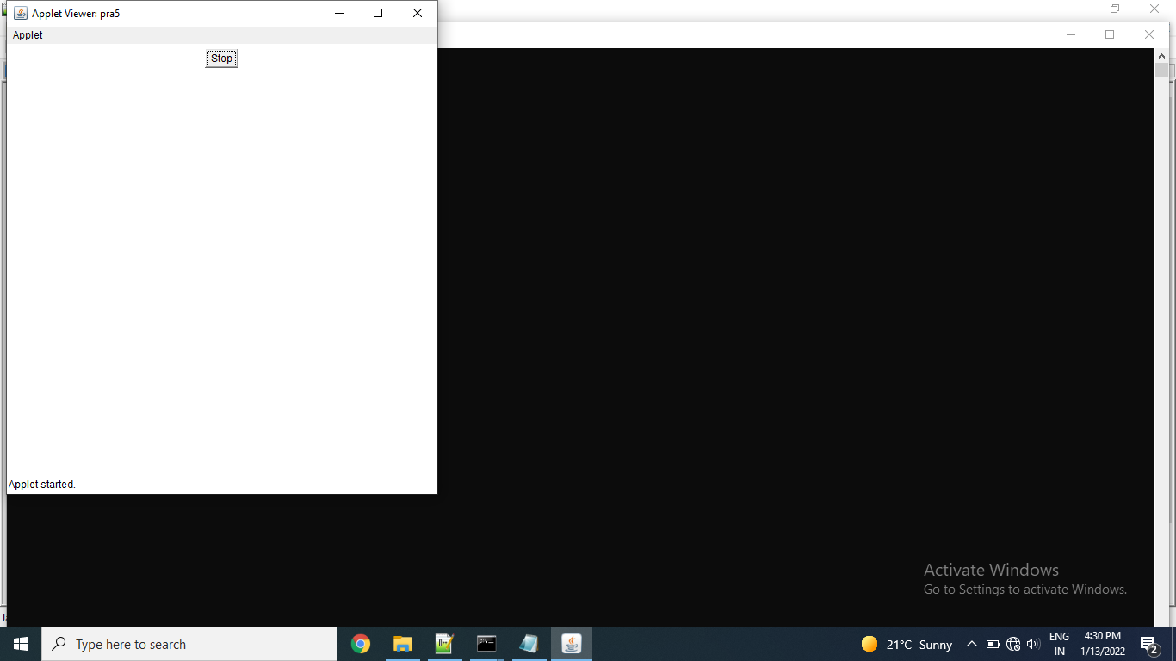

Exercise:

Develop an applet that contains two buttons. Initialize the label on the buttons to “red” and “green”, when the user presses the button, it should change the content on the label according to the button pressed.

Code:

import java.applet.*;

import java.awt.*;

import java.awt.event.*;

/*<applet code = "pra5e1.class" width = "500" height= "300" ></applet>*/

public class pra5e1 extends Applet

{

TextField tf1=new TextField(15);

Button b1=new Button("RED");

Button b2=new Button("GREEN");

public void init()

{

add(tf1);

add(b1);

add(b2);

}

public boolean action(Event evt,Object obj)

{

if(evt.target.equals(b1))

{

getAppletContext().showStatus("red");

tf1.setText("RED");

}

if(evt.target.equals(b2))

{

getAppletContext().showStatus("green");

tf1.setText("GREEN");

}

return true;

}

}

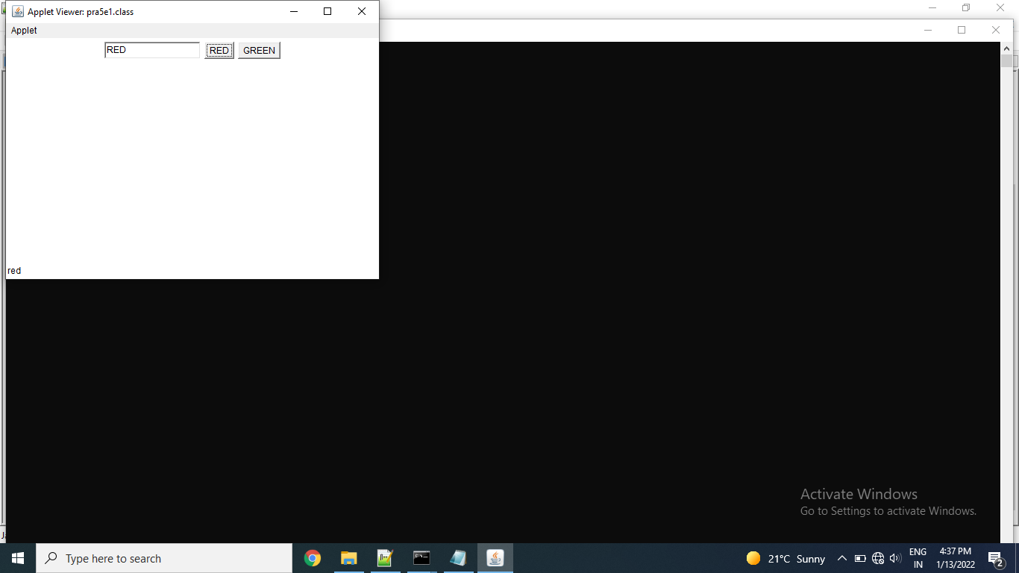

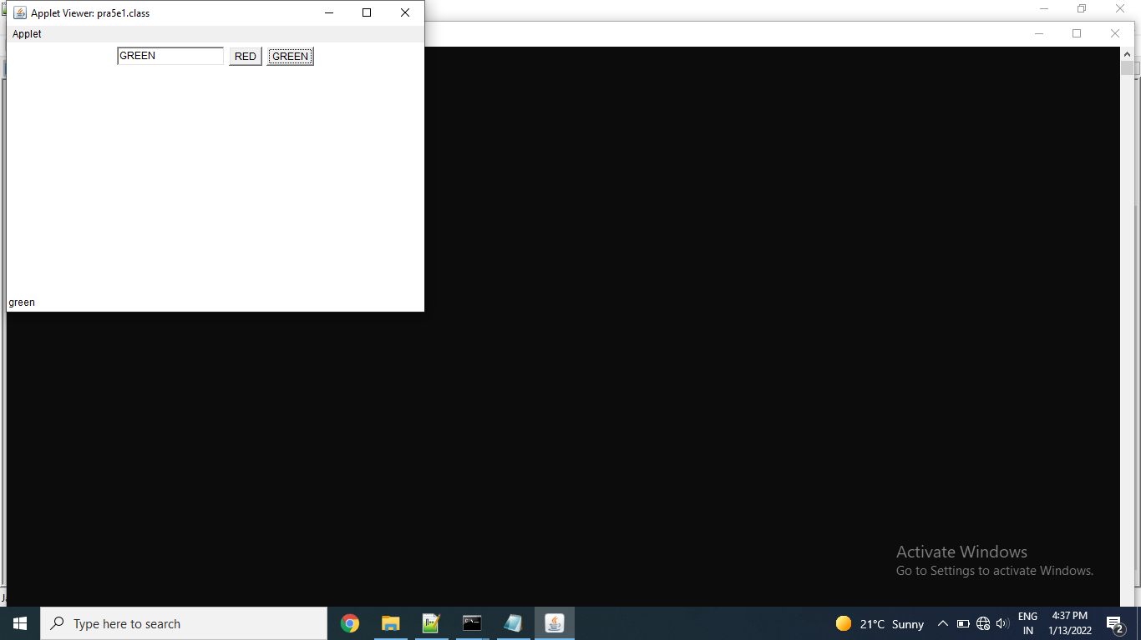

Thanks mam!!

Name: Astha Arpit Bhatt

Enroll: 196140316006

Practical-6

Aim: Develop an applet that uses the mouse listener, which overrides only two methods which are mousePressed and mouseReleased

Code:

import java.applet.*;

import java.awt.*;

import java.awt.event.*;

/*<applet code="pra6" height=500 width=500></applet>*/

public class pra6 extends Applet implements MouseListener

{

static String msg;

public void init()

{

addMouseListener(this);

}

public void paint(Graphics g)

{

g.drawString(msg,10,10);

}

public void mousePressed(MouseEvent me)

{

msg="Mouse Pressed";

repaint();

}

public void mouseReleased(MouseEvent me)

{

msg="Mouse Released";

repaint();

}

public void mouseExited(MouseEvent me)

{

}

public void mouseEntered(MouseEvent me)

{

}

public void mouseClicked(MouseEvent me)

{

}

}

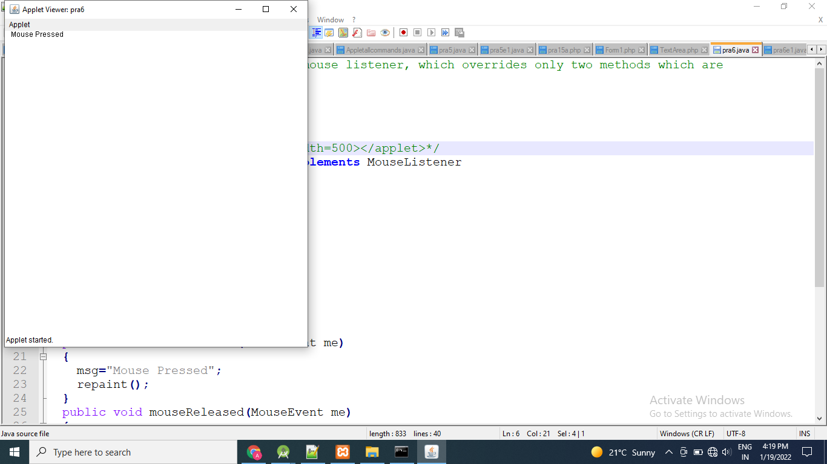

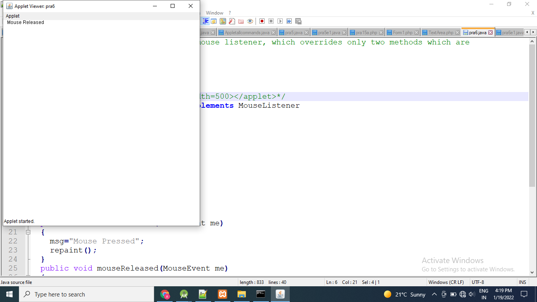

Exercise:

Write a java program to handle, mouse motion listener events.

import java.applet.*;

import java.awt.*;

import java.awt.event.*;

/*<applet code="pra6e1" height=500 width=500></applet>*/

public class pra6e1 extends Applet implements MouseMotionListener

{

static String msg;

public void init()

{

addMouseMotionListener(this);

}

public void paint(Graphics g)

{

g.drawString(msg,10,10);

}

public void mouseDragged(MouseEvent e)

{

msg="Mouse Dragged";

repaint();

}

public void mouseMoved(MouseEvent e)

{

msg="Mouse Moved";

repaint();

}

}

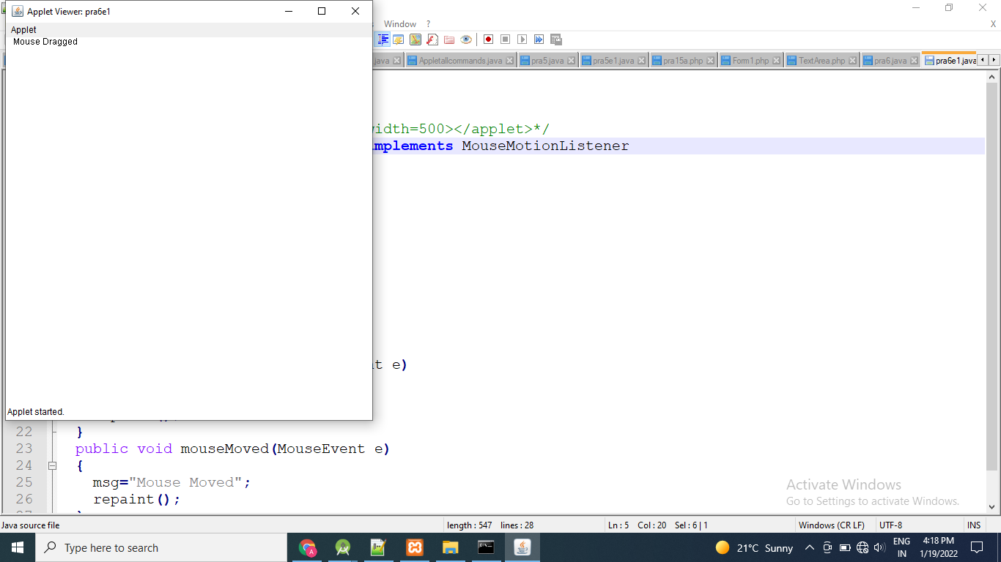

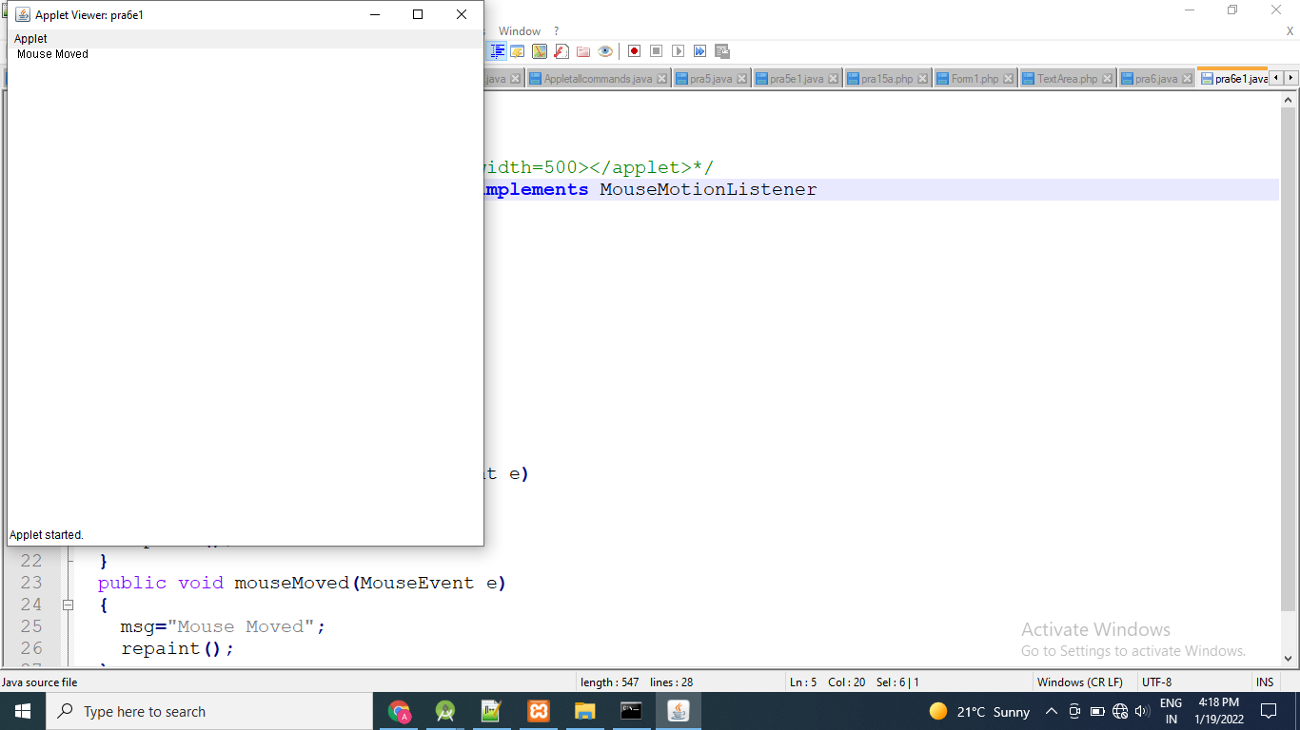

Thanks mam!!

Name: Astha Arpit Bhatt

Enroll: 196140316006

**Practical 7**

Aim: Develop a program that has only one button in the frame, clicking on the button cycles through the colors: red->green->blue and so on. One color changes per click.

Code:

import java.awt.*;

import java.awt.event.*;

public class pra7 implements ActionListener

{

Frame f;

Button b;

public pra7()

{

f = new Frame("pra7");

b = new Button("Click");

b.setBackground(Color.RED);

f.setBackground(Color.RED);

b.addActionListener(this);

f.setLayout(new FlowLayout());

f.add(b);

f.setSize(300,300);

f.setVisible(true);

}

public void actionPerformed(ActionEvent o)

{

if(f.getBackground() == Color.BLUE)

{

b.setBackground(Color.RED);

f.setBackground(Color.RED);

}

else if(f.getBackground() == Color.RED)

{

b.setBackground(Color.GREEN);

f.setBackground(Color.GREEN);

}

else if(f.getBackground() == Color.GREEN)

{

b.setBackground(Color.BLUE);

f.setBackground(Color.BLUE);

}

}

public static void main(String args[])

{

pra7 o = new pra7();

}

}

Output:

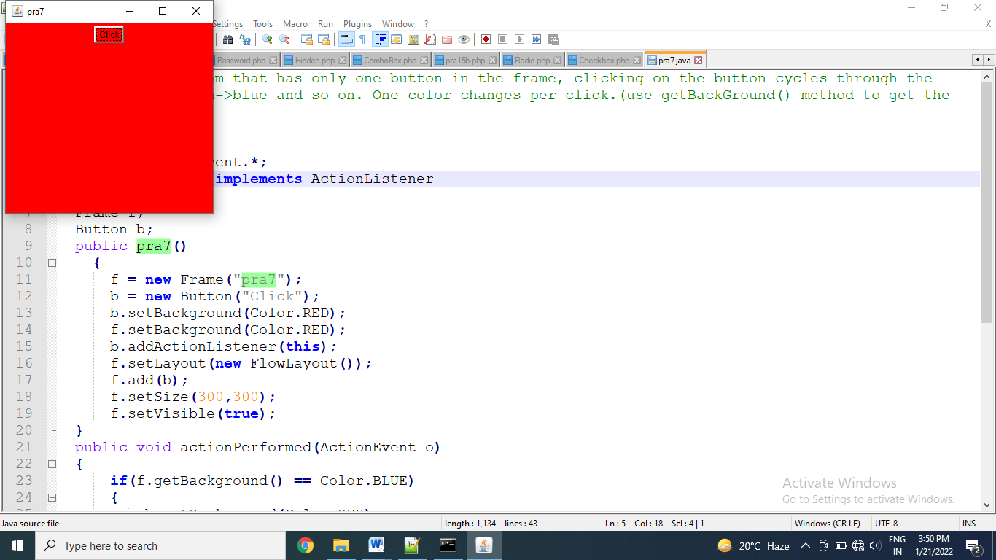

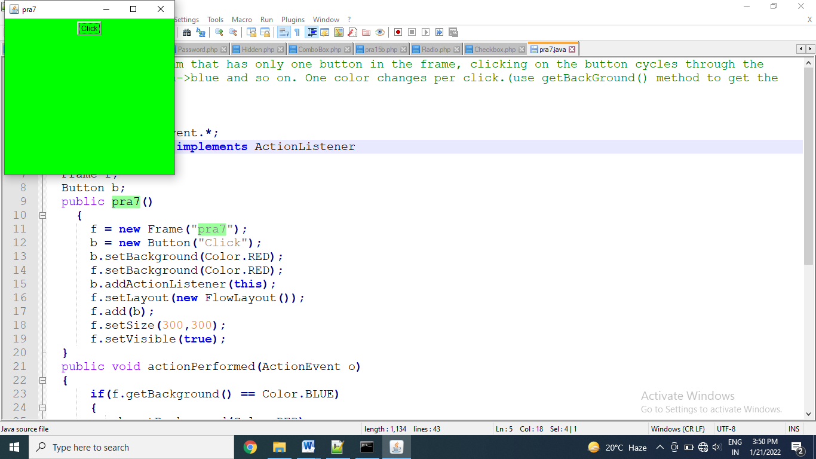

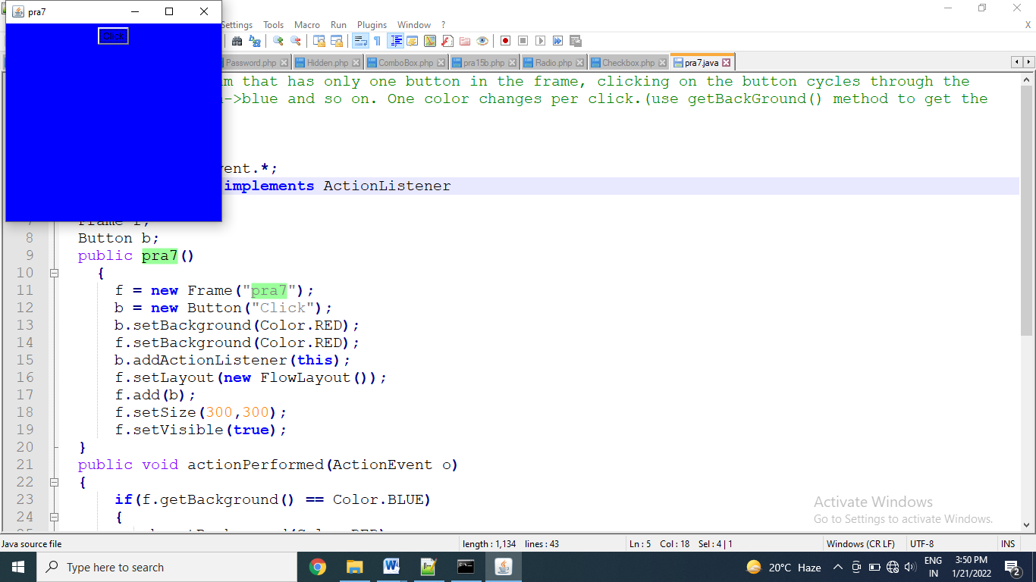

Thanks mam!!

Name: Astha Arpit Bhatt

Enroll: 196140316006

**Practical 8**

Aim :- Develop an program that contains three check boxes and 30 x 30 pixel canvas.The three checkboxes should be labeled "Red", "Green","Blue". The selection of the check boxes determine the color of the canvas. For example, if the user selects both "Red" and "Blue", the canvas should be purple.

Code:

import java.awt.*;

import java.applet.*;

import java.awt.event.*;

/*<applet code="pra8.class" height=500 width=500></applet>*/

public class pra8 extends Applet implements ItemListener

{

Checkbox c1 = new Checkbox("Red");

Checkbox c2 = new Checkbox("Green");

Checkbox c3 = new Checkbox("Blue");

Canvas c = new Canvas();

int red=0,blue=0,green=0;

public void init()

{

c1.addItemListener(this);

c2.addItemListener(this);

c3.addItemListener(this);

c.setSize(30,30);

c.setBackground(Color.BLACK);

setLayout(new FlowLayout());

add(c1);

add(c2);

add(c3);

add(c);

}

public void itemStateChanged(ItemEvent o)

{

if(c1.getState())

red=255;

else

red=0;

if(c2.getState())

green=255;

else

green=0;

if(c3.getState())

blue=255;

else

blue=0;

Color clr = new Color(red,green,blue);

c.setBackground(clr);

}

}

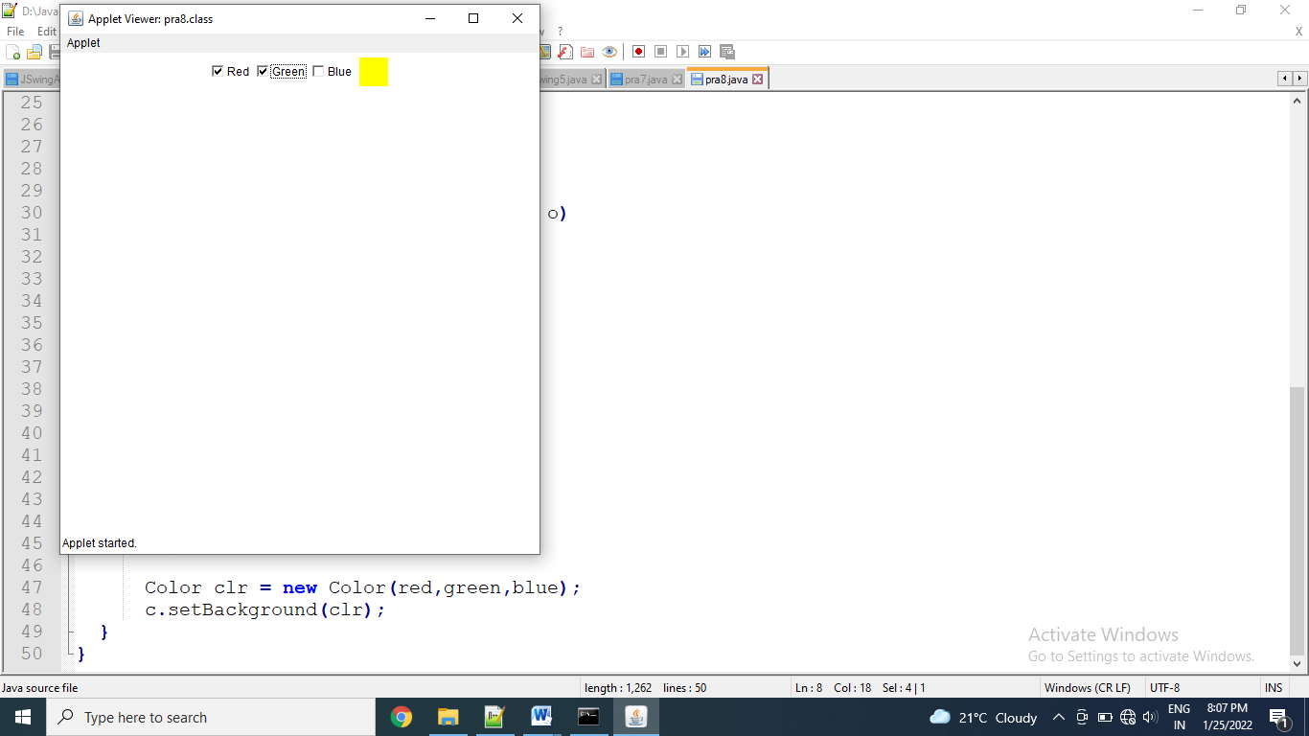

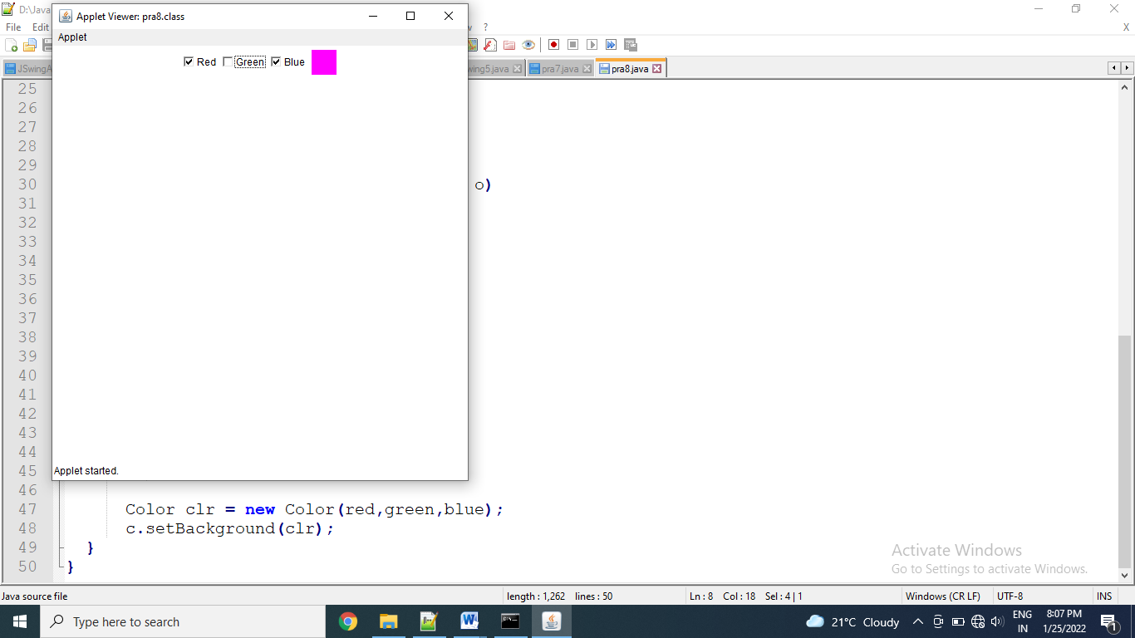

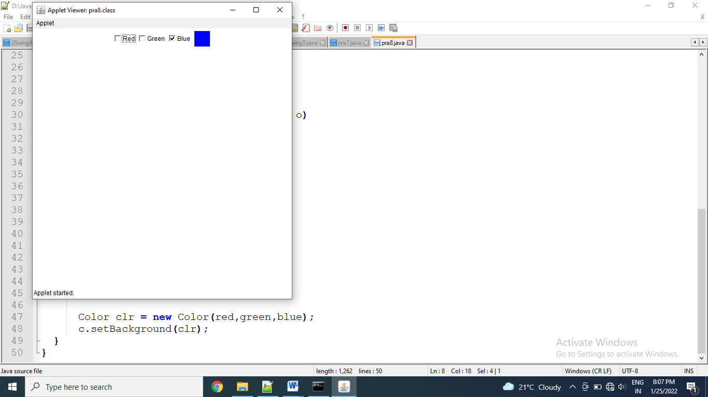

Exercise:

Write an applet that contains three buttons OK,CANCEL and HELP and a text field. if OK is pressed shown on the status bar-“OK is pressed” and the text field should turn red. When CANCEL is pressed -shown on the status bar-“ CANCEL is pressed” and text field should turn green. When HELP is pressed- shown on the status bar-“HELP is pressed” and the text field should turn yellow

Code:

import java.awt.*;

import java.applet.*;

//<applet code="pra8e1.class" height=500 width=500></applet>

public class pra8e1 extends Applet

{

Button b1 = new Button("OK");

Button b2 = new Button("CANCLE");

Button b3 = new Button("HELP");

TextField tf1 = new TextField(15);

public void init()

{

add(tf1);

add(b1);

add(b2);

add(b3);

}

public boolean action(Event e,Object o)

{

if(e.target.equals(b1))

{

getAppletContext().showStatus("OK is pressed");

tf1.setBackground(Color.RED);

}

if(e.target.equals(b2))

{

getAppletContext().showStatus("CANCLE is pressed");

tf1.setBackground(Color.GREEN);

}

if(e.target.equals(b3))

{

getAppletContext().showStatus("HELP is pressed");

tf1.setBackground(Color.YELLOW);

}

return true;

}

}

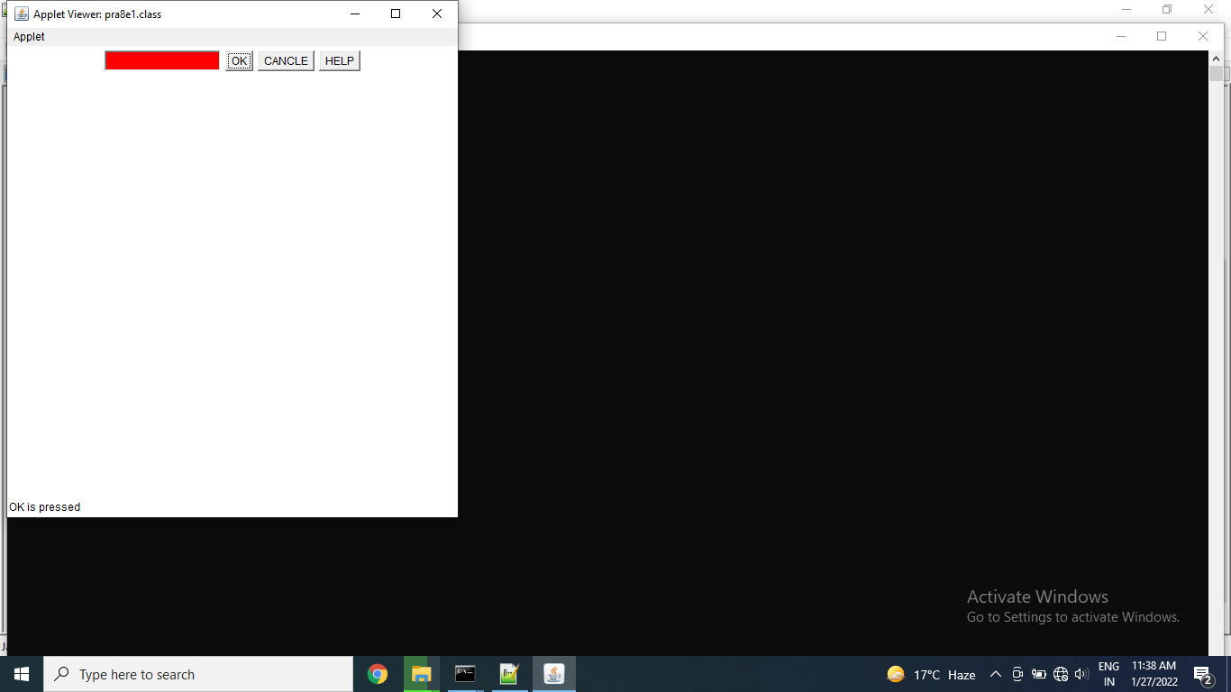

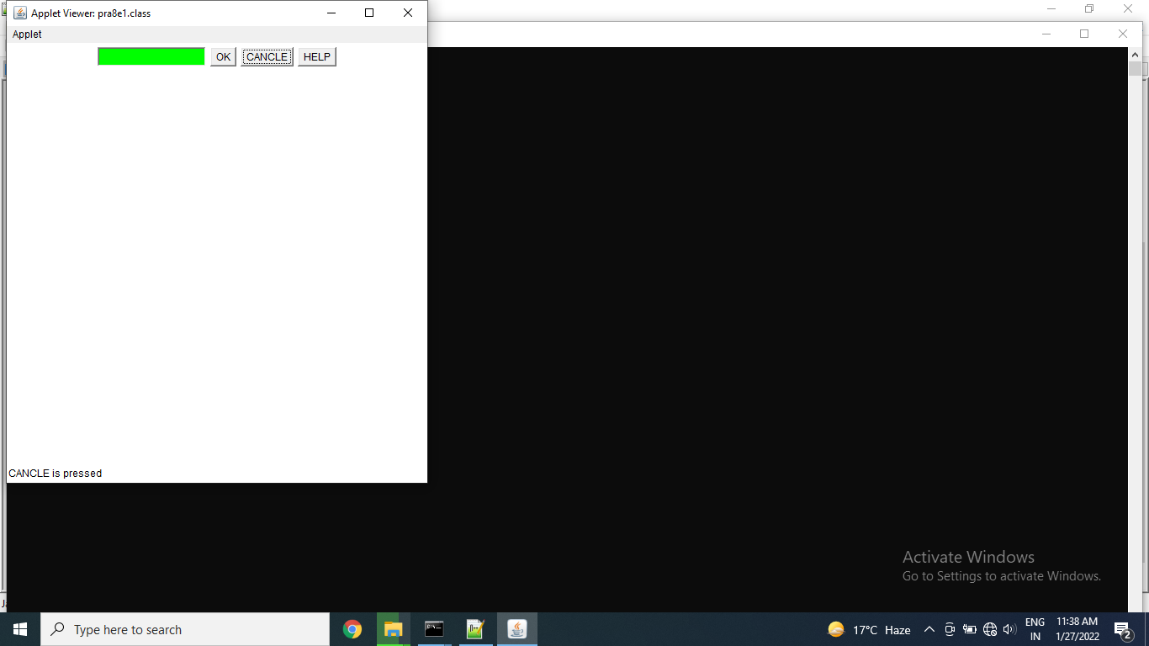

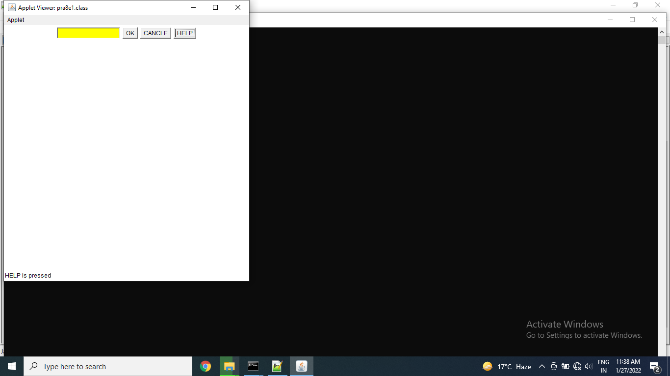

Thanks mam!!

Name: Astha Arpit Bhatt

Enroll: 196140316006

**Practical 9**

Aim :- Create an application that displays a frame with a menu bar. When a user selects any menu or menu item, display that selection on a text area in the center of the frame.

Code:

import java.awt.*;

import java.awt.event.*;

import java.applet.*;

/*<applet code="pra9.class" height=500 width=500></applet>*/

public class pra9 extends Applet implements ActionListener

{

Frame f;

Label l;

public void init()

{

f = new Frame("Menu Demo");

l = new Label("Select any MenuItem from File Menu");

MenuBar mb = new MenuBar();

Menu mn = new Menu("File");

MenuItem mi1 = new MenuItem("New");

mi1.addActionListener(this);

MenuItem mi2 = new MenuItem("Open");

mi2.addActionListener(this);

MenuItem mi3 = new MenuItem("Save");

mi3.addActionListener(this);

MenuItem mi4 = new MenuItem("Close");

mi4.addActionListener(this);

mn.add(mi1);

mn.add(mi2);

mn.add(mi3);

mn.add(mi4);

mb.add(mn);

f.setMenuBar(mb);

f.setLayout(new FlowLayout());

f.add(l);

f.setSize(300,300);

f.setVisible(true);

}

public void actionPerformed(ActionEvent o)

{

if(o.getSource() instanceof MenuItem)

{

l.setText(o.getActionCommand());

}

}

}

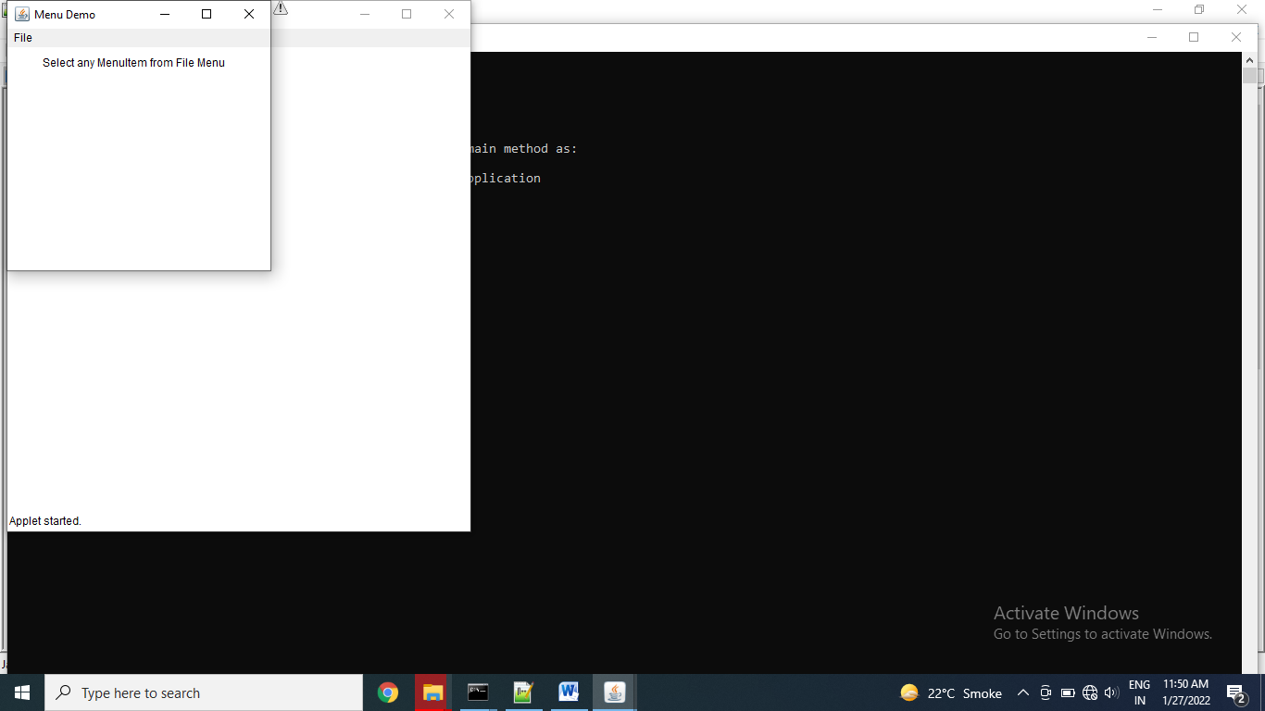

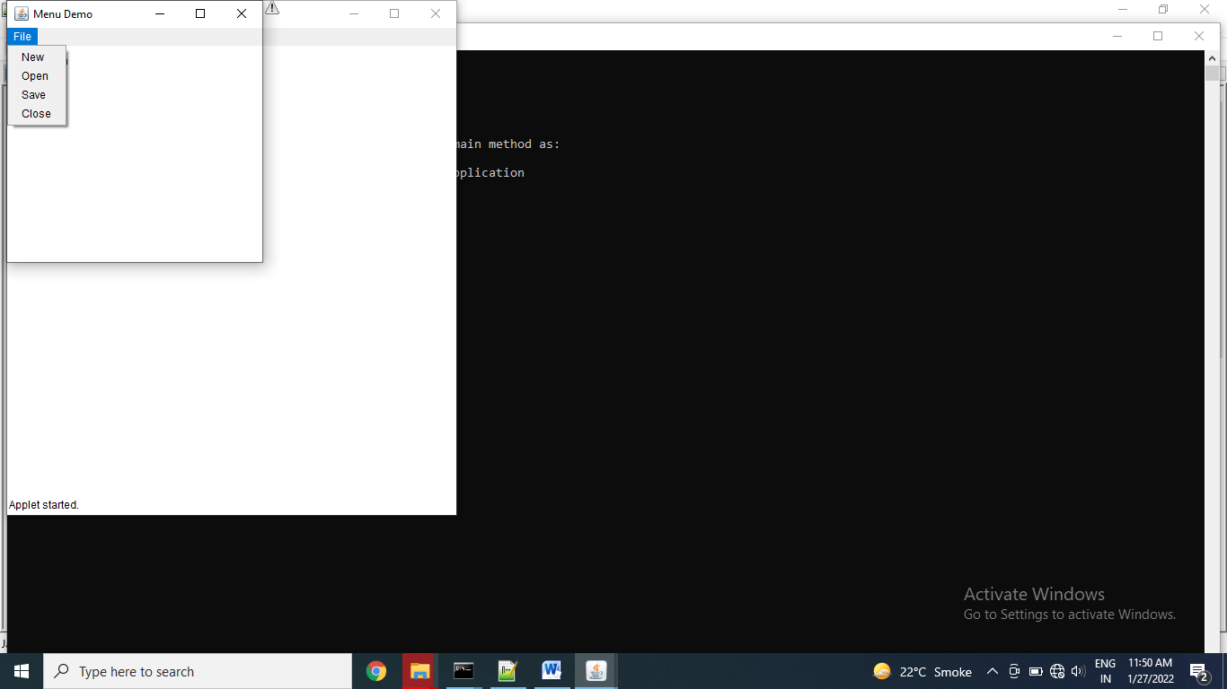

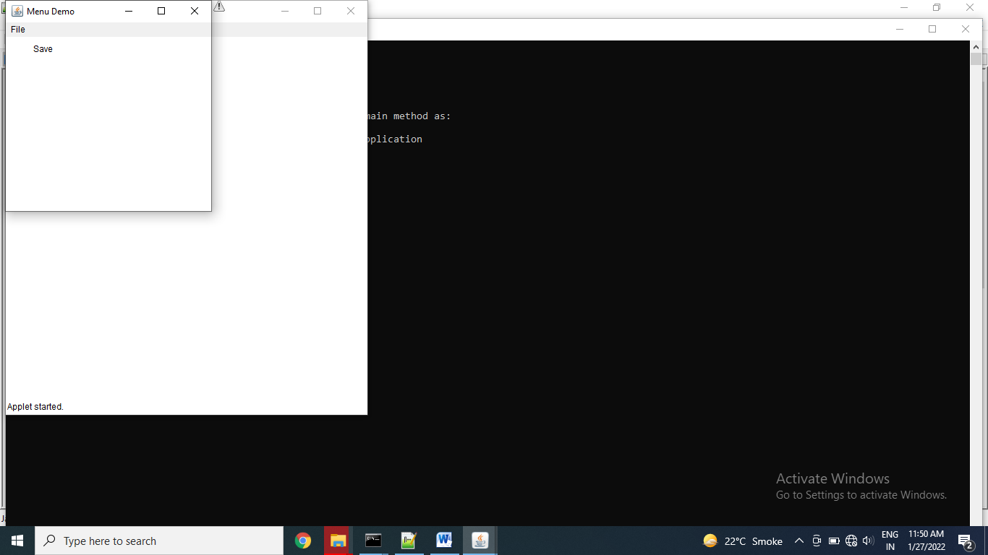

Exercise:

Create a screen with three menus with minimum 2 sub menu’s in each.

import java.awt.*;

public class pra9e1

{

Frame f;

public pra9e1()

{

f=new Frame("Practical of Menu");

// l.setBounds(50,50,10,10);

MenuBar mb=new MenuBar();

Menu mn=new Menu("File");

Menu mn1=new Menu("New");

MenuItem e1=new MenuItem("Item 1");

MenuItem e2=new MenuItem("Item 2");

MenuItem mi2=new MenuItem("Open");

MenuItem mi3=new MenuItem("Save");

Menu mn4=new Menu("Exit");

MenuItem e3=new MenuItem("Item 3");

mn4.setActionCommand("I am exit command");

mn.add(mn1);

mn1.add(e1);

mn1.add(e2);

mn.add(mi2);

mn.add(mi3);

mn.add(mn4);

mn4.add(e3);

mb.add(mn);

// f.setMenuBar(mb);

Menu mn2=new Menu("Edit");

MenuItem mn21=new MenuItem("Cut");

Menu mn22=new Menu("Copy");

MenuItem e4=new MenuItem("Item 4");

Menu mn23=new Menu("Paste");

MenuItem e5=new MenuItem("Item 5");

MenuItem mn24=new MenuItem("Undo");

mn2.add(mn21);

mn22.add(e4);

mn2.add(mn22);

mn23.add(e5);

mn2.add(mn23);

mn2.add(mn24);

mb.add(mn2);

Menu mn3=new Menu("Design");

Menu mn31=new Menu("Font");

MenuItem e6=new MenuItem("Times New Roman");

MenuItem e7=new MenuItem("Dancing script");

MenuItem mn32=new MenuItem("Syntax");

MenuItem mn33=new MenuItem("Size");

Menu mn34=new Menu("Color");

MenuItem e8=new MenuItem("Black");

MenuItem e9=new MenuItem("Blue");

MenuItem e10=new MenuItem("White");

mn31.add(e6);

mn31.add(e7);

mn3.add(mn31);

mn3.add(mn32);

mn3.add(mn33);

mn34.add(e8);

mn34.add(e9);

mn34.add(e10);

mn3.add(mn34);

mb.add(mn3);

f.setMenuBar(mb);

f.setSize(500,500);

f.setVisible(true);

}

public static void main(String args[])

{

pra9e1 ob=new pra9e1();

}

}

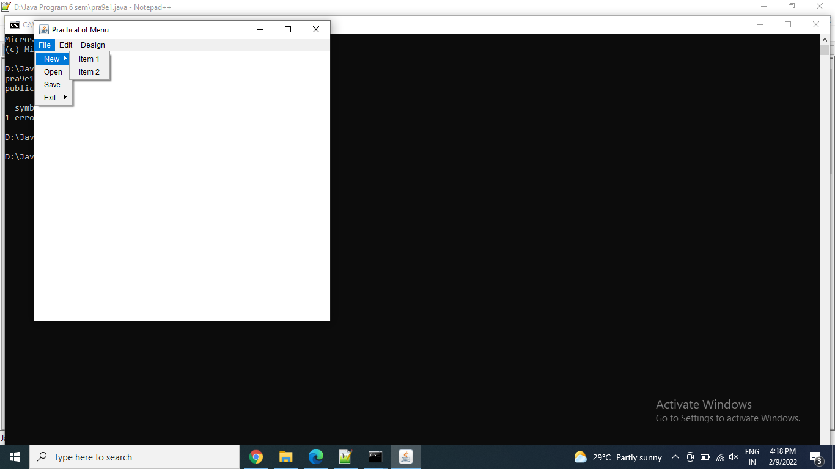

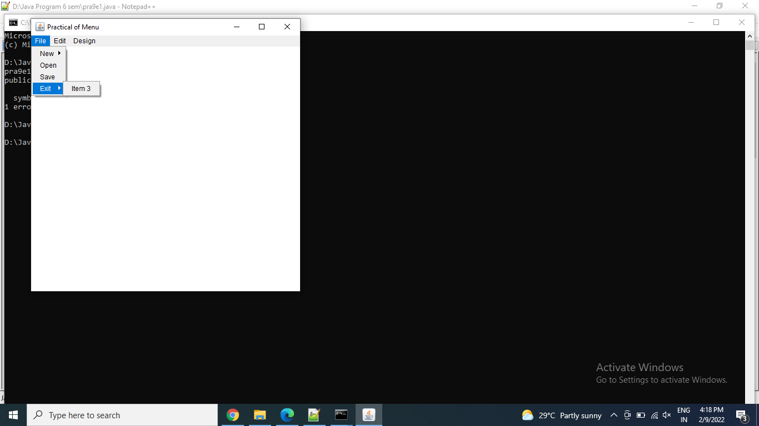

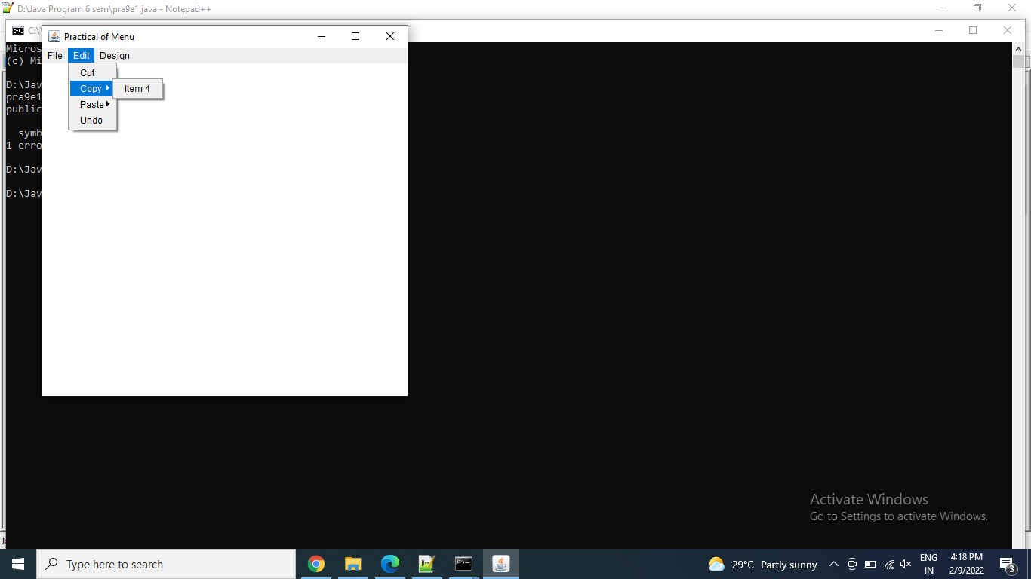

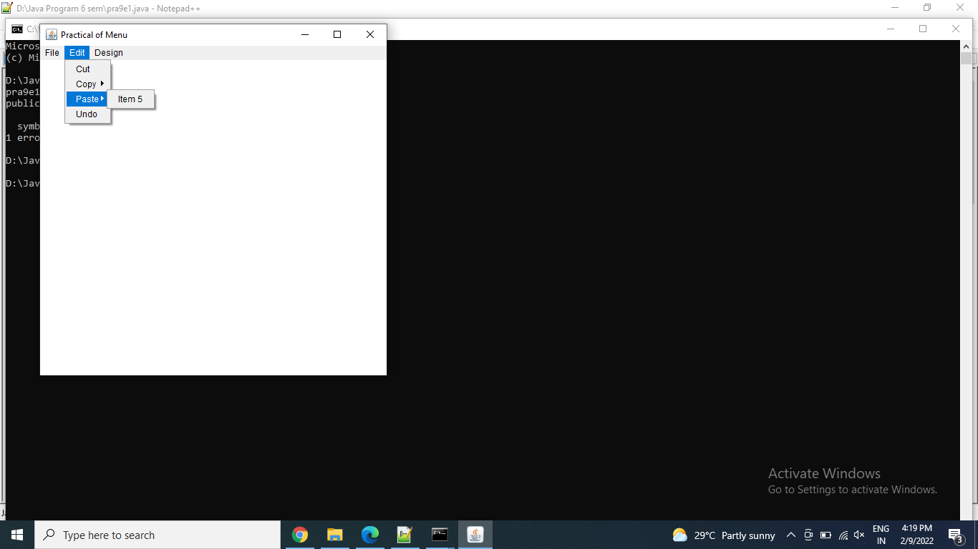

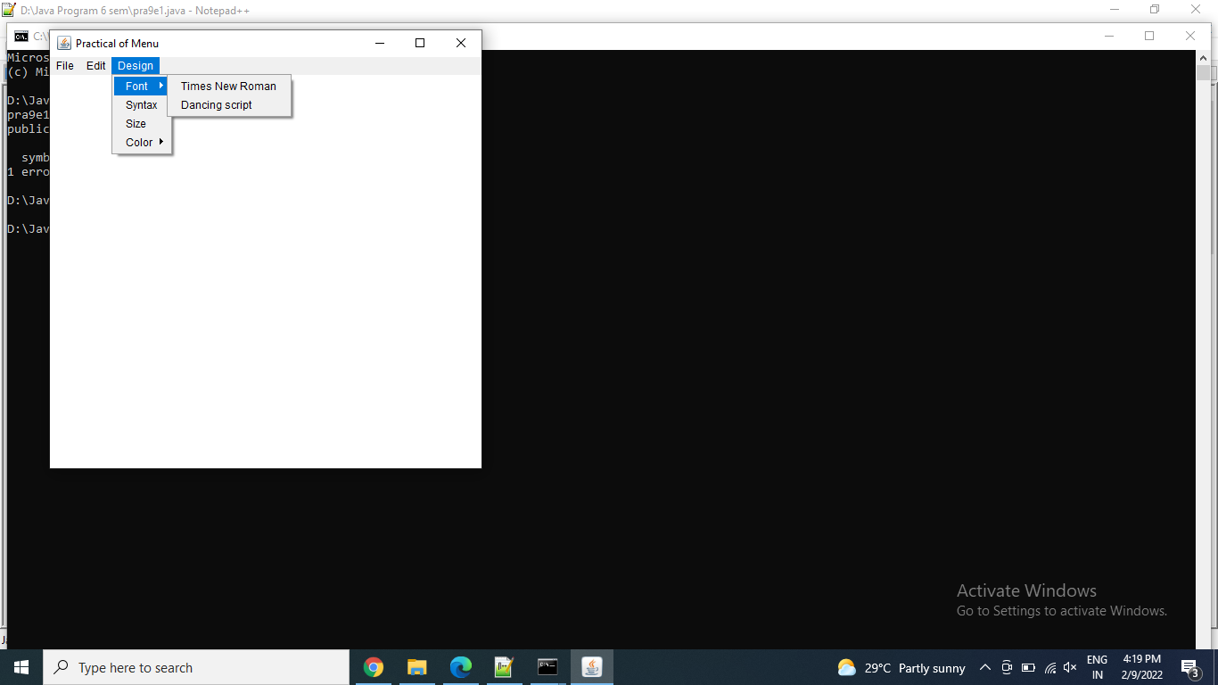

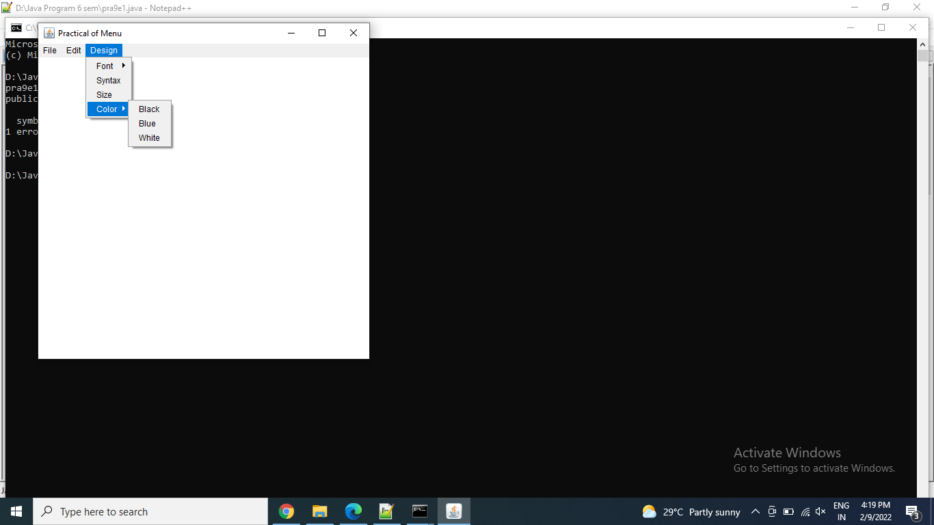

Thanks mam!!

Name: Astha Arpit Bhatt

Enroll: 196140316006

**Practical 10**

Aim: Develop a program that draws two sets of ever-decreasing rectangles one in outline form and one filled alternately in black and white.

import java.awt.*;

public class pra10 extends Canvas

{

Frame f;

public pra10()

{

f = new Frame("Practical - 10");

f.setSize(500,300);

f.setVisible(true);

f.setLayout(new FlowLayout());

setSize(400,200);

setVisible(true);

f.add(this);

}

public void paint(Graphics g)

{

g.setColor(Color.RED);

g.fillRect(0,0,400,200);

int x=0;

int y=0;

int width=400;

int height=200;

int i=0;

while(i<19)

{

width=width-10;

height=height-10;

x=(400-width)/2;

y=(200-height)/2;

if(i%2==1)

g.setColor(Color.WHITE);

else

g.setColor(Color.BLACK);

g.fillRect(x,y,width,height);

i++;

try

{

Thread.sleep(1000);

}

catch(InterruptedException e)

{}

}

}

public static void main(String a[])

{

pra10 fd = new pra10();

}

}

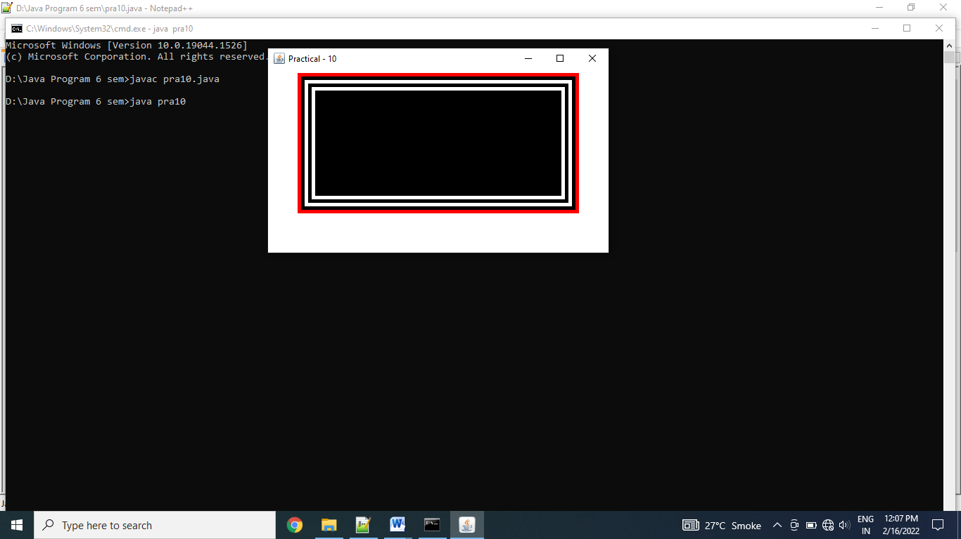

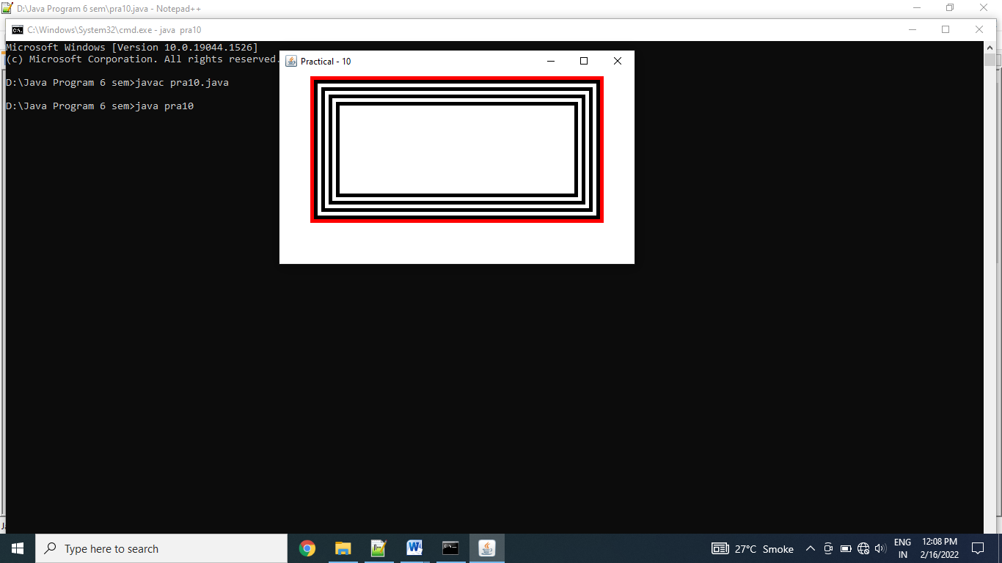

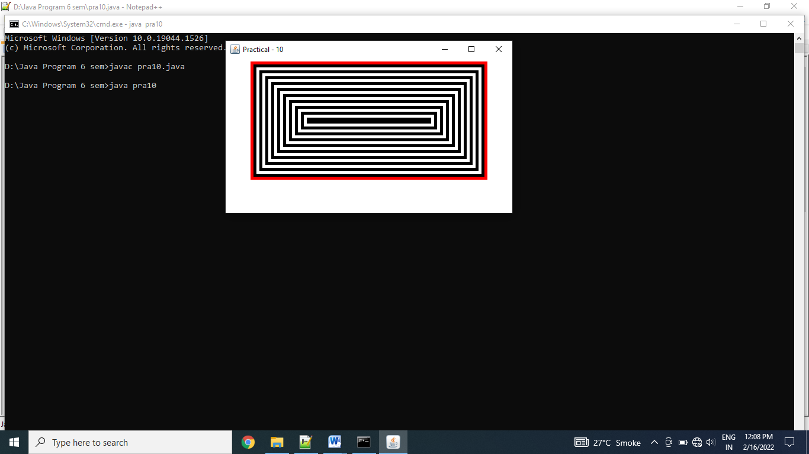

Exercise:  
Write an AWT GUI application. Each time the "Count" button is clicked, the counter value shall increase by 1.

import java.awt.*;

import java.awt.event.*;

public class AWTCounter extends Frame implements ActionListener

{

Label l;

TextField tf;

Button b;

int count = 0;

public AWTCounter()

{

setLayout(new FlowLayout());

l = new Label("Counter");

add(l);

tf = new TextField(count + "",10);

tf.setEditable(false);

add(tf);

b = new Button("Count");

add(b);

b.addActionListener(this);

setSize(300,300);

setVisible(true);

setTitle("AWT Counter");

}

public void actionPerformed(ActionEvent e)

{

++count;

tf.setText(count+ "");

}

public static void main(String args[])

{

AWTCounter ob = new AWTCounter();

}

}

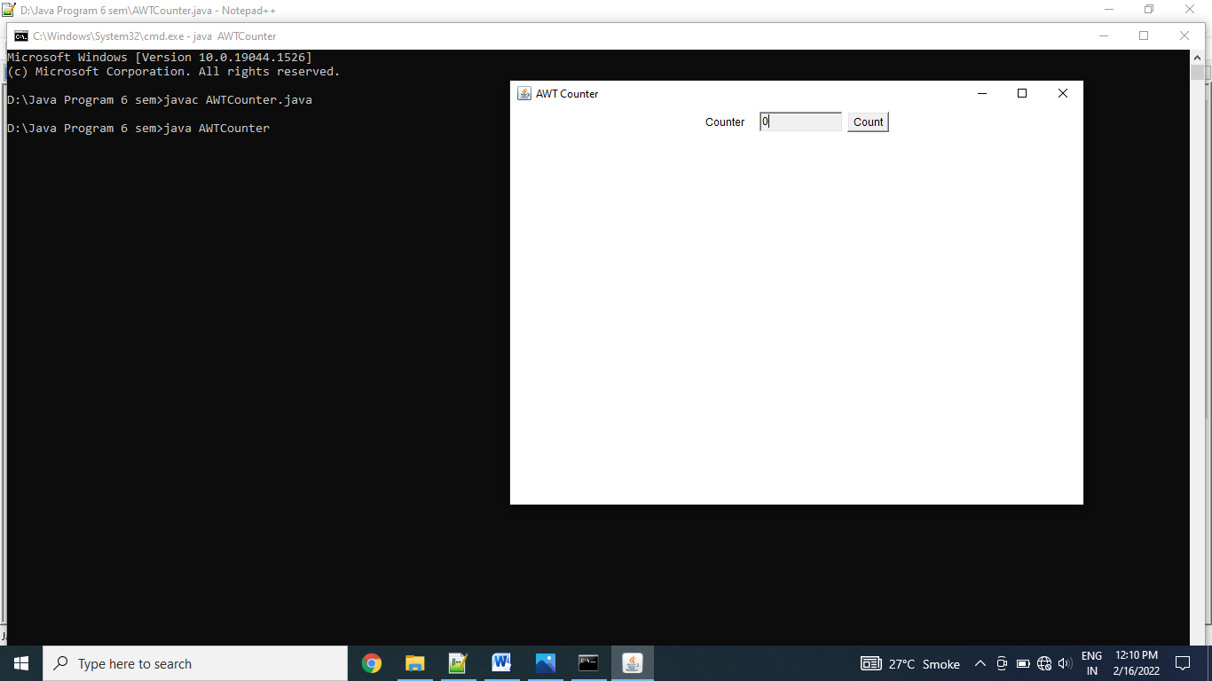

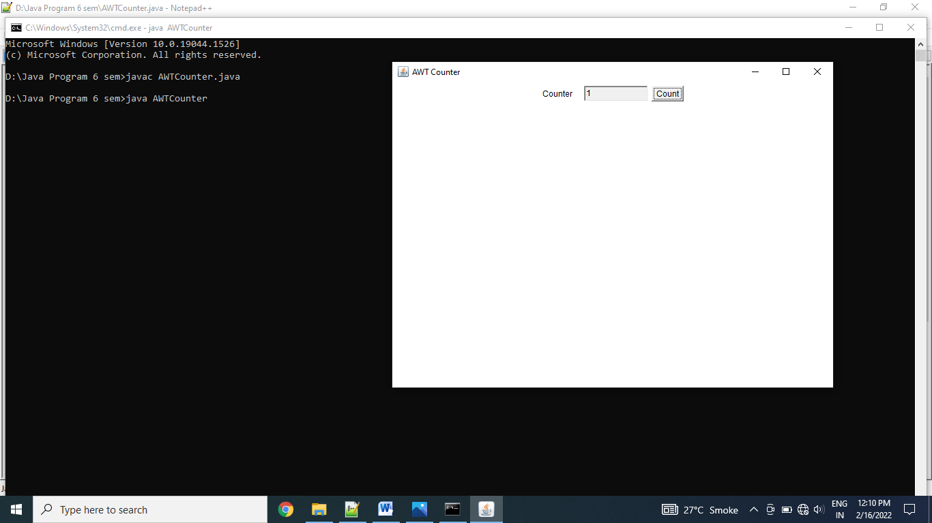

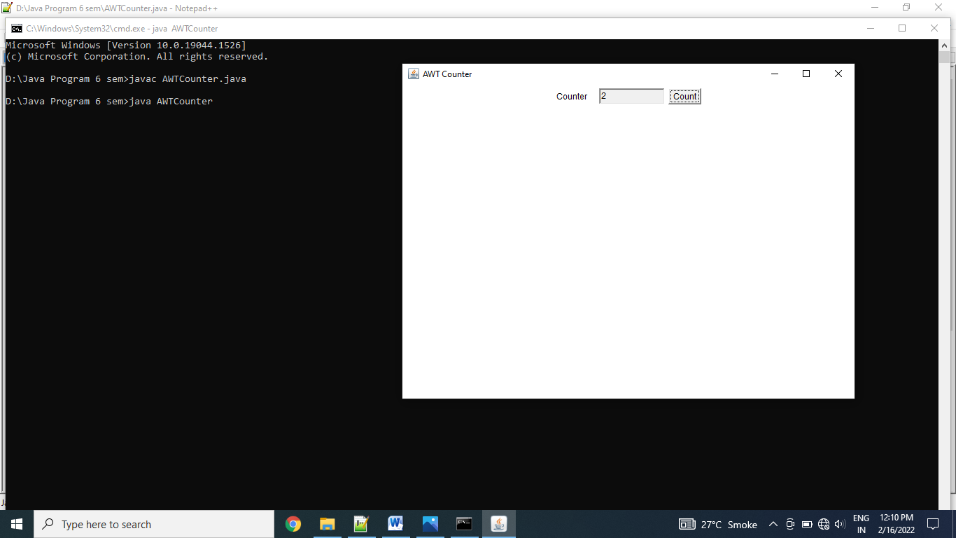

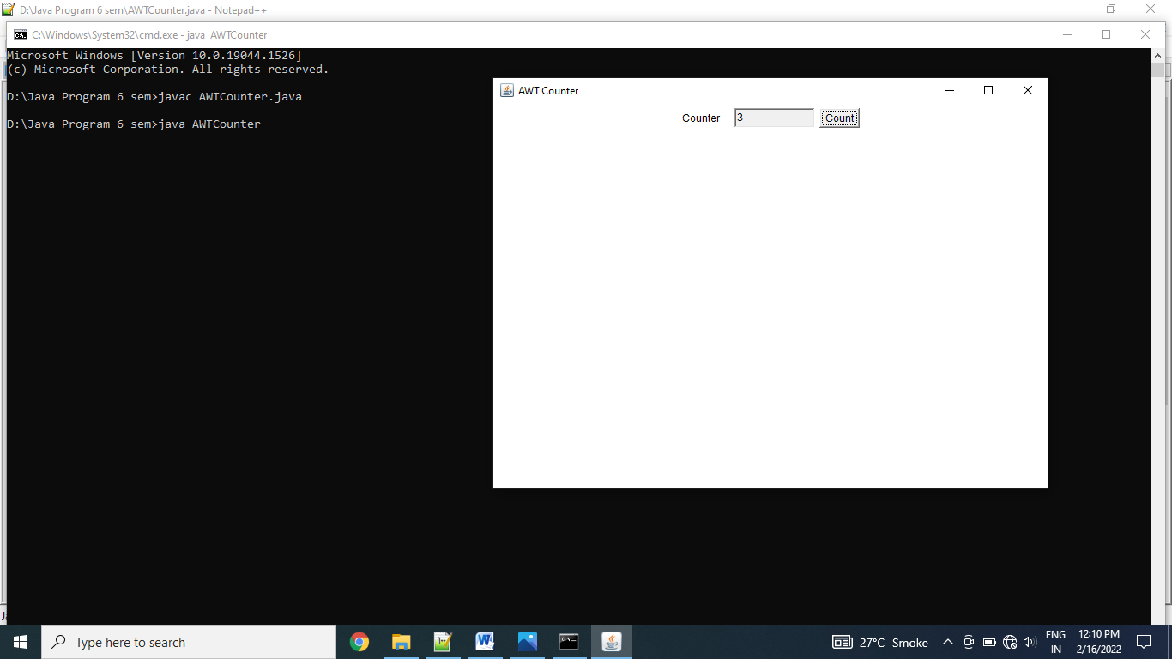

Thanks mam!!

Name: Astha Arpit Bhatt

Enroll: 196140316006

**Practical 11**

|  |
| --- |
| **Develop a database application that uses any JDBC driver**  **Code:**  package pra11;  import java.sql.*;  public class Pra11  {  public static void main(String[] args)  {  try  {  Class.forName("com.mysql.jdbc.Driver");  Connection con = DriverManager.getConnection("jdbc:mysql://localhost:3306/","root","");  Statement stmt = con.createStatement();  String q = "CREATE DATABASE practical11";  stmt.executeUpdate(q);  System.out.println("Database creation success");  con.close();  }  catch(Exception e)  {}  }  }  **Output:**  C:\Users\hp\Pictures\pra11.JPG |

|  |
| --- |
|  |

Name: Astha Arpit Bhatt

Enroll: 196140316006

**Practical 12**

**Develop a Graphical User Interface that performs the following SQL operations: a) Insert b) Delete c)Update.**

1. **Insert:**

package studentdb;

import java.sql.*;

public class Studentdb {

public static void main(String[] args) {

try{

Class.forName("com.mysql.jdbc.Driver");

Connection con = DriverManager.getConnection("jdbc:mysql://localhost:3306/studb","root","");

Statement stmt = con.createStatement();

String qry = "insert into studb value(5,'Riya',19)";

stmt.executeUpdate(qry);

System.out.println("Record insert successfully");

con.close();

}

catch(Exception e){

}

}

}

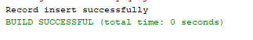

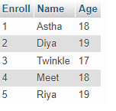

1. **Delete**

package studentdb;

import java.sql.Connection;

import java.sql.DriverManager;

import java.sql.Statement;

import java.util.Scanner;

public class Deleterecord {

public static void main(String args[])

{

try

{

Class.forName("com.mysql.jdbc.Driver");

Connection con = DriverManager.getConnection("jdbc:mysql://localhost:3306/studb","root","");

Statement stmt = con.createStatement();

int rno;

Scanner sc = new Scanner(System.in);

System.out.println("Enter rno to delete record");

rno=sc.nextInt();

String qry = "delete from studb where Enroll=" +rno;

stmt.executeUpdate(qry);

System.out.println("Record deleted successfully");

con.close();

}

catch(Exception e)

{ }

}

}

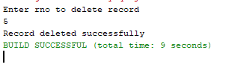

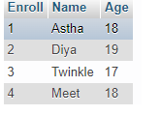

1. **Update**

package studentdb;

import java.sql.Connection;

import java.sql.DriverManager;

import java.sql.Statement;

public class Updaterecord {

public static void main(String args[])

{

try

{

Class.forName("com.mysql.jdbc.Driver");

Connection con = DriverManager.getConnection("jdbc:mysql://localhost:3306/studb","root","");

Statement stmt = con.createStatement();

String qry = "update studb set Age=22 where Enroll=2";

stmt.executeUpdate(qry);

System.out.println("Record updated");

con.close();

}

catch(Exception e)

{}

}}

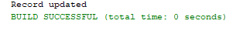

Before update:

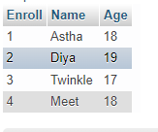

After update:

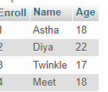

Name: Astha Arpit Bhatt

Enroll: 196140316006

**Practical 13**

|  |
| --- |
| **Develop a program to present a set of choice for user to select a product and display the price of product.**  package javapra13;  import java.awt.event.ItemEvent;  import java.awt.event.ItemListener;  import java.sql.Connection;  import java.sql.DriverManager;  import java.sql.ResultSet;  import java.sql.Statement;  import javax.swing.JComboBox;  import javax.swing.JFrame;  import javax.swing.JLabel;  public class Javapra13 extends JFrame implements ItemListener  {    JComboBox cb;  static JLabel lb1;  static String p;    Javapra13()  {  String product[] = {"Laptop","Mouse","Computer","Hard-disk","CPU"};  cb = new JComboBox(product);  cb.setBounds(80,50,200,20);  add(cb);  cb.addItemListener(this);    lb1 = new JLabel();  lb1.setBounds(80,100,200,20);  add(lb1);    setSize(400,400);  setLayout(null);  setTitle("Pra 13");  setVisible(true);  }  @Override  public void itemStateChanged(ItemEvent e) {  p = cb.getSelectedItem().toString();  p = (String)cb.getItemAt(cb.getSelectedIndex());  getdata(p);  //throw new UnsupportedOperationException("Not supported yet."); //To change body of generated methods, choose Tools | Templates.  }  public void getdata(String name)  {  try  {  Class.forName("com.mysql.jdbc.Driver");  Connection con = DriverManager.getConnection("jdbc:mysql://localhost:3306/javapra13","root","");  Statement stmt = con.createStatement();  ResultSet rs = stmt.executeQuery("SELECT * FROM product WHERE Product_name = '"+name+"' ");  while(rs.next())  lb1.setText("Price: " +rs.getInt("Product_price"));  con.close();  }  catch(Exception e)  {    }  }  public static void main(String[] args)  {  Javapra13 ob = new Javapra13();  }  } |

Name: Astha Bhatt

Enroll: 196140316006

**PRACTICAL : 14**

**Aim :- Develop a simple servlet program which maintains a counter for the number of times it has been accessed since its loading, initialize the counter using deployment descriptor.**

**Hitcounter.java:**

**package** com.astha;

**import** java.io.IOException;

**import** java.io.PrintWriter;

**import** javax.servlet.ServletConfig;

**import** javax.servlet.ServletException;

**import** javax.servlet.annotation.WebServlet;

**import** javax.servlet.http.HttpServlet;

**import** javax.servlet.http.HttpServletRequest;

**import** javax.servlet.http.HttpServletResponse;

/**

* Servlet implementation class hitCounter

*/

@WebServlet("/hitCounter")

**public** **class** hitCounter **extends** HttpServlet {

**private** **static** **final** **long** ***serialVersionUID*** = 1L;

/**

* **@see** HttpServlet#HttpServlet()

*/

**int** counter;

**public** hitCounter() {

**super**();

// **TODO** Auto-generated constructor stub

}

/**

* **@see** HttpServlet#doGet(HttpServletRequest request, HttpServletResponse response)

*/

**protected** **void** doGet(HttpServletRequest request, HttpServletResponse response) **throws** ServletException, IOException {

// **TODO** Auto-generated method stub

response.setContentType("text/html");

PrintWriter pw = response.getWriter();

counter++;

pw.println("Total Hits:" + counter);

}

/**

* **@see** HttpServlet#doPost(HttpServletRequest request, HttpServletResponse response)

*/

**protected** **void** doPost(HttpServletRequest request, HttpServletResponse response) **throws** ServletException, IOException {

// **TODO** Auto-generated method stub

doGet(request, response);

}

}

**OUTPUT:**

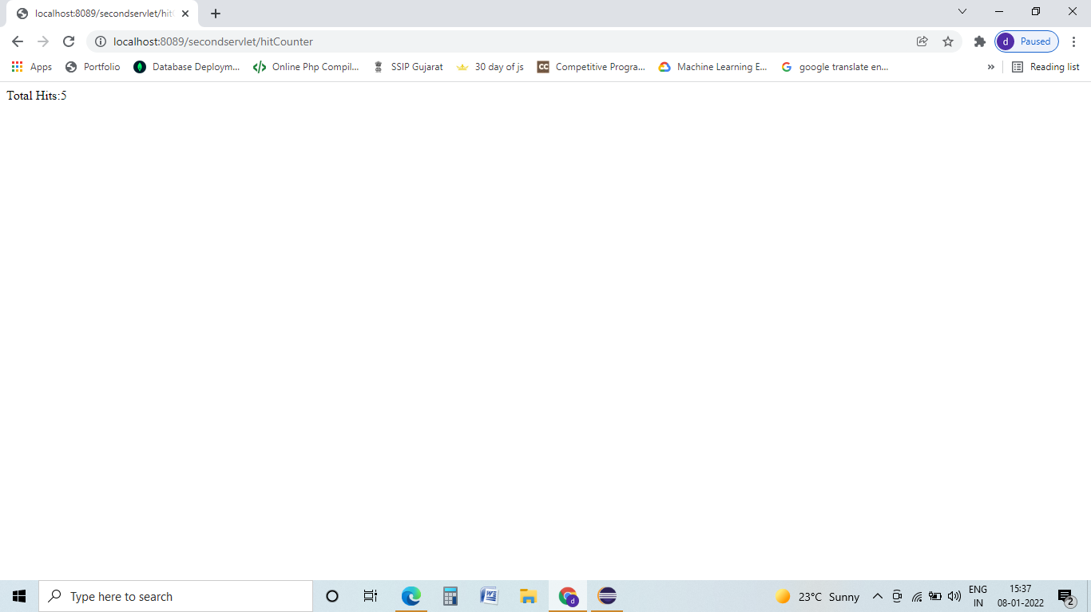

Name: Astha Arpit Bhatt

Enroll: 196140316006

**PRACTICAL-15**

**Aim: Create a web form which processes servlet and demonstrates use of cookies and sessions.  [Create an html page login that fetches username and password. Create two servlets "ReadParameter.java" and "Display.java". ReadParameter should pass Username and Password to display servlet using session and cookies]**

1. **Using session:**

Login.html:

<!DOCTYPE html>

<html>

<body>

<form action=*"ReadParameter"*>

UserName : <input type=*"text"* name=*"nm"*><br>

Password : <input type=*"password"* name=*"pass"*><br>

<input type=*"submit"*>

</form>

</body>

</html>

ReadParameter.java:

**package** pr_15;

**import** java.io.IOException;

**import** javax.servlet.http.HttpServlet;

**import** javax.servlet.http.HttpServletRequest;

**import** javax.servlet.http.HttpServletResponse;

**import** javax.servlet.http.HttpSession;

**public** **class** ReadParameter **extends** HttpServlet{

**public** **void** service(HttpServletRequest req,HttpServletResponse res) **throws** IOException {

String n=req.getParameter("nm");

String p=req.getParameter("pass");

HttpSession session=req.getSession();

session.setAttribute("n", n);

session.setAttribute("p", p);

res.sendRedirect("Display");

}

}

Display.java:

**package** pr_15;

**import** java.io.IOException;

**import** java.io.PrintWriter;

**import** javax.servlet.http.HttpServlet;

**import** javax.servlet.http.HttpServletRequest;

**import** javax.servlet.http.HttpServletResponse;

**import** javax.servlet.http.HttpSession;

**public** **class** Display **extends** HttpServlet{

**public** **void** service(HttpServletRequest req,HttpServletResponse res) **throws** IOException {

HttpSession session=req.getSession();

String nm=(String) session.getAttribute("n");

String pass=(String) session.getAttribute("p");

PrintWriter out=res.getWriter();

out.println("UserName is :"+nm);

out.println("Password is : "+pass);

}

}

Web.xml:

<?xml version=*"1.0"* encoding=*"UTF-8"*?>

<web-app xmlns:xsi=*"http://www.w3.org/2001/XMLSchema-instance"* xmlns=*"http://xmlns.jcp.org/xml/ns/javaee"* xsi:schemaLocation=*"http://xmlns.jcp.org/xml/ns/javaee http://xmlns.jcp.org/xml/ns/javaee/web-app_3_1.xsd"* id=*"WebApp_ID"* version=*"3.1"*>

<servlet>

<servlet-name>s1</servlet-name>

<servlet-class>pr_15.ReadParameter</servlet-class>

</servlet>

<servlet-mapping>

<servlet-name>s1</servlet-name>

<url-pattern>/ReadParameter</url-pattern>

</servlet-mapping>

<servlet>

<servlet-name>s2</servlet-name>

<servlet-class>pr_15.Display</servlet-class>

</servlet>

<servlet-mapping>

<servlet-name>s2</servlet-name>

<url-pattern>/Display</url-pattern>

</servlet-mapping>

</web-app>

**b)Using Cookie:**

Login.html:

<!DOCTYPE html>

<html>

<body>

<form action=*"ReadParameter"*>

UserName : <input type=*"text"* name=*"nm"*><br>

Password : <input type=*"password"* name=*"pass"*><br>

<input type=*"submit"*>

</form>

</body>

</html>

ReadParameter.java:

**package** pr_15;

**import** java.io.IOException;

**import** javax.servlet.http.HttpServlet;

**import** javax.servlet.http.HttpServletRequest;

**import** javax.servlet.http.HttpServletResponse;

**public** **class** ReadParameter **extends** HttpServlet{

**public** **void** service(HttpServletRequest req,HttpServletResponse res) **throws** IOException {

String n=req.getParameter("nm");

String p=req.getParameter("pass");

Cookie ck=**new** Cookie("n",n);

Cookie ck1=**new** Cookie("p",p);

res.addCookie(ck);

res.addCookie(ck1);

res.sendRedirect("Display");

}}

Display.java:

**package** pr_15;

**import** java.io.IOException;

**import** java.io.PrintWriter;

**import** javax.servlet.http.HttpServlet;

**import** javax.servlet.http.HttpServletRequest;

**import** javax.servlet.http.HttpServletResponse;

**public** **class** Display **extends** HttpServlet{

**public** **void** service(HttpServletRequest req,HttpServletResponse res) **throws** IOException {

String nm = **null**,pass=**null**;

Cookie cks[]=req.getCookies();

**for**(Cookie c:cks) {

**if**(c.getName().equals("n")) {

nm=c.getValue();

}

}

Cookie cks1[]=req.getCookies();

**for**(Cookie c:cks1) {

**if**(c.getName().equals("p")) {

pass=c.getValue();

}

}

PrintWriter out=res.getWriter();

out.println("UserName is :"+nm);

out.println("Password is : "+pass);

}

}

Web.xml:

<?xml version=*"1.0"* encoding=*"UTF-8"*?>

<web-app xmlns:xsi=*"http://www.w3.org/2001/XMLSchema-instance"* xmlns=*"http://xmlns.jcp.org/xml/ns/javaee"* xsi:schemaLocation=*"http://xmlns.jcp.org/xml/ns/javaee http://xmlns.jcp.org/xml/ns/javaee/web-app_3_1.xsd"* id=*"WebApp_ID"* version=*"3.1"*>

<servlet>

<servlet-name>s1</servlet-name>

<servlet-class>pr_15.ReadParameter</servlet-class>

</servlet>

<servlet-mapping>

<servlet-name>s1</servlet-name>

<url-pattern>/ReadParameter</url-pattern>

</servlet-mapping>

<servlet>

<servlet-name>s2</servlet-name>

<servlet-class>pr_15.Display</servlet-class>

</servlet>

<servlet-mapping>

<servlet-name>s2</servlet-name>

<url-pattern>/Display</url-pattern>

</servlet-mapping>

</web-app>

**Exercise:**

1. **Create a web form that demonstrates the use of URL Rewriting.**

addsq.html :

<!DOCTYPE html>

<html>

<body>

<form action=*"add"*>

Enter first number:<input type=*text* name=*no1*><br><br>

Enter second number:<input type=*text* name=*no2*><br><br>

<input type=*submit*>

</form>

</body>

</html>

add.java:

**package** urlrewriting;

**import** java.io.IOException;

**import** javax.servlet.http.HttpServlet;

**import** javax.servlet.http.HttpServletRequest;

**import** javax.servlet.http.HttpServletResponse;

**public** **class** add **extends** HttpServlet{

**public** **void** service(HttpServletRequest req,HttpServletResponse res) **throws** IOException {

**int** i=Integer.*parseInt*(req.getParameter("no1"));

**int** j=Integer.*parseInt*(req.getParameter("no2"));

**int** k=i+j;

res.sendRedirect("square?k="+k);

}

}

square.java:

**package** urlrewriting;

**import** java.io.IOException;

**import** java.io.PrintWriter;

**import** javax.servlet.http.HttpServlet;

**import** javax.servlet.http.HttpServletRequest;

**import** javax.servlet.http.HttpServletResponse;

**public** **class** square **extends** HttpServlet {

**public** **void** service(HttpServletRequest req,HttpServletResponse res) **throws** IOException {

**int** k=Integer.*parseInt*(req.getParameter("k"));

k=k*k;

PrintWriter out=res.getWriter();

out.println("Square is : "+k);

}

}

Web.xml:

<?xml version=*"1.0"* encoding=*"UTF-8"*?>

<web-app xmlns:xsi=*"http://www.w3.org/2001/XMLSchema-instance"* xmlns=*"http://xmlns.jcp.org/xml/ns/javaee"* xsi:schemaLocation=*"http://xmlns.jcp.org/xml/ns/javaee http://xmlns.jcp.org/xml/ns/javaee/web-app_3_1.xsd"* id=*"WebApp_ID"* version=*"3.1"*>

<servlet>

<servlet-name>s1</servlet-name>

<servlet-class>urlrewriting.add</servlet-class>

</servlet>

<servlet-mapping>

<servlet-name>s1</servlet-name>

<url-pattern>/add</url-pattern>

</servlet-mapping>

<servlet>

<servlet-name>s2</servlet-name>

<servlet-class>urlrewriting.square</servlet-class>

</servlet>

<servlet-mapping>

<servlet-name>s2</servlet-name>

<url-pattern>/square</url-pattern>

</servlet-mapping>

</web-app>

**OUTPUT:**

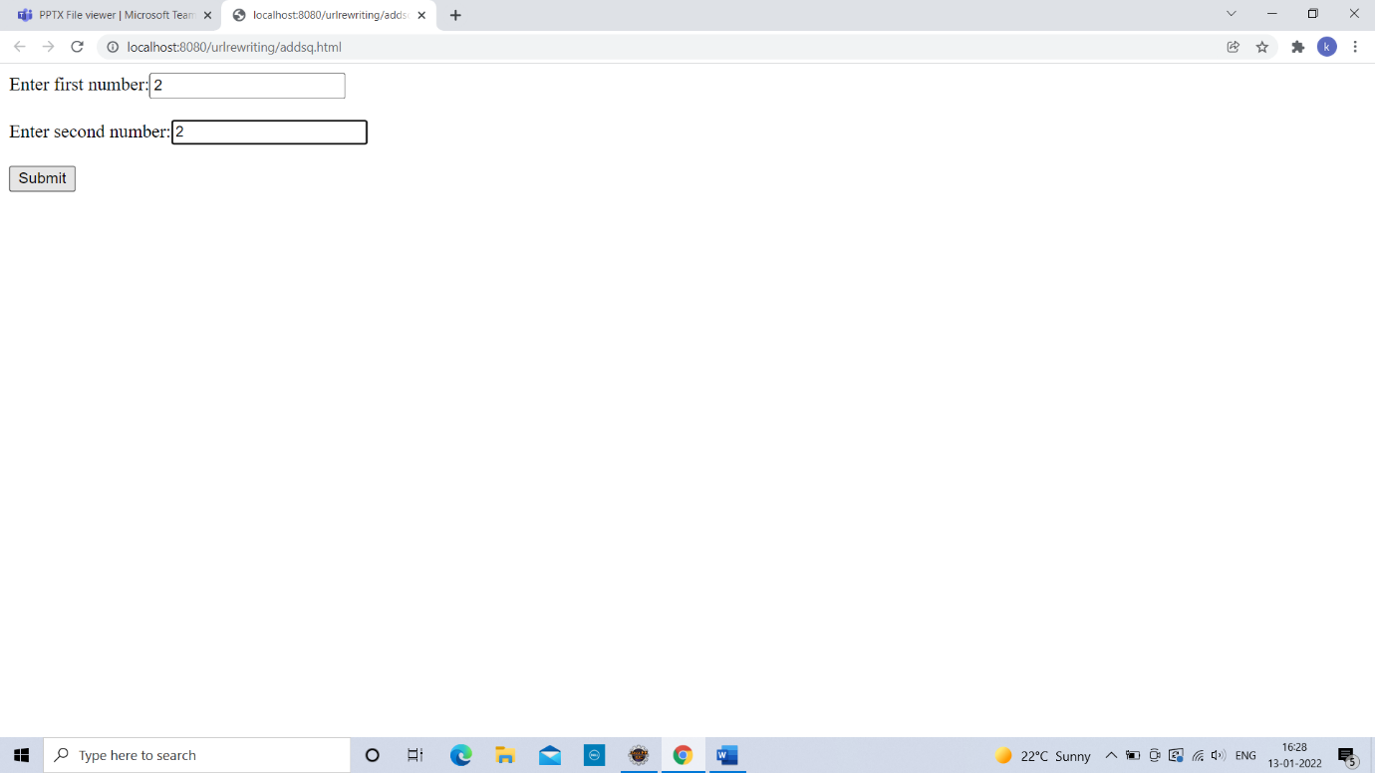

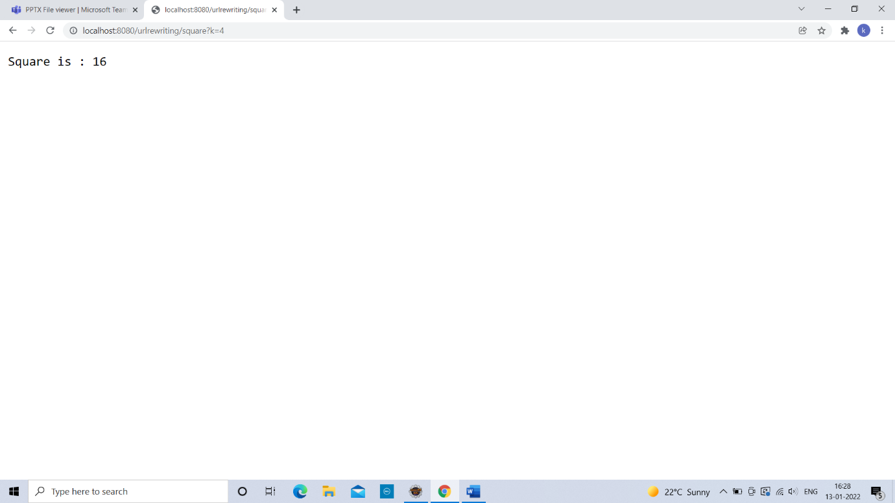

**2)Create a web form that demonstrates the use of Hidden form field.**

index.html:

<!DOCTYPE html>

<html>

<body>

<form action=*"first"*>

Name : <input type=*text* name=*nm*><br>

<input type=*submit*>

</form>

</body>

</html>

first.java:

**package** hiddenfield;

**import** java.io.IOException;

**import** java.io.PrintWriter;

**import** javax.servlet.http.HttpServlet;

**import** javax.servlet.http.HttpServletRequest;

**import** javax.servlet.http.HttpServletResponse;

**public** **class** first **extends** HttpServlet{

**public** **void** service(HttpServletRequest req,HttpServletResponse res) **throws** IOException {

res.setContentType("text/html");

String n=req.getParameter("nm");

PrintWriter out=res.getWriter();

out.println("Welcome "+n);

out.print("<form action='second'>");

out.print("<input type='hidden' name='uname' value='"+n+"'>");

out.print("<input type='submit' value='go'>");

out.print("</form>");

out.close();

}

}

second.java:

**package** hiddenfield;

**import** java.io.IOException;

**import** java.io.PrintWriter;

**import** javax.servlet.http.HttpServlet;

**import** javax.servlet.http.HttpServletRequest;

**import** javax.servlet.http.HttpServletResponse;

**public** **class** second **extends** HttpServlet{

**public** **void** service(HttpServletRequest req,HttpServletResponse res) **throws** IOException {

res.setContentType("text/html");

String n=req.getParameter("uname");

PrintWriter out=res.getWriter();

out.println("Welcome "+n);

}

}

web.xml:

<?xml version=*"1.0"* encoding=*"UTF-8"*?>

<web-app xmlns:xsi=*"http://www.w3.org/2001/XMLSchema-instance"* xmlns=*"http://xmlns.jcp.org/xml/ns/javaee"* xsi:schemaLocation=*"http://xmlns.jcp.org/xml/ns/javaee http://xmlns.jcp.org/xml/ns/javaee/web-app_3_1.xsd"* id=*"WebApp_ID"* version=*"3.1"*>

<servlet>

<servlet-name>s1</servlet-name>

<servlet-class>hiddenfield.first</servlet-class>

</servlet>

<servlet-mapping>

<servlet-name>s1</servlet-name>

<url-pattern>/first</url-pattern>

</servlet-mapping>

<servlet>

<servlet-name>s2</servlet-name>

<servlet-class>hiddenfield.second</servlet-class>

</servlet>

<servlet-mapping>

<servlet-name>s2</servlet-name>

<url-pattern>/second</url-pattern>

</servlet-mapping>

</web-app>

Thanks mam!!

Name: Astha Arpit Bhatt

Enroll: 196140316006

**Practical 16**

Develop a simple JSP program for user registration and then control will be transfer it into second page.

**File name: index.html**

<html>

<body>

<form action="hello.jsp" method="post">

Name: <input type="text" name="name" /><br>

Password: <input type="password" name="p" /><br>

<input type="submit">

</form>

</body>

</html>

**File name: hello.jsp**

<%--

Document : hello

Created on : Feb 9, 2022, 4:51:47 PM

Author : hp

--%>

<%@page contentType="text/html" pageEncoding="UTF-8"%>

<!DOCTYPE html>

<html>

<head>

<meta http-equiv="Content-Type" content="text/html; charset=UTF-8">

<title>JSP Page</title>

</head>

<body bgcolor="grey">

<%

String s1 = request.getParameter("name");

String s2 = request.getParameter("p");

out.println("Name: " +s1);

out.println("Password: " +s2);

%>

</body>

</html>

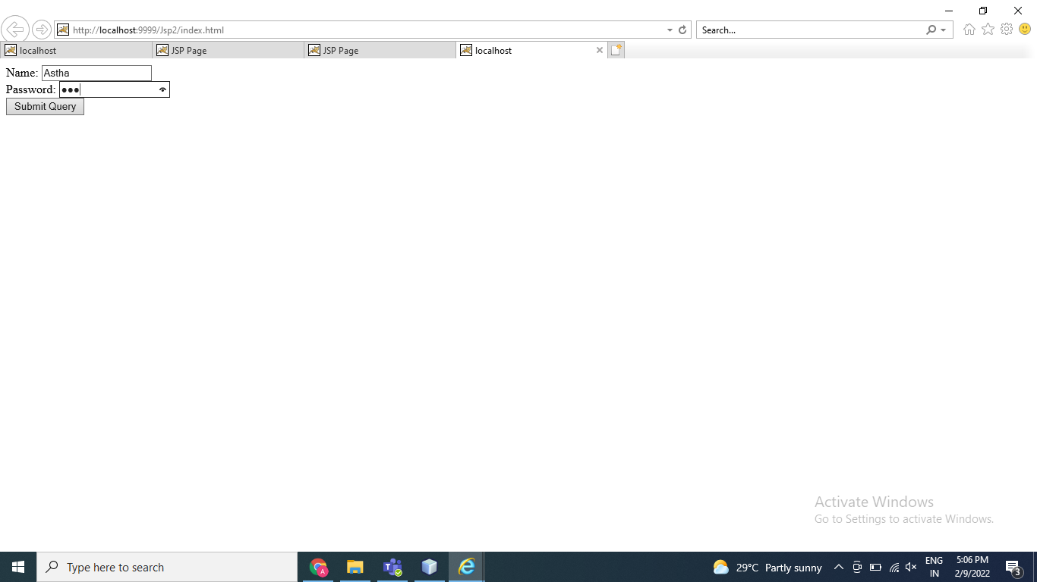

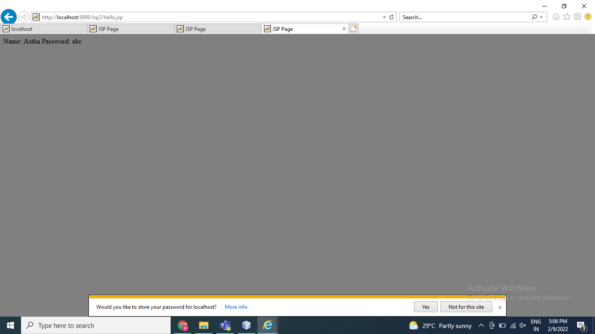

Thanks mam!!

Top of Form

Bottom of Form

Name: Astha Arpit Bhatt

Enroll: 196140316006

**Practical 17**

**Develop a simple JSP program for user login form with static and dynamic database**

Static :

**File name: index.html**

<html>

<head>

<title>Static Database</title>

</head>

<body>

<form action="Process.jsp" method="post">

Username:<input type="text" name="uname">

password:<input type="password" name="pass">

<input type="submit">

</form>

</body>

</html>

**File name: Process.jsp**

<%@page contentType="text/html" pageEncoding="UTF-8"%>

<!DOCTYPE html>

<html>

<head>

<title>JSP Page</title>

</head>

<body>

<%

String a=request.getParameter("uname");

String b=request.getParameter("pass");

if(a.equals("Astha") && b.equals("1210"))

{

response.sendRedirect("Welcome.jsp");

}

%>

</body>

</html>

**File name: Welcome.jsp**

<%@page contentType="text/html" pageEncoding="UTF-8"%>

<!DOCTYPE html>

<html>

<head>

<title>JSP Page</title>

</head>

<body>

<%

out.println("Welcome to world of jsp");

%>

</body>

</html>

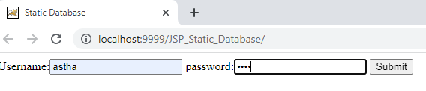

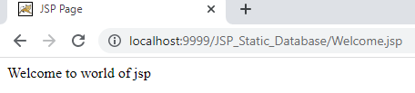

Dynamic:

Name: Astha Arpit Bhatt

Enrollment: 196140316006

**Practical-18**

Develop a JSP program to display the grade of a student by accepting the marks of five subjects

Code: **File name: Index.html**

<html>

<head>

<title>TODO supply a title</title>

<meta charset="UTF-8">

<meta name="viewport" content="width=device-width, initial-scale=1.0">

</head>

<body>

<h1>Student Marks</h1>

<form action="marks.jsp" method="post">

Enter C: <input type="text" name="c"><br>

Enter JAVA: <input type="text" name="java"><br>

Enter KOTLIN: <input type="text" name="kotlin"><br>

Enter SWING: <input type="text" name="swing"><br>

Enter PYTHON: <input type="text" name="python"><br>

<input type="Submit">

</form>

</body>

</html>

**File name: marks.jsp**

<%@page contentType="text/html" pageEncoding="UTF-8"%>

<!DOCTYPE html>

<html>

<head>

<meta http-equiv="Content-Type" content="text/html; charset=UTF-8">

<title>JSP Page</title>

</head>

<body>

<%

int c = Integer.parseInt(request.getParameter("c"));

int java = Integer.parseInt(request.getParameter("java"));

int kotlin = Integer.parseInt(request.getParameter("kotlin"));

int swing = Integer.parseInt(request.getParameter("swing"));

int python = Integer.parseInt(request.getParameter("python"));

int total = c+java+kotlin+swing+python;

double avg = total/5;

if(avg>70)

out.println("Your grade is AA");

else if(avg>=65)

out.println("Your grade is AB");

else if(avg>=60)

out.println("Your grade is BB");

else if(avg>=55)

out.println("Your grade is BC");

else if(avg>=50)

out.println("Your grade is CC");

%>

</body>

</html>

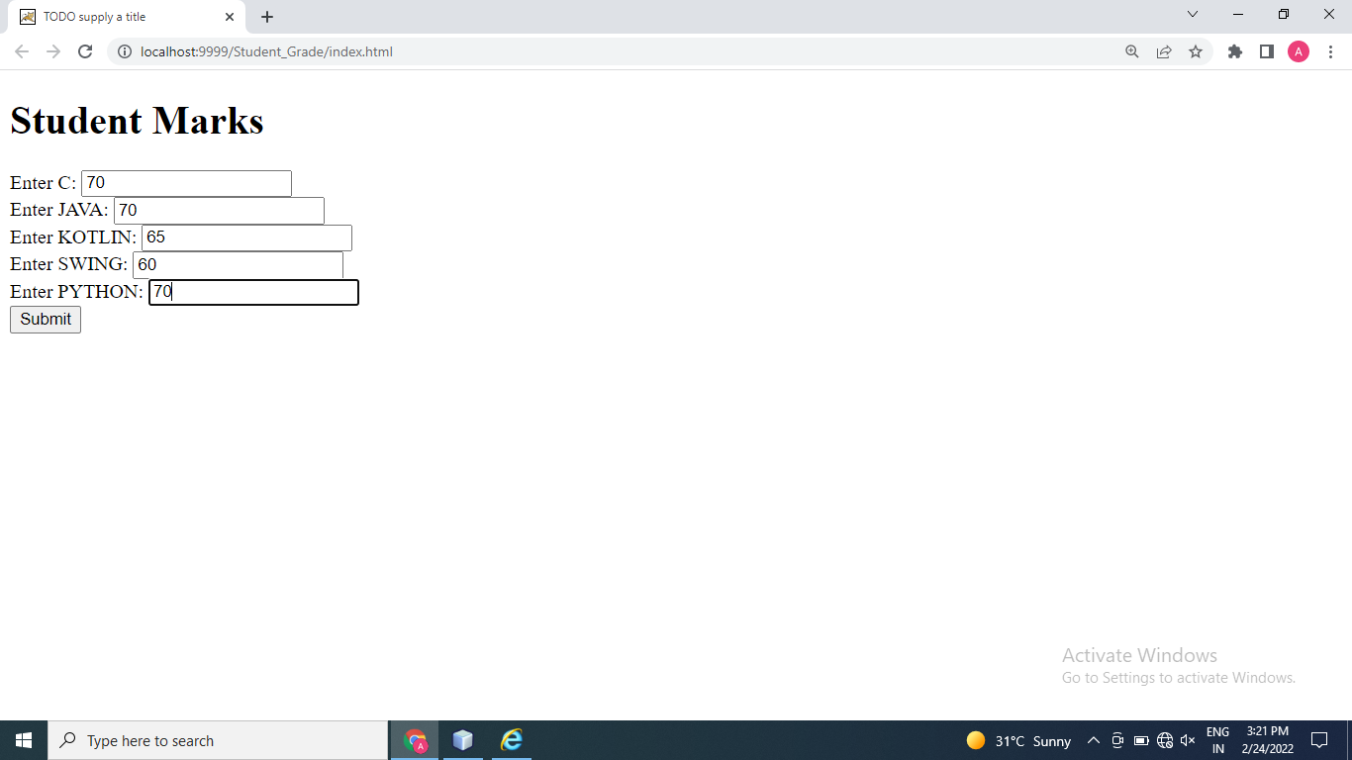

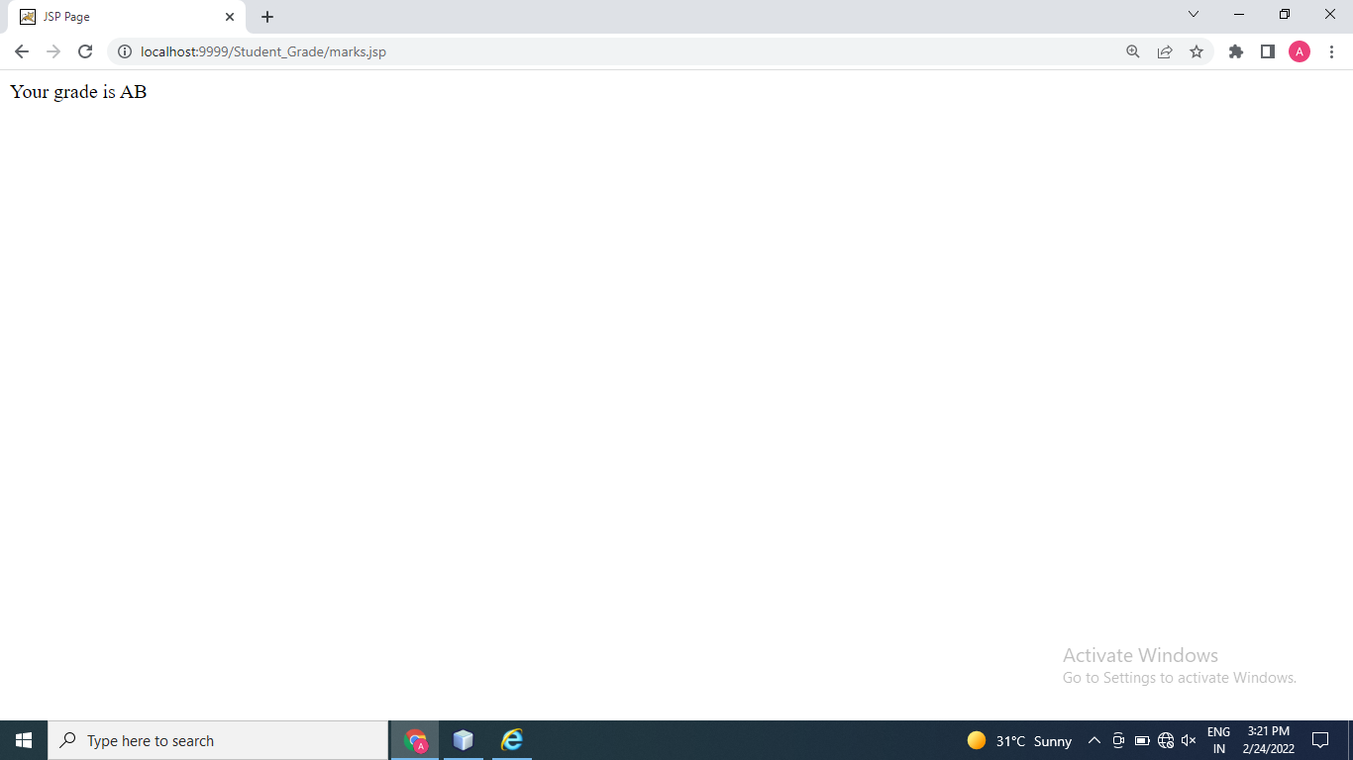

Thanks mam!!

Name : Bhatt Astha Arpit

Enrollment : 196140316006

IT 6 Advance Java Programming

**SERVLET PRACTICALS**

1. Write a Servlet code to print “Hi”.

* HTML File.

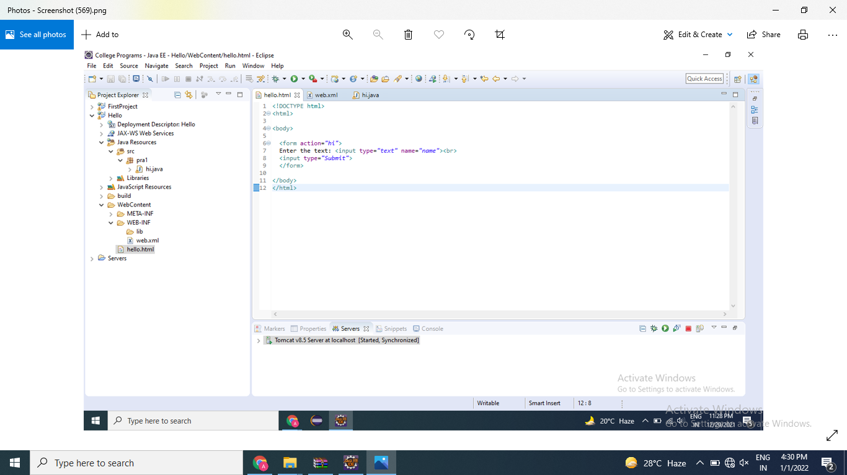

* JAVA File

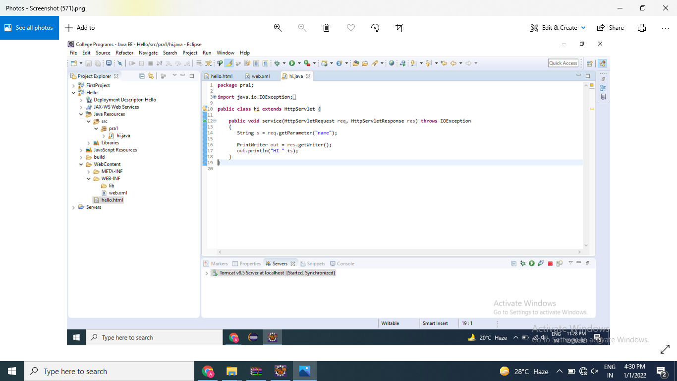

* Web.xml

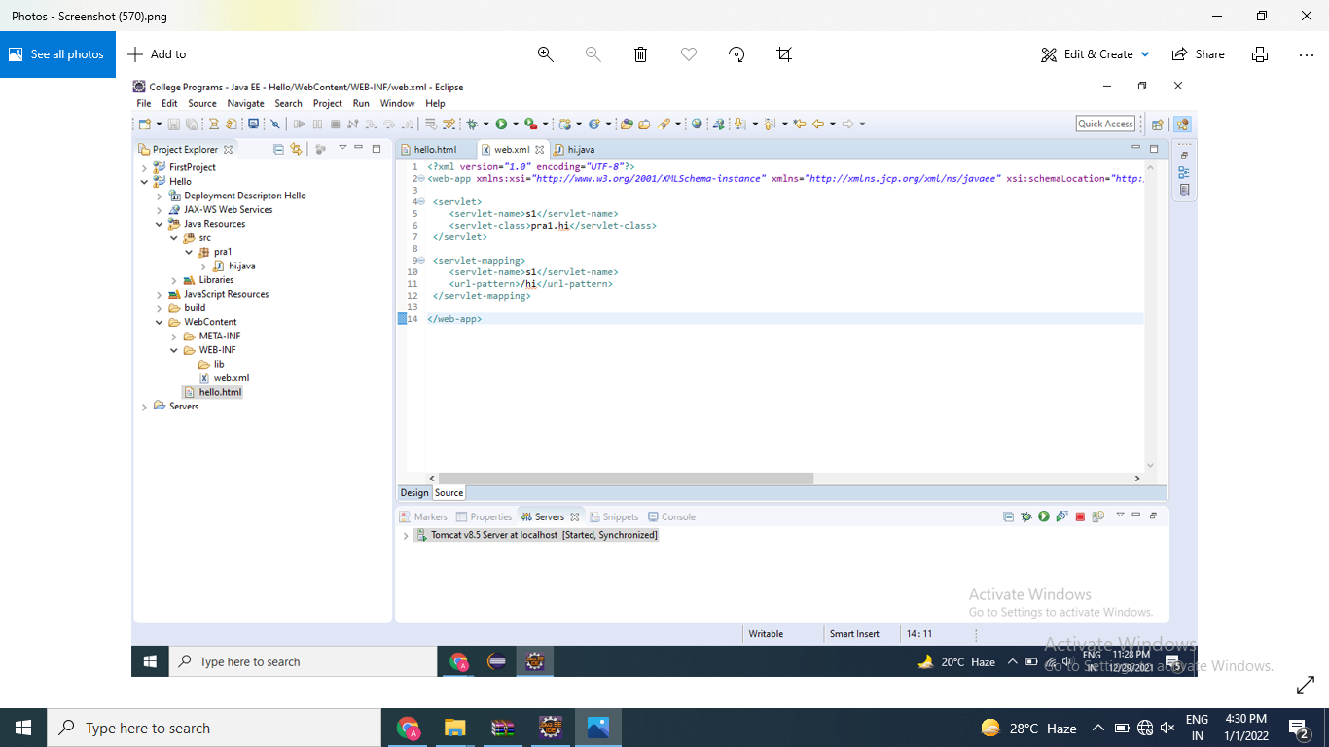

* Output :-

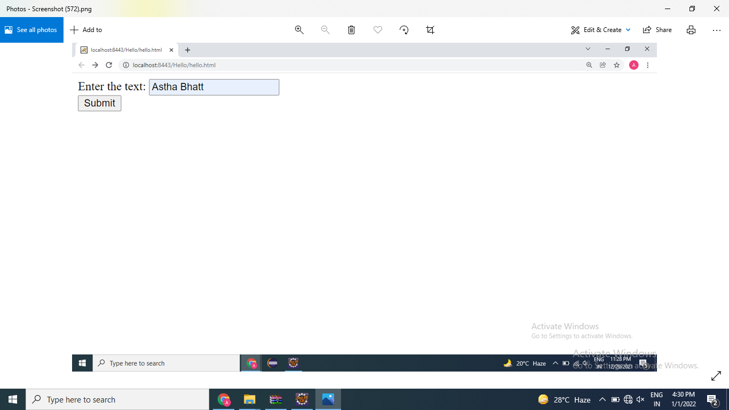

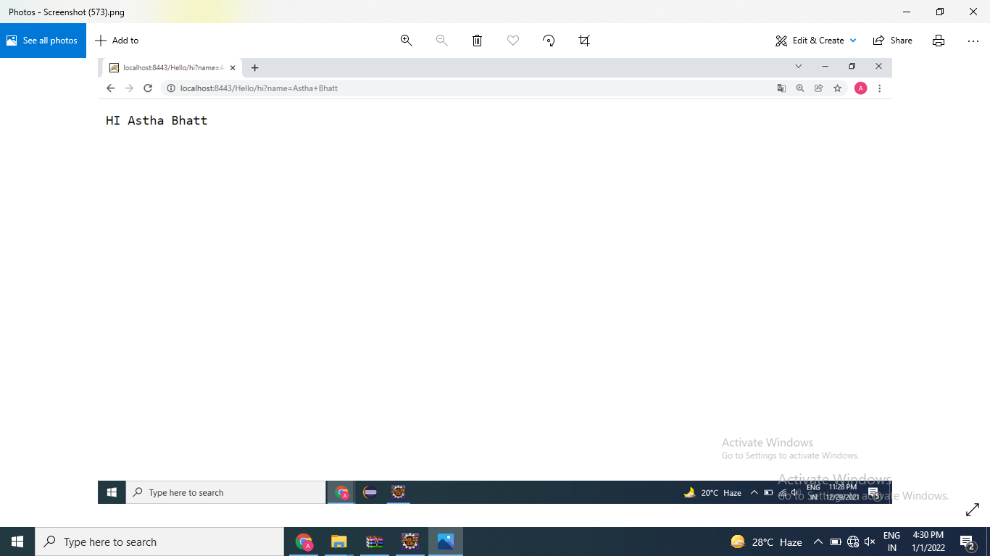

1. Write Servlet code to add two numbers

* HTML File

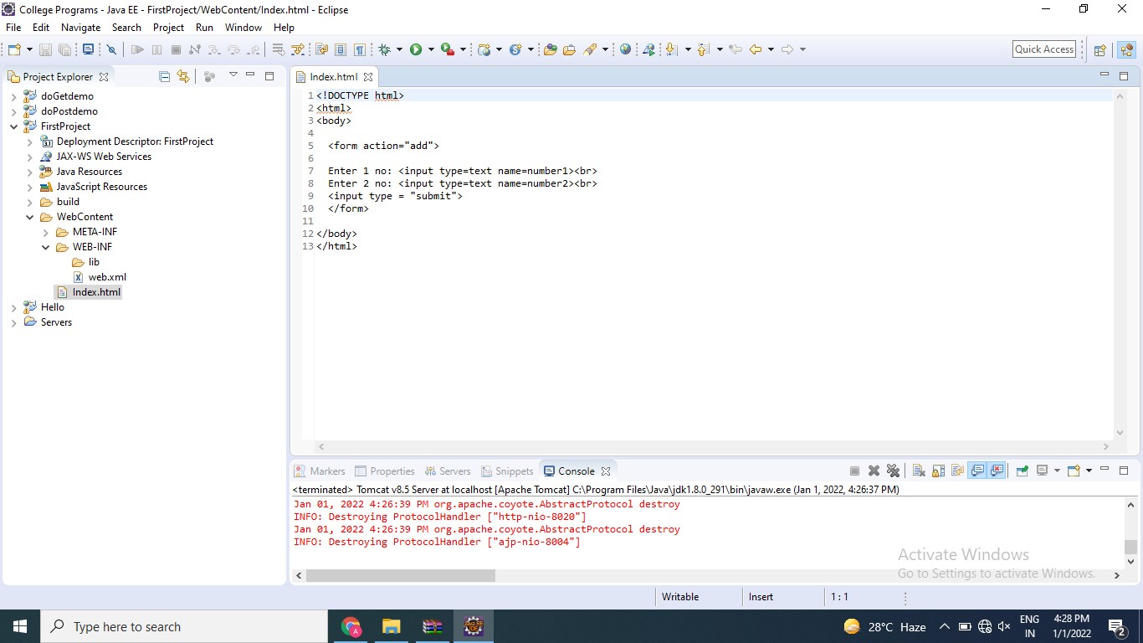

* JAVA File

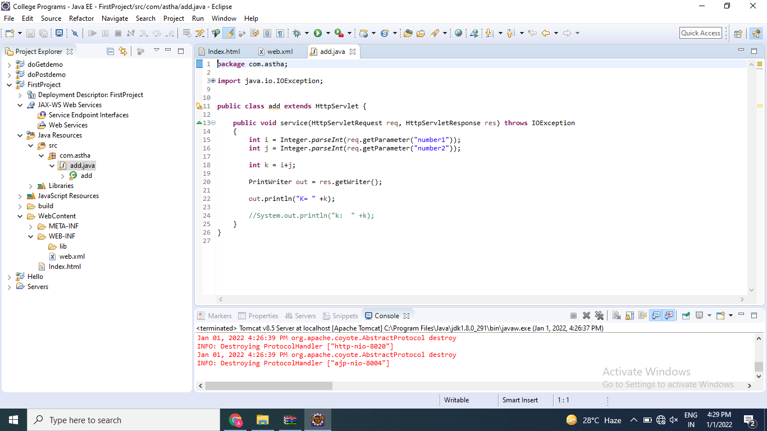

* Web.xml

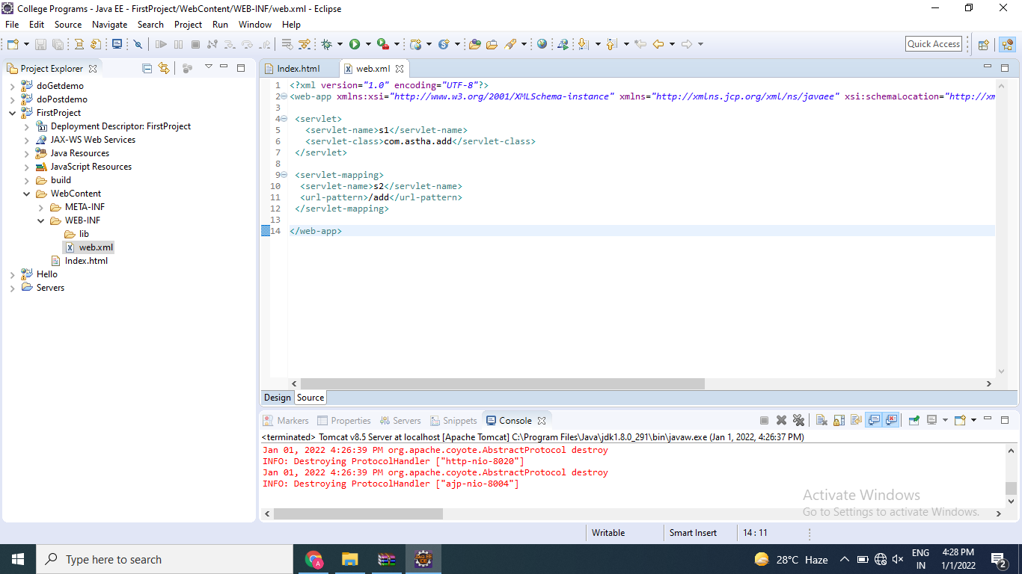

1. Write an HTML code to create login form having one submit button, two textboxes labeled as Login name and Password as respectively. Write a Servlet class named as ReadParameter to read these two parameters and display entered parameters values on the page using doGet() method when user clicked on submit button.

* HTML File

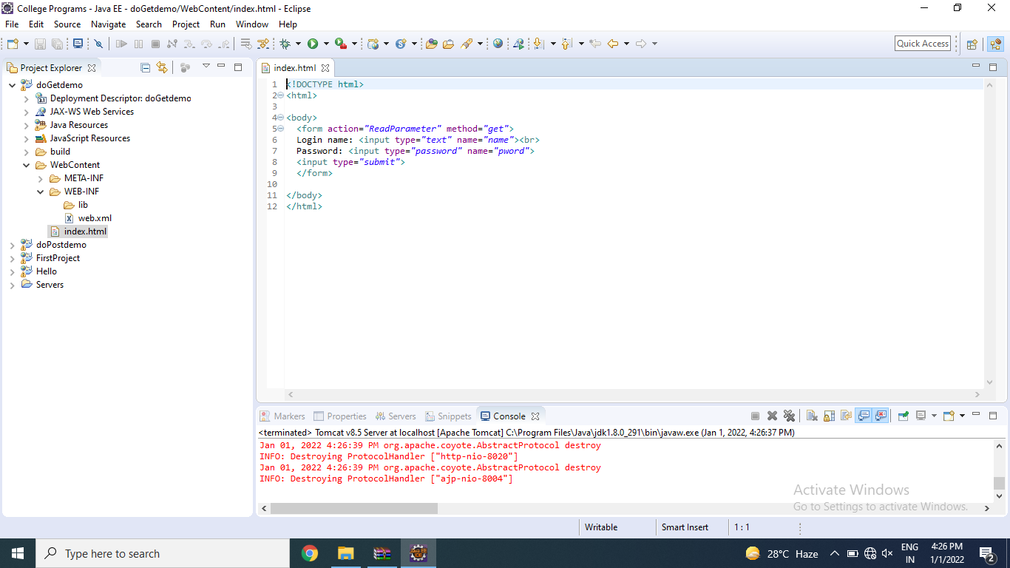

* JAVA File

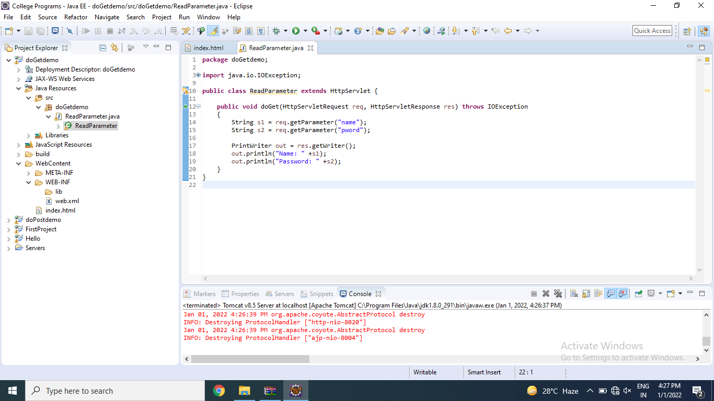

* Web.xml

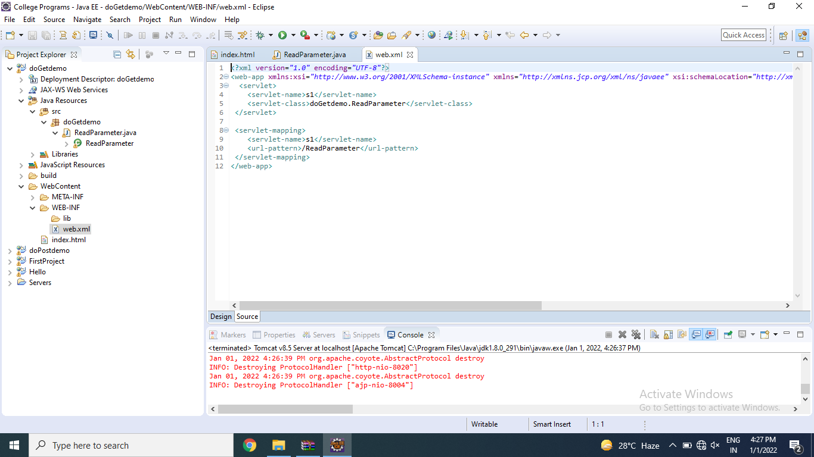

4)Write an HTML code to create login form having one submit button , two textboxes labeled as Login and Password as respectively. Write a Servlet class named as ReadParameter to read these two parameters and display entered parameters values on the page using doPost() method when user clicked on submit button.

- HTML File

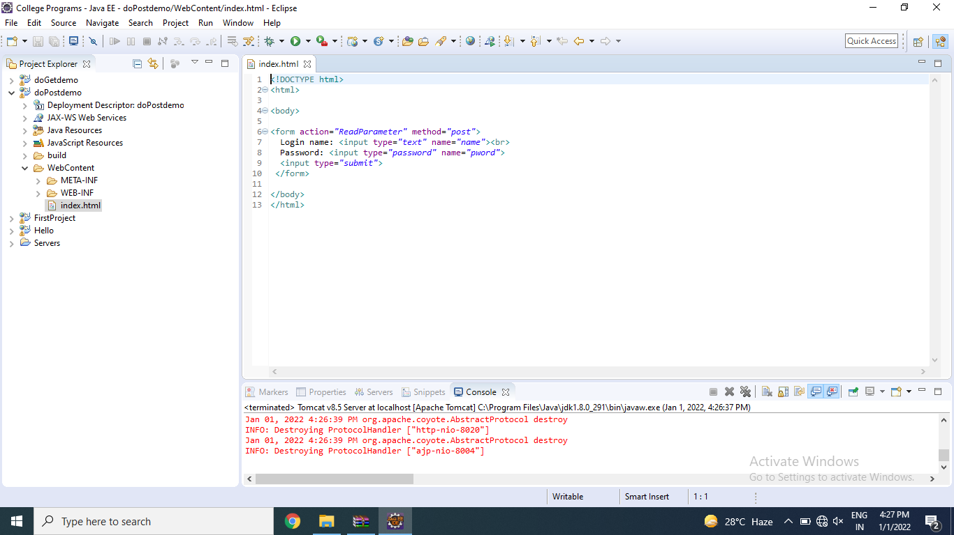

* JAVA File

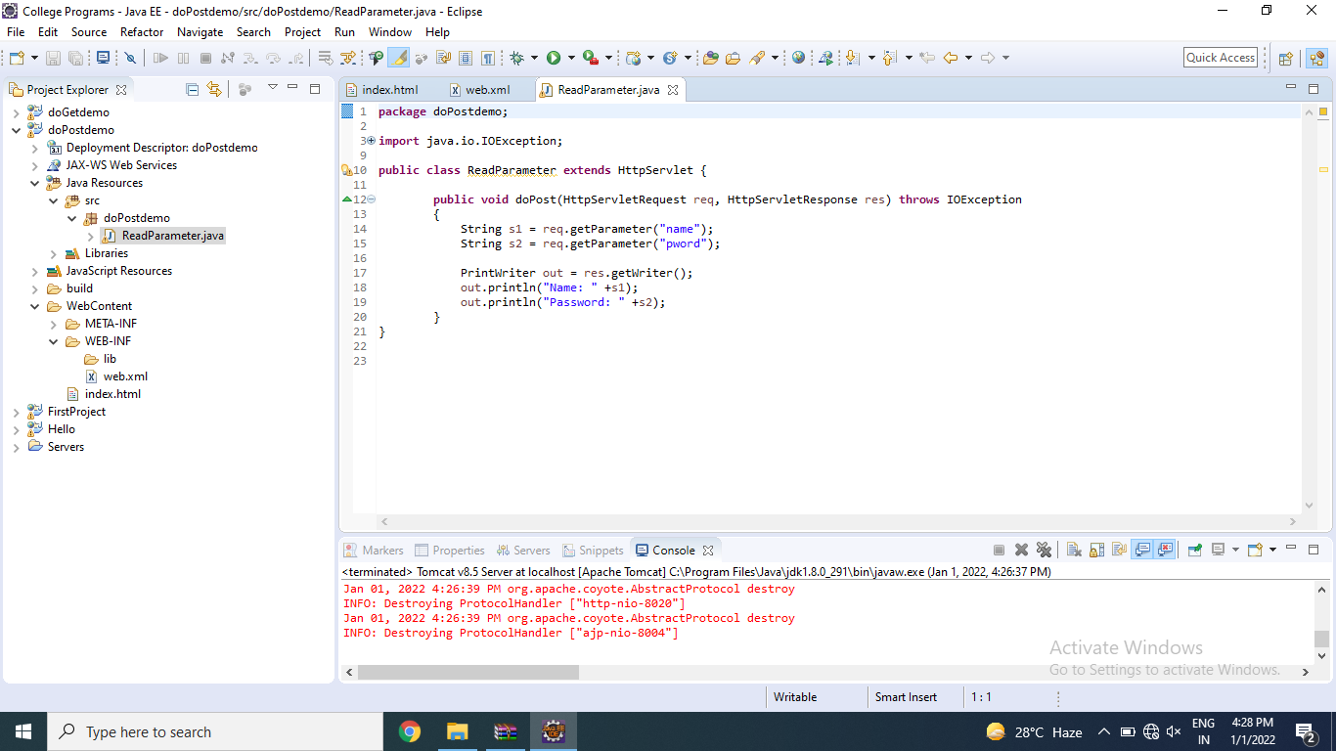

* Web.xml

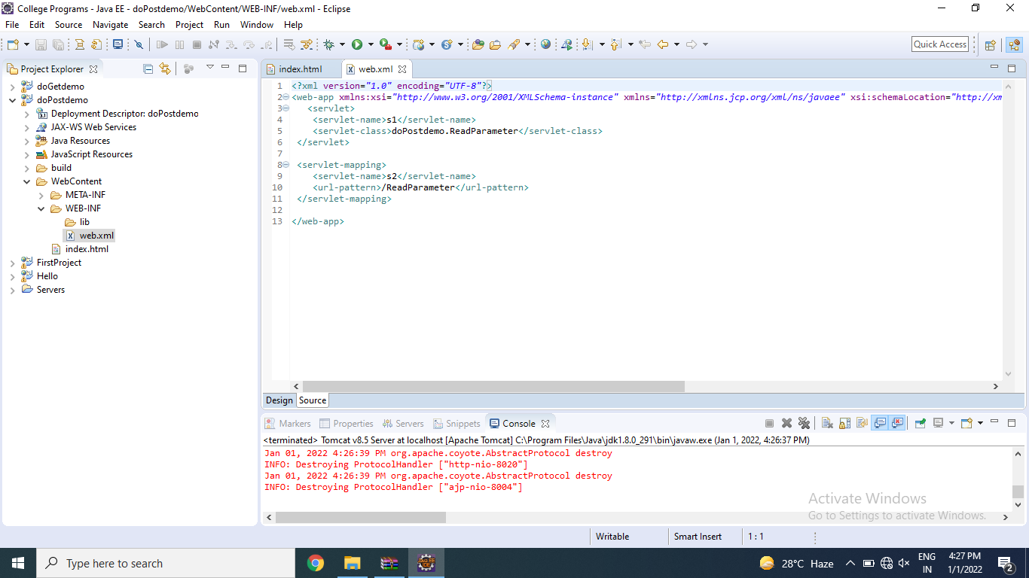

**\*\*\*\*\***

Name: Astha Arpit Bhatt

Enrollment: 196140316006

**Write a simple JSP code to print "Hello World".**

<%@page contentType="text/html" pageEncoding="UTF-8"%>

<!DOCTYPE html>

<html>

<head>

<meta http-equiv="Content-Type" content="text/html; charset=UTF-8">

<title>Hello</title>

</head>

<body>

<%= "Hello World!" %>

</body>

</html>

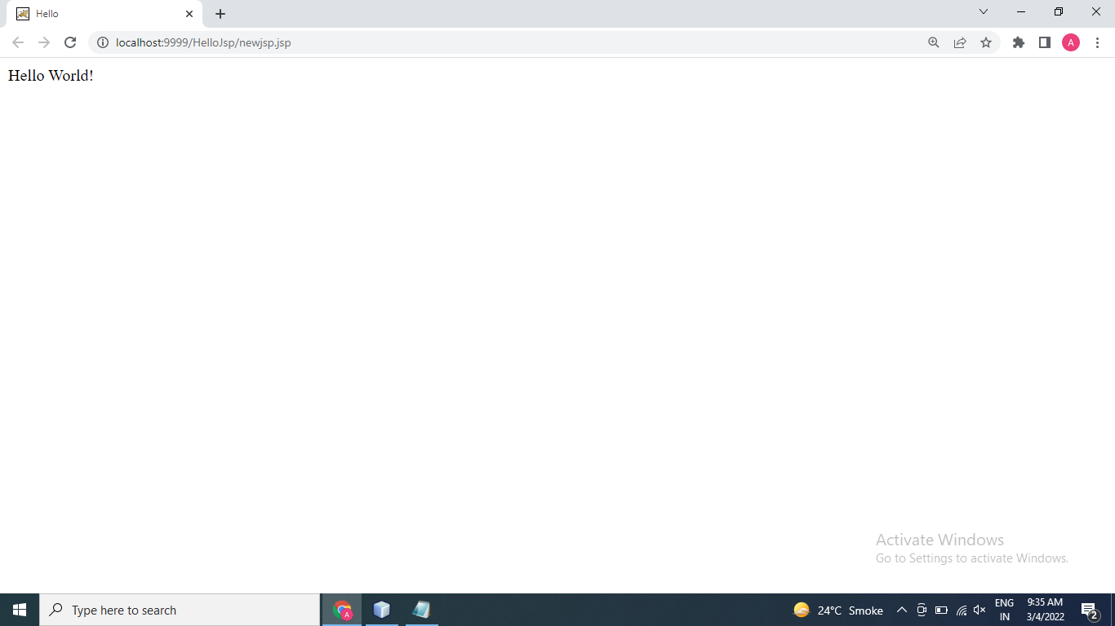

**Write JSP code to determine how many times the visitor has loaded the page.**

<%@page contentType="text/html" pageEncoding="UTF-8"%>

<!DOCTYPE html>

<html>

<head>

<meta http-equiv="Content-Type" content="text/html; charset=UTF-8">

<title>My First JSP Page</title>

</head>

<%!

int count=0;

int getCount()

{

return (++count);

}

%>

<body>

Page count is:

<% out.println(getCount()); %>

</body>

</html>

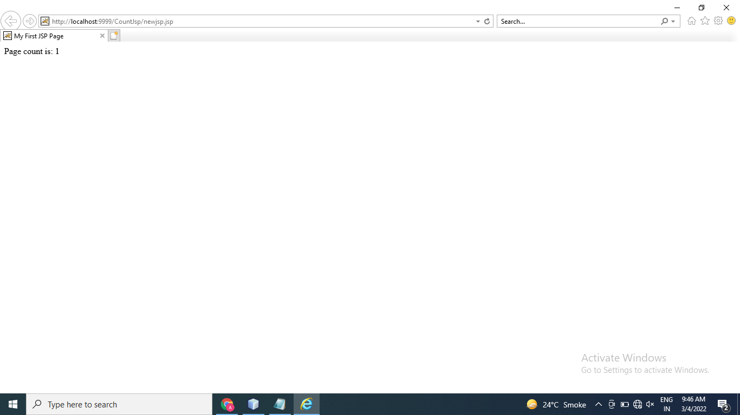

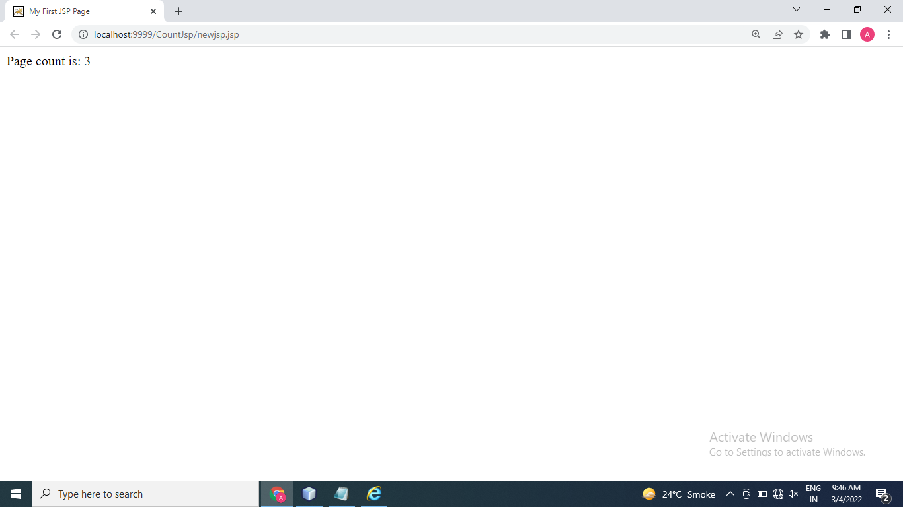

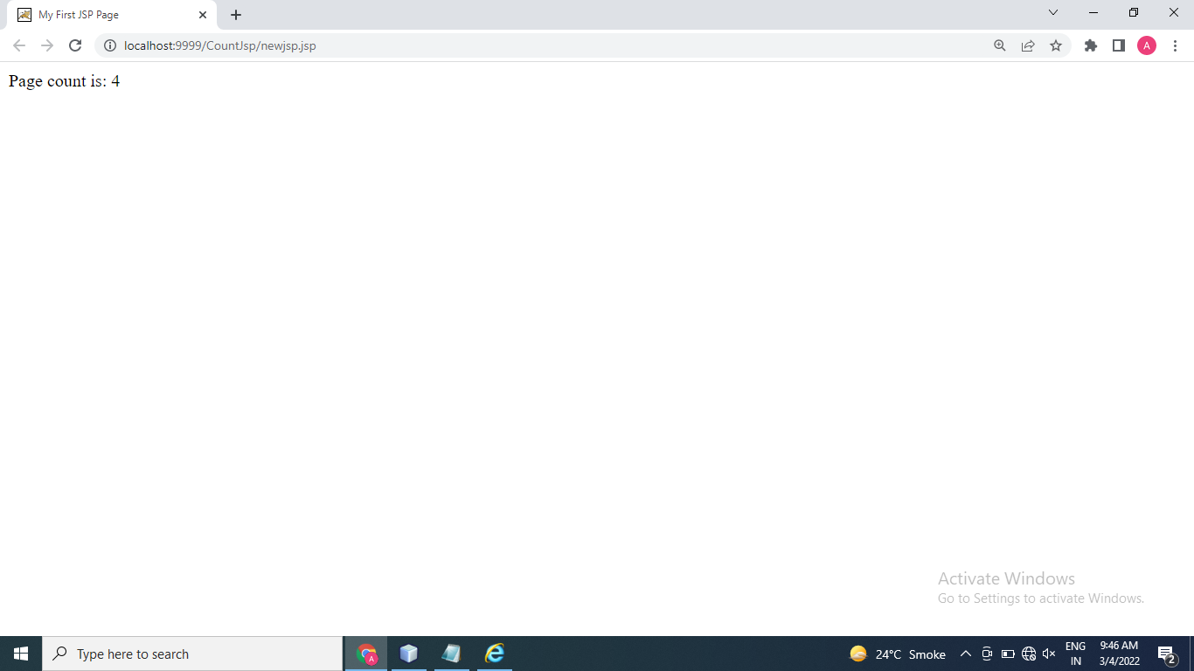

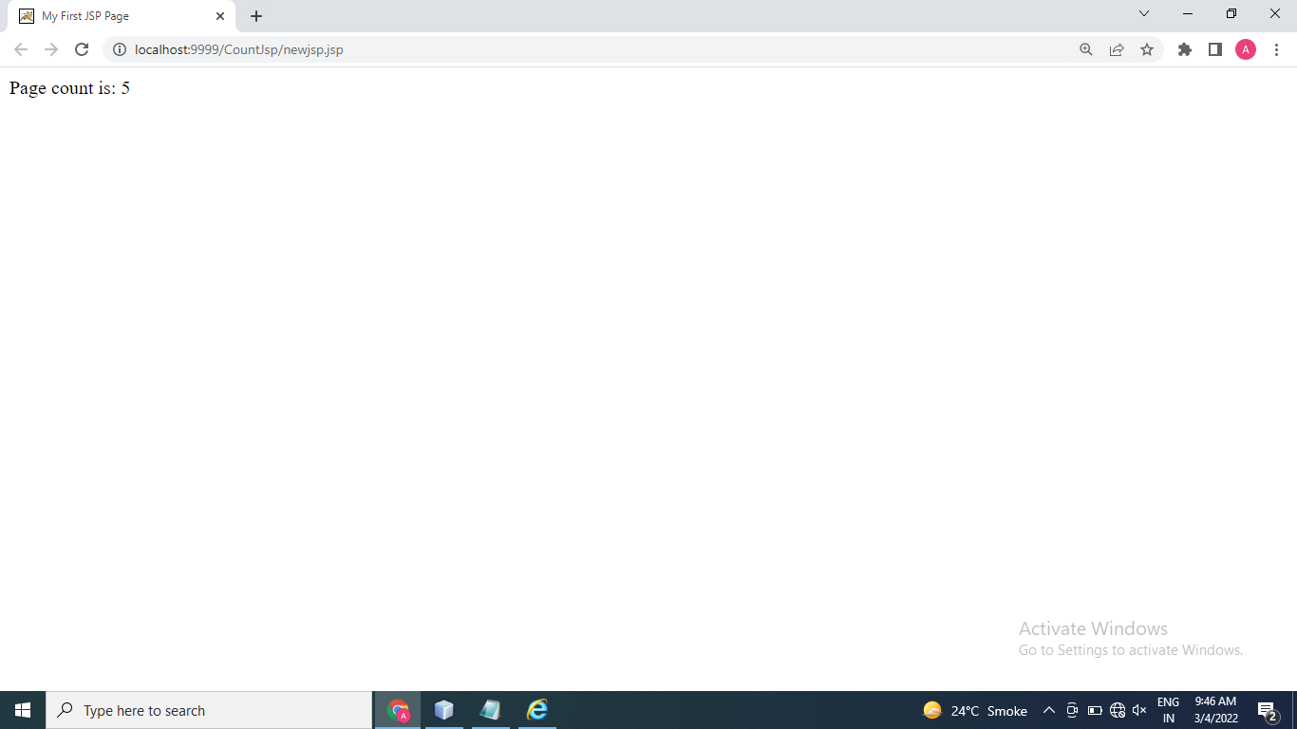

Thanks mam!!

Name: Astha Arpit Bhatt

Enroll: 196140316006

ITA Sem:6

**MINI-PROJECT**

Aim: Develop Student Registration form with the use of Java-swing and store these data on MySQL database.Show Button shows all detail of student table.

**CODE:**

package miniproject1;

import javax.swing.*;

import java.awt.*;

import java.awt.event.*;

import java.sql.*;

public class MiniProject1 extends JFrame implements ActionListener{

JTextField t1,t2,t3,t4;

JTextArea ta1,ta2;

JLabel l1,l2,l3,l4,l5,l6,l7,l8,msg;

JRadioButton it,cmp,civil,mechanical;

JCheckBox first,sec,third,fourth,fifth,sixth;

JComboBox term;

JButton save,show;

JTextArea screen;

public void regis(){

setTitle("Registration Form");

setSize(900,700);

Container c = getContentPane();

c.setLayout(null);

JLabel title = new JLabel("Student Registration Form");

title.setBounds(330,10,250,50);

title.setFont(title.getFont().deriveFont(20.0f));

c.add(title);

l1 = new JLabel("Name");

l1.setBounds(20,70,100,20);

l1.setFont(title.getFont().deriveFont(15.0f));

c.add(l1);

t1 = new JTextField();

t1.setBounds(130,70,240,20);

c.add(t1);

l2 = new JLabel("GTU No");

l2.setBounds(20,110,100,20);

l2.setFont(title.getFont().deriveFont(15.0f));

c.add(l2);

t2 = new JTextField();

t2.setBounds(130,110,240,20);

c.add(t2);

l3 = new JLabel("Branch");

l3.setBounds(20,150,100,20);

l3.setFont(title.getFont().deriveFont(15.0f));

c.add(l3);

it = new JRadioButton("IT");

cmp = new JRadioButton("Computer");

civil = new JRadioButton("Civil");

mechanical = new JRadioButton("Mechanical");

it.setBounds(130,150,50,20);

it.setFont(title.getFont().deriveFont(15.0f));

cmp.setBounds(210,150,100,20);

cmp.setFont(title.getFont().deriveFont(15.0f));

civil.setBounds(130,180,80,20);

civil.setFont(title.getFont().deriveFont(15.0f));

mechanical.setBounds(210,180,120,20);

mechanical.setFont(title.getFont().deriveFont(15.0f));

it.setSelected(true);

c.add(it);

c.add(cmp);

c.add(civil);

c.add(mechanical);

ButtonGroup bn = new ButtonGroup();

bn.add(it);

bn.add(cmp);

bn.add(civil);

bn.add(mechanical);

l4= new JLabel("Sem");

l4.setBounds(20,220,100,20);

l4.setFont(title.getFont().deriveFont(15.0f));

c.add(l4);

first = new JCheckBox("First");

first.setBounds(130,220,60,20);

first.setFont(title.getFont().deriveFont(15.0f));

first.setSelected(true);

c.add(first);

sec = new JCheckBox("Second");

sec.setBounds(210,220,80,20);

sec.setFont(title.getFont().deriveFont(15.0f));

c.add(sec);

third = new JCheckBox("Third");

third.setBounds(300,220,80,20);

third.setFont(title.getFont().deriveFont(15.0f));

c.add(third);

fourth = new JCheckBox("Fourth");

fourth.setBounds(130,260,80,20);

fourth.setFont(title.getFont().deriveFont(15.0f));

c.add(fourth);

fifth = new JCheckBox("Fifth");

fifth.setBounds(210,260,80,20);

fifth.setFont(title.getFont().deriveFont(15.0f));

c.add(fifth);

sixth = new JCheckBox("Sixth");

sixth.setBounds(300,260,80,20);

sixth.setFont(title.getFont().deriveFont(15.0f));

c.add(sixth);

l5 = new JLabel("Address");

l5.setBounds(20,300,100,20);

l5.setFont(title.getFont().deriveFont(15.0f));

c.add(l5);

ta1 = new JTextArea();

ta1.setBounds(130,300,240,80);

c.add(ta1);

l6 = new JLabel("term");

l6.setBounds(20,410,110,20);

l6.setFont(title.getFont().deriveFont(15.0f));

c.add(l6);

String term_[] = {"2019-2020","2020-2021","2021-2022"};

term = new JComboBox(term_);

term.setBounds(130,410,240,20);

c.add(term);

l7 = new JLabel("Contact No");

l7.setBounds(20,450,100,20);

l7.setFont(title.getFont().deriveFont(15.0f));

c.add(l7);

t3 = new JTextField();

t3.setBounds(130,450,240,20);

c.add(t3);

l8 = new JLabel("Email-id");

l8.setBounds(20,490,100,20);

l8.setFont(title.getFont().deriveFont(15.0f));

c.add(l8);

t4 = new JTextField();

t4.setBounds(130,490,240,20);

c.add(t4);

ta2 =new JTextArea();

ta2.setBounds(430,70,800,512);

c.add(ta2);

save = new JButton("Save");

save.setBounds(130,550,110,30);

save.setFont(title.getFont().deriveFont(15.0f));

c.add(save);

save.addActionListener(this);

show = new JButton("Show");

show.setBounds(255,550,110,30);

show.setFont(title.getFont().deriveFont(15.0f));

c.add(show);

save.addActionListener(this);

setVisible(true);

}

public static void main(String[] args) {

MiniProject1 p = new MiniProject1();

p.regis();

}

@Override

public void actionPerformed(ActionEvent a) {

String s= a.getActionCommand();

if(s=="Save")

{

String name=t1.getText();

String gtuno=t2.getText();

String branch=" ";

if(it.isSelected())

{

branch="IT";

}

else if(cmp.isSelected())

{

branch="Computer";

}

else if(civil.isSelected())

{

branch="Civil";

}

else if(mechanical.isSelected())

{

branch="Mechanical";

}

String sem=" ";

if(first.isSelected())

{

sem ="First";

}

else if(sec.isSelected())

{

sem ="Second";

}

else if(third.isSelected())

{

sem ="Third";

}

else if(fourth.isSelected())

{

sem ="Fourth";

}

else if(fifth.isSelected())

{

sem ="Fifth";

}

else if(sixth.isSelected())

{

sem ="Sixth";

}

String add=ta1.getText();

String c=(String)term.getSelectedItem();

String cn=t3.getText();

String email=t4.getText();

try

{

Class.forName("com.mysql.jdbc.Driver");

Connection con=DriverManager.getConnection("jdbc:mysql://localhost:3306/ajava","root","");

Statement stmt=con.createStatement();

String sql1 = "Insert INTO student_registeration (name,gtuno,branch,sem,address,term,mobile,email)VALUES "+ "('"+name+"','"+gtuno+"','"+branch+"','"+sem+"','"+add+"','"+c+"','"+cn+"','"+email+"')";

stmt.executeUpdate(sql1);

ta2.setText("Data inserted");

stmt.close();

con.close();

}

catch(Exception e)

{

System.out.println(e);

}

}

if(s=="Show")

{

String em=t4.getText();

try

{

Class.forName("com.mysql.jdbc.Driver");

Connection con=DriverManager.getConnection("jdbc:mysql://localhost:3306/ajava","root","");

Statement stmt=con.createStatement();

String sql1="SELECT * FROM student_registeration where email='"+em+"'";

ResultSet rs1=stmt.executeQuery(sql1);

while(rs1.next())

{

String name=rs1.getString("name");

String gtuno=rs1.getString("gtuno");

String branch=rs1.getString("branch");

String sem=rs1.getString("sem");

String add=rs1.getString("address");

String term=rs1.getString("term");

String mobile=rs1.getString("mobile");

String email=rs1.getString("email");

ta2.setText("Name: "+name+"\n Gtu No: "+gtuno+"\n Branch: "+branch+"\n Semester: "+sem+"\n "

+ "Address:"+add+"\n Academic Term: "+term+"\n Mobile Number: "+mobile+"\n Email-id: "+email+"\n");

}

con.close();

}

catch(Exception e)

{

System.out.println(e);

}

}

}

}

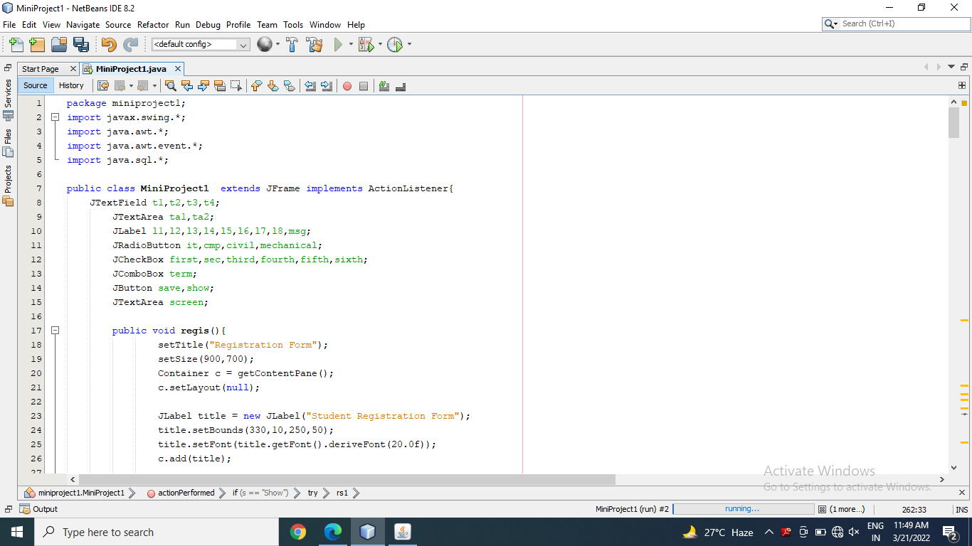

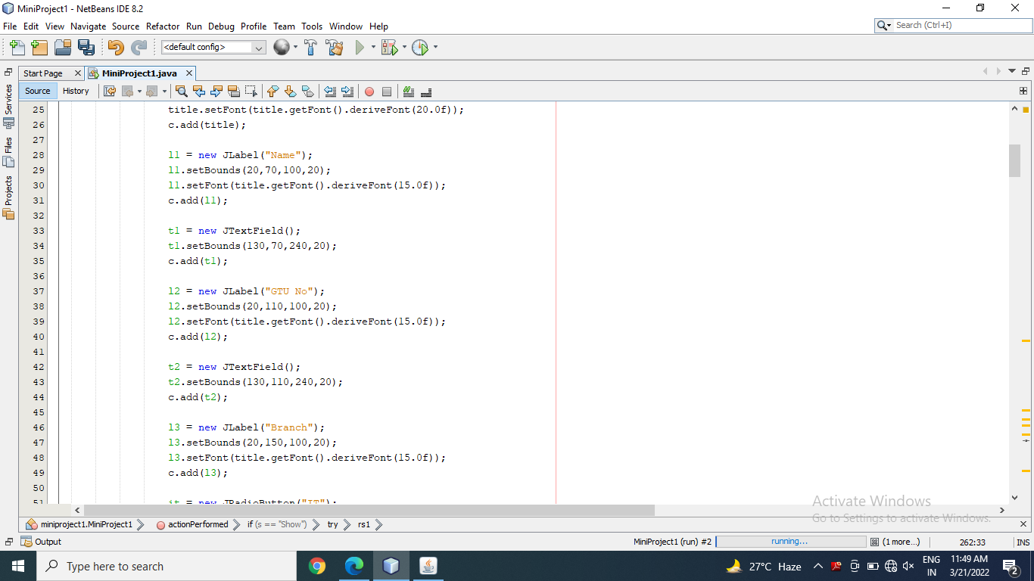

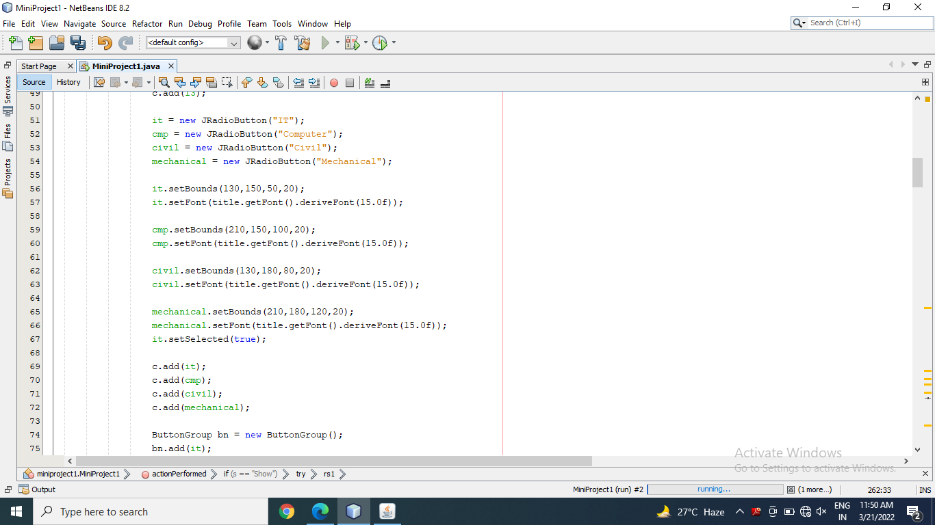

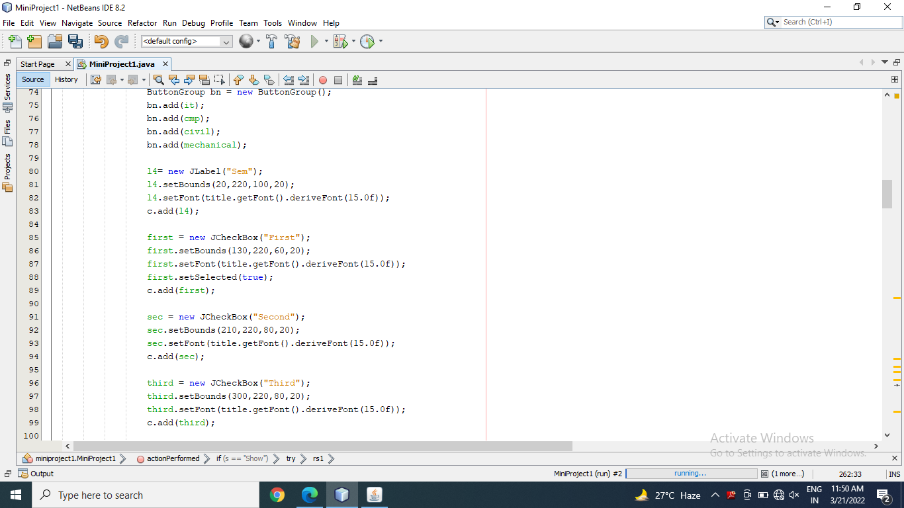

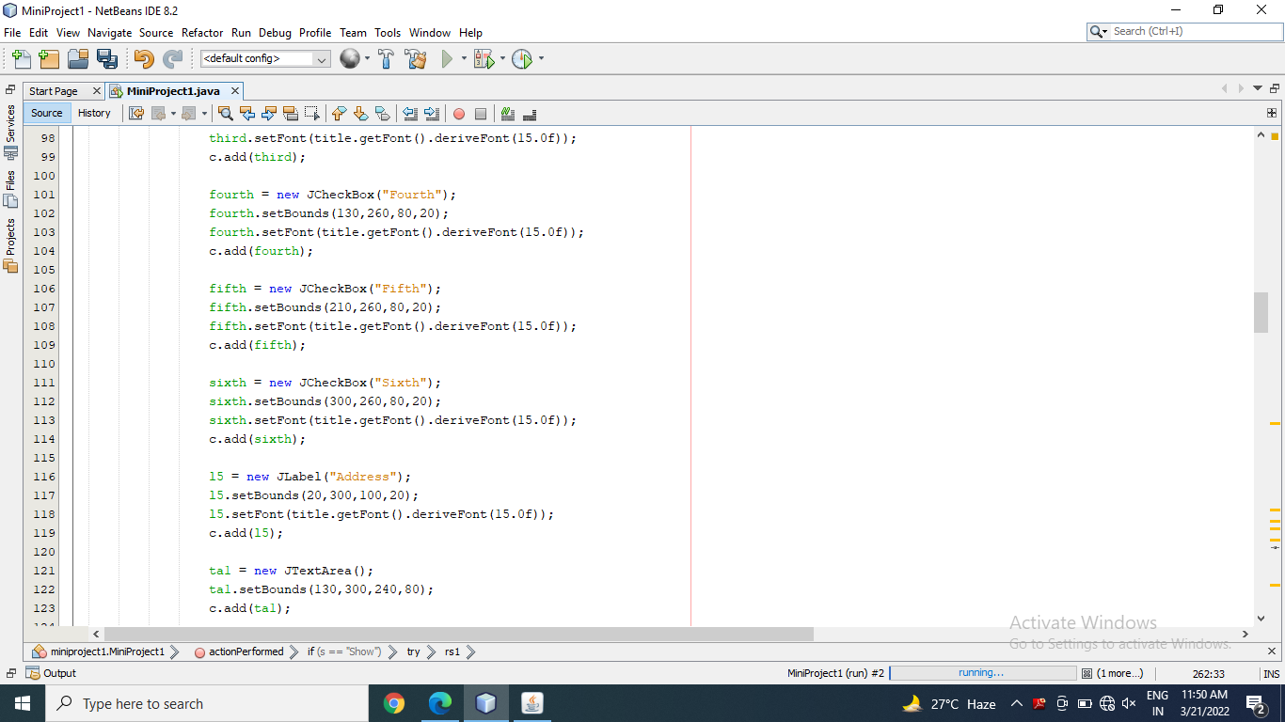

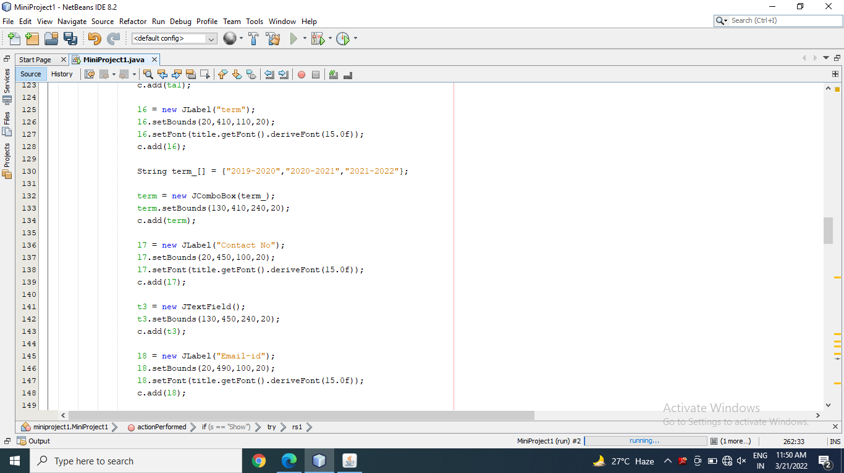

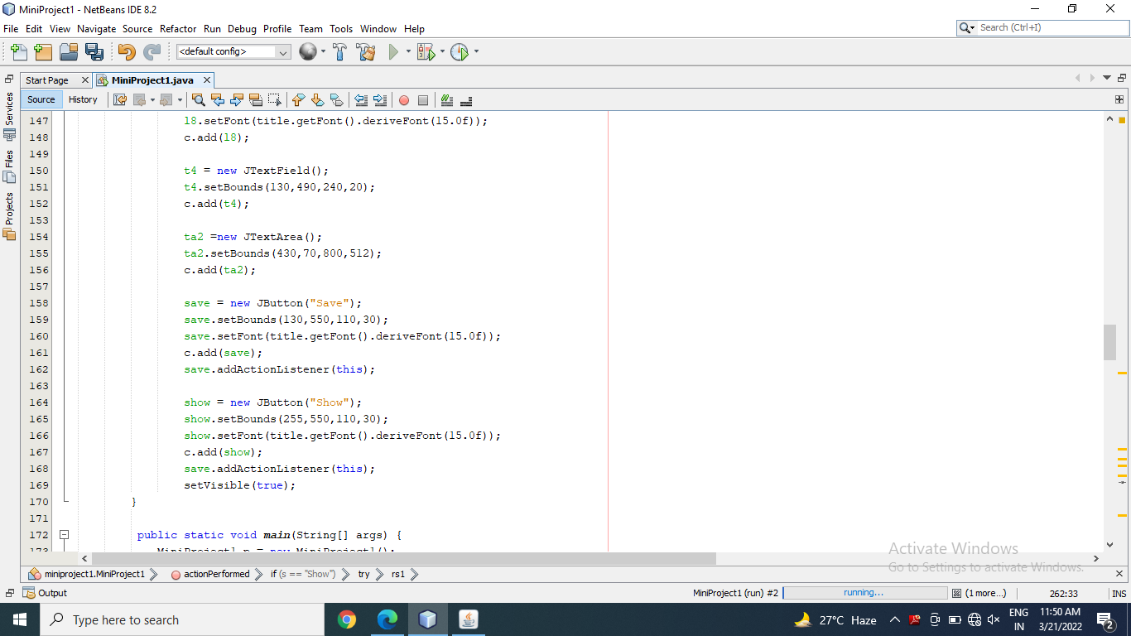

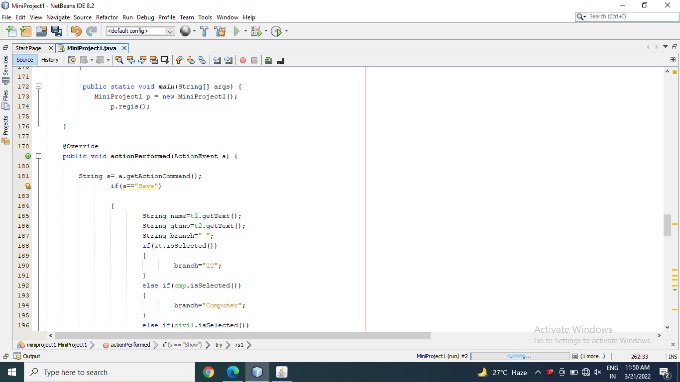

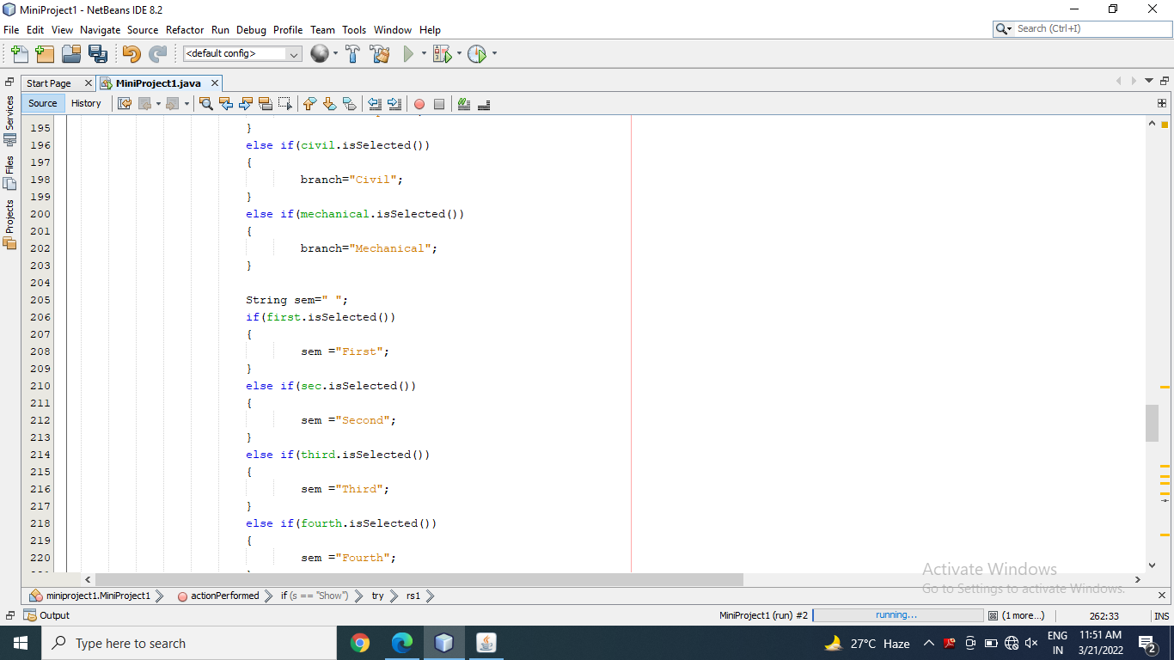

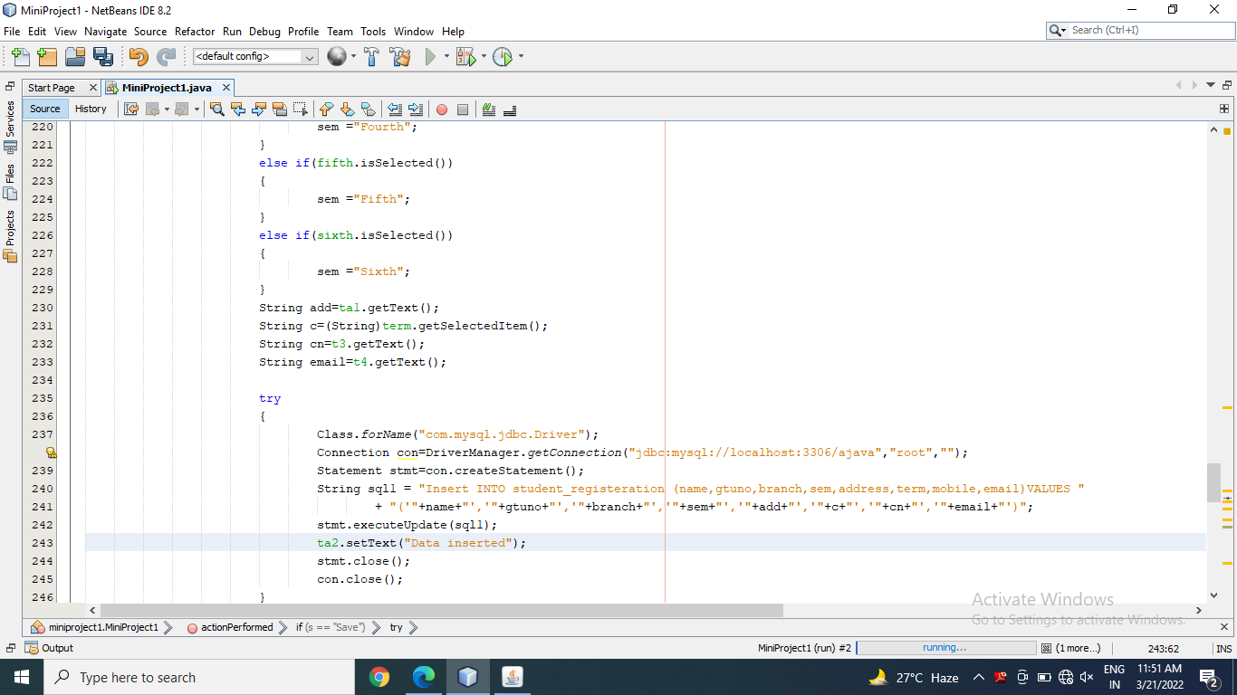

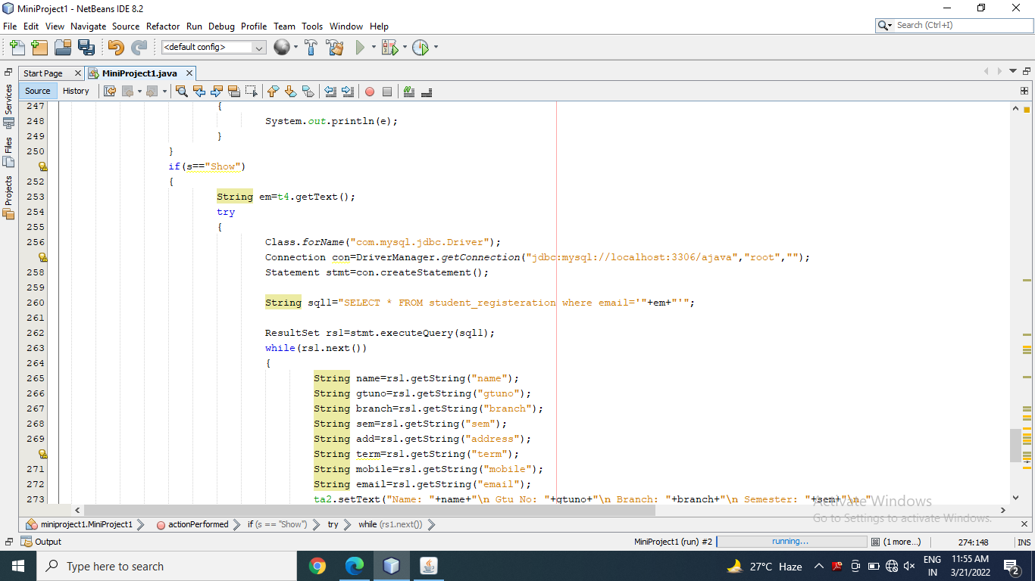

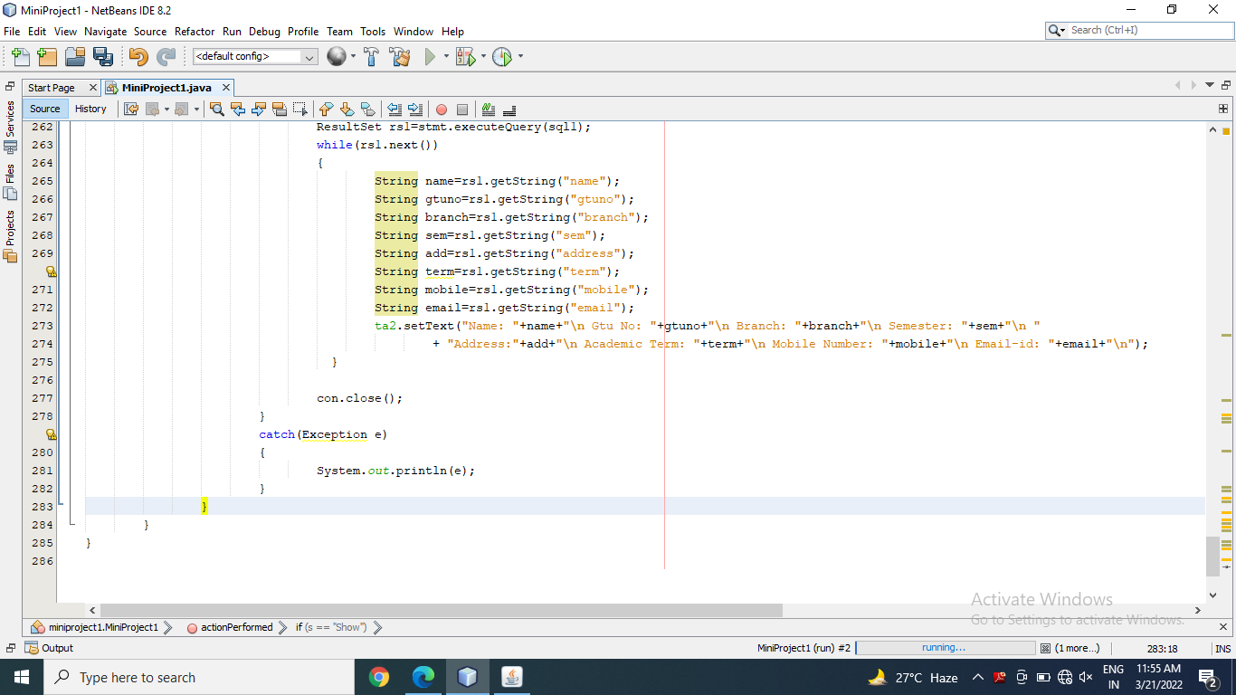

**OUTPUT:**

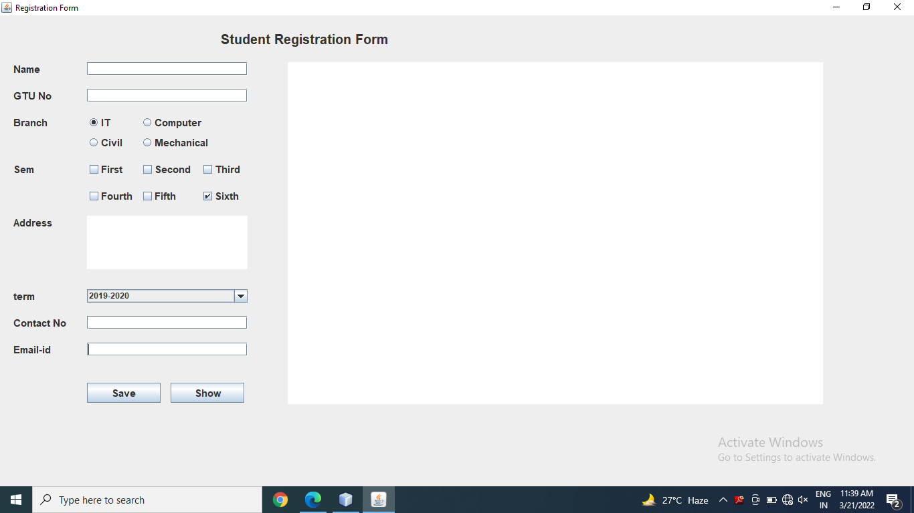

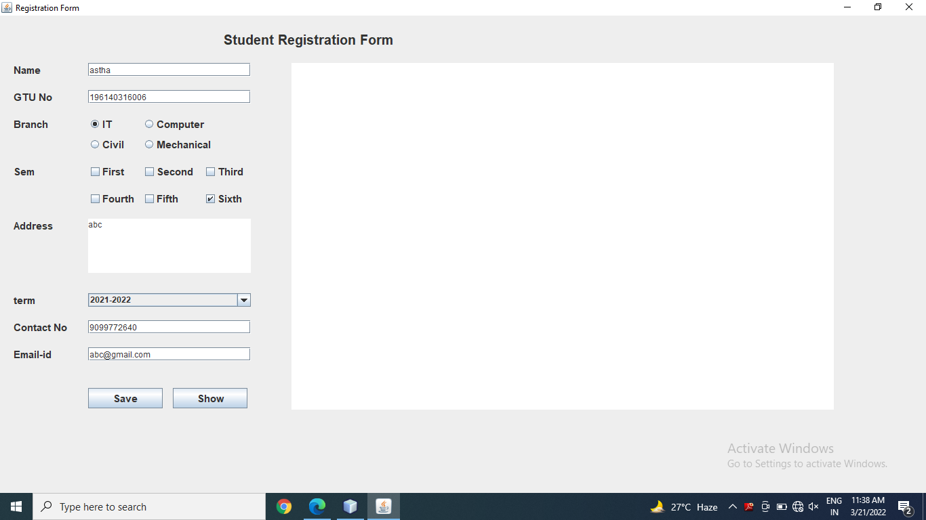

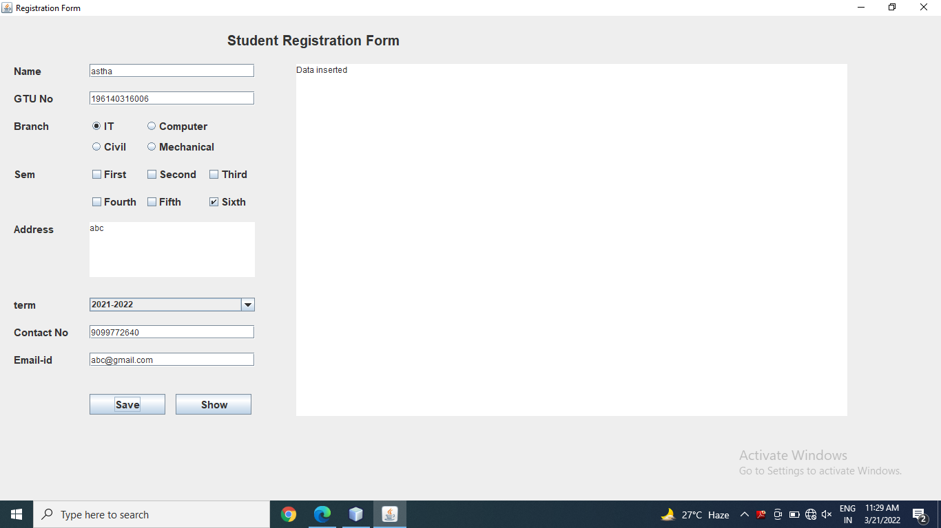

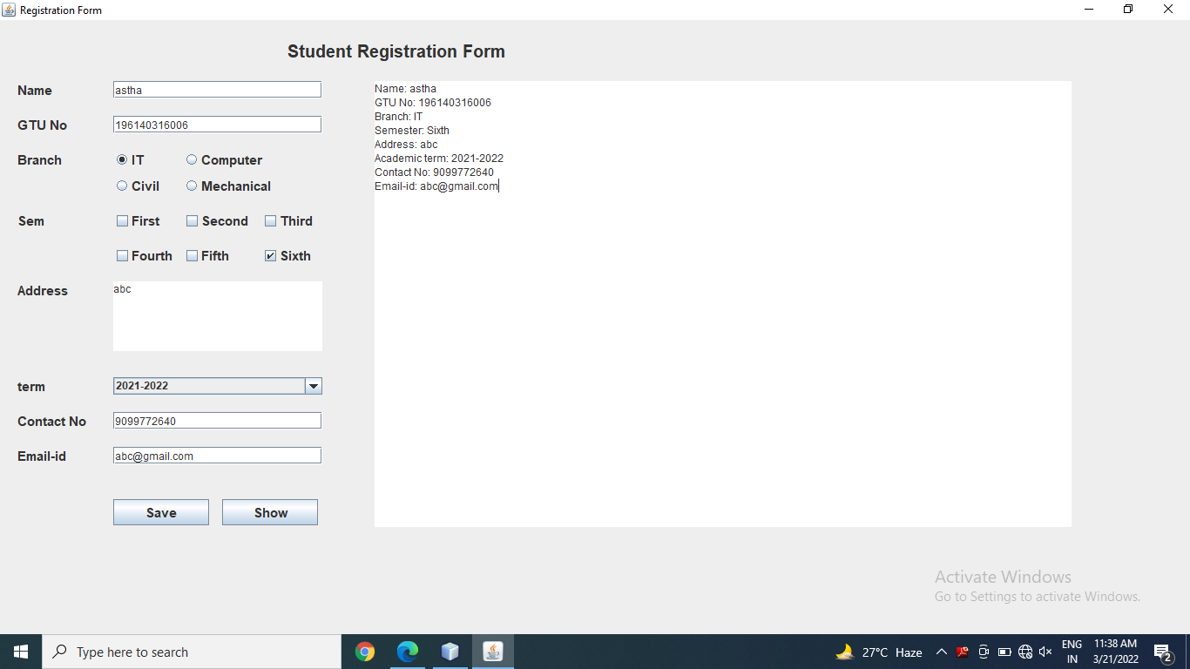

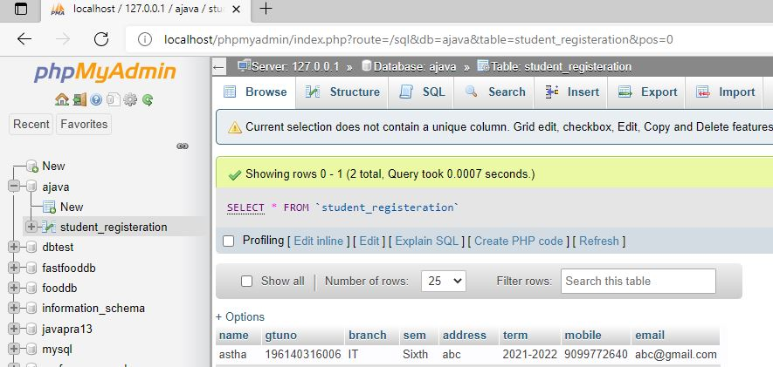

Thanks mam!!